S1 Fig. consistency plots
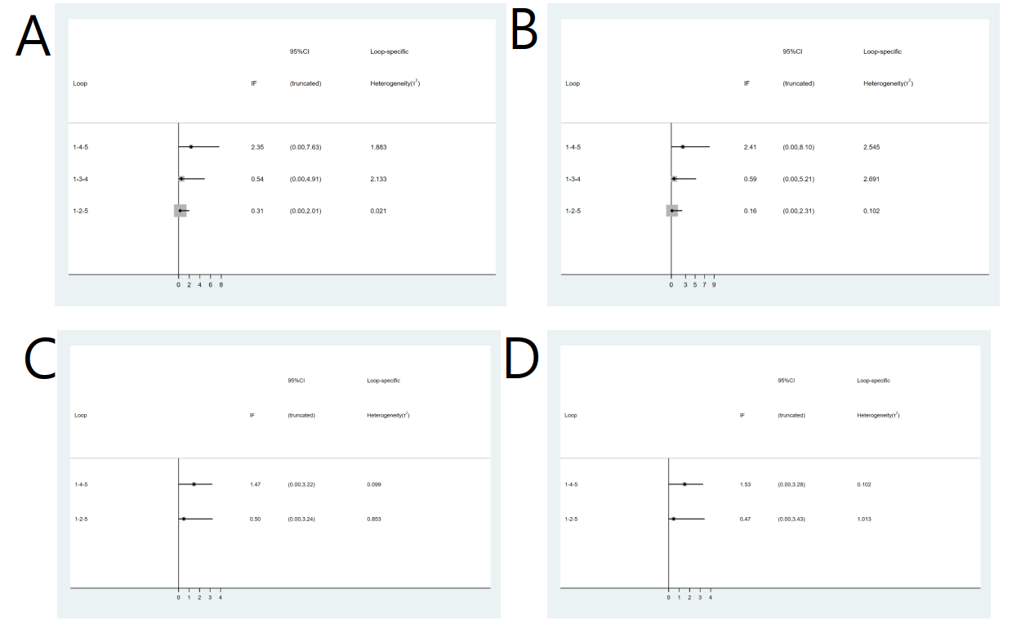
S1 Fig. Inconsistency plots of direct and indirect comparisons in this network meta-analysis. A. Overall success rate of unassisted intubation by ITT; B. Overall success rate of unassisted intubation by PP; C. Success rate of first attempt by ITT; D. Success rate of first attempt by PP.
ITT, intention to treat; PP, per protocol.

