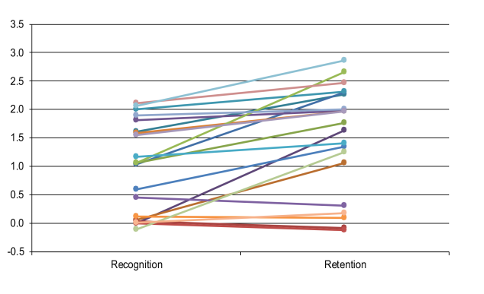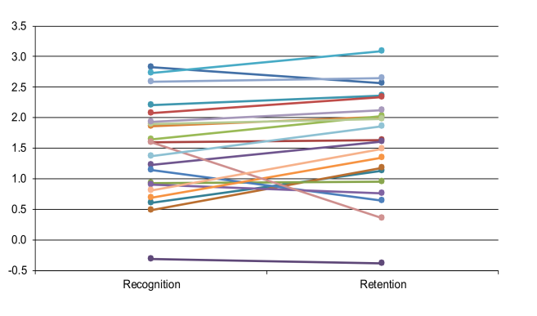
B. TD ttTD?TTddddd.
A. SLI

S1 Fig. Individual participant performance on the nonverbal task for the SLI (A) and TD (B) groups. The figures show d’ performance for each individual, collapsed over both Real and Novel items, at both Recognition (10 minutes after encoding) and Retention (24 hours after encoding). SLI: children with specific language impairment; TD: typically-developing children; d': d-prime scores.

