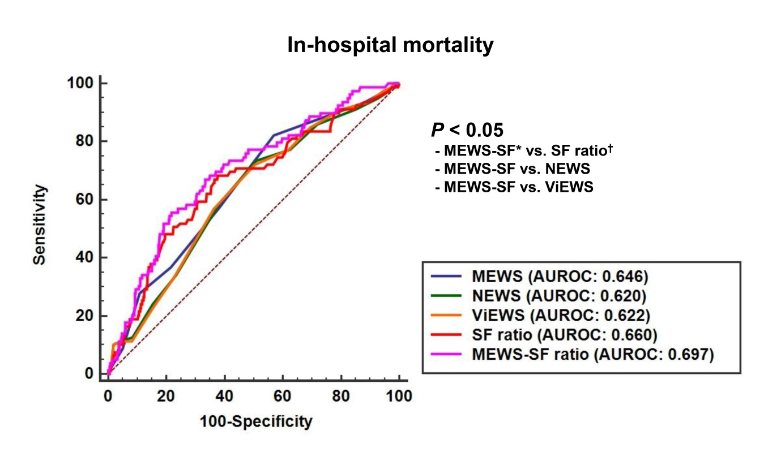
Fig 2. Comparison of the area of under the receiver operating characteristics curve for in-hospital mortality. MEWS, Modified Early Warning Score; NEWS, National Early Warning Score; ViEWS, VitalPAC Early Warning Score; AUROC, area under the receiver operating characteristic curve. *MEWS-SF ratio: the combination MEWS and SF ratio was calculated using predicted probability; †SF ratio: SpO2/FiO2 ratio.

