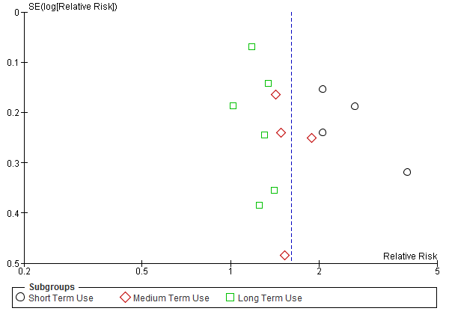
Supplementary Figure 1 – Sensitivity analysis funnel plot, showing the three subgroup

