Figure S1
(A) Collapsed tree on an unburned site (Photo: David Lindenmayer)
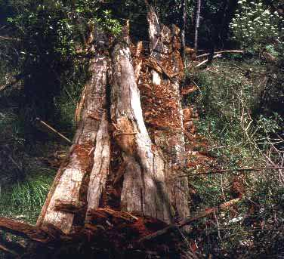
(B) Fire-consumed tree on a site burned at moderate severity (Photo: David Blair)
