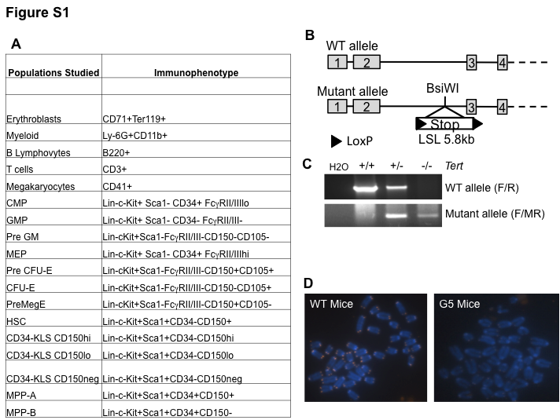

S1 Fig. Generation of Tert-/- mice, Chromosomal Abnormalities and Immunophenotypes of Cell Poplulations Studied. (A) Immunophenotypes of the hematopoietic subpopulations studied. (B) A LSL cassette was knocked into the second intron of the telomerase gene at the BsiWI site to generate telomerase heterozygous knockout mice, G0 Tert^{+/LSL} (G0 Tert+/-). (C) PCR of the WT, Tert+/- and Tert-/- mouse DNA showing heterozygous and homozygous knockout of the telomerase gene using wild type F primer with either wild type R primers or mutant R (MR) primer. (D) Metaphase of WT spleen cell showing bright telomere signal and G5 Tert-/- spleen cell showing weak telomere signal. In total 3 mice of each genotype was studied and ~20 metaphase chromosomes per mice were analyzed.

