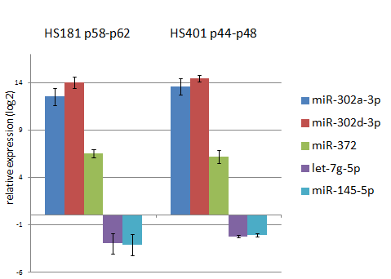Supplementary Figure S1. Relative expression of hESC-specific miRNAs (miR-302a-3p/d-3p and miR-372) and differentiation driving miRNAs (let-7g-5p, miR-145-5p) in HS181 and HS401 against HFF-1 fibroblast line. If the signal was absent, ct value 40 was used to calculate relative expression. n=3.

