Thin sections of C. marri femora

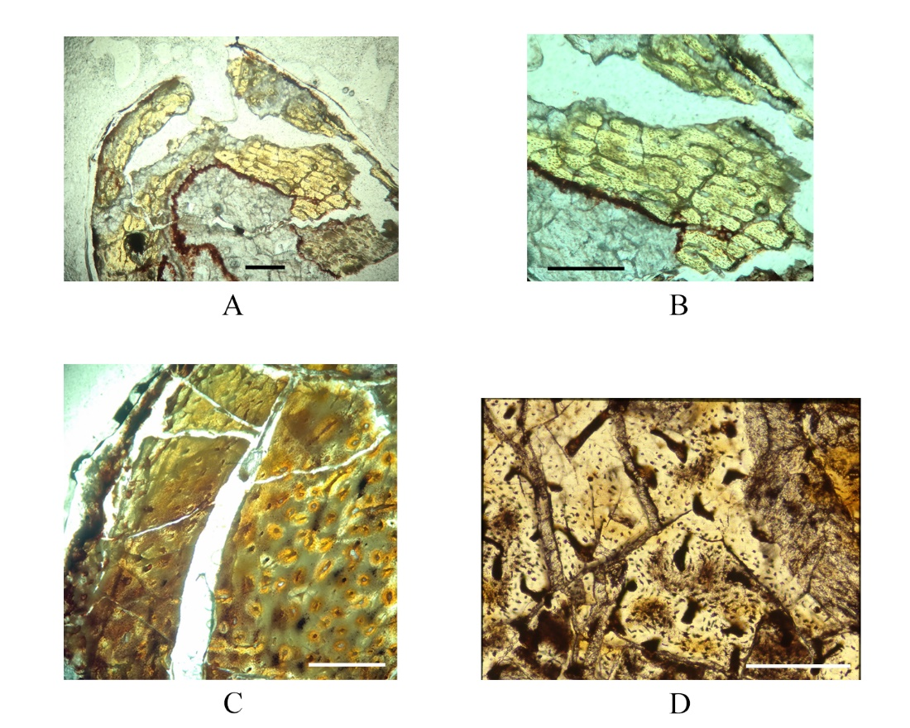

Thin Sections of C marri femora
(A) SMU 70447 femora at midshaft displaying highly vascularized lamellar bone with poorly developed primary osteons (B) SMU 70447 femora at midshaft detail of (A); (C) SMU 73569 femora at midshaft displaying primary and secondary osteons; (D) SMU 72834 femora at midshaft displaying primary and secondary osteons. Scale bar equals 1 mm.

