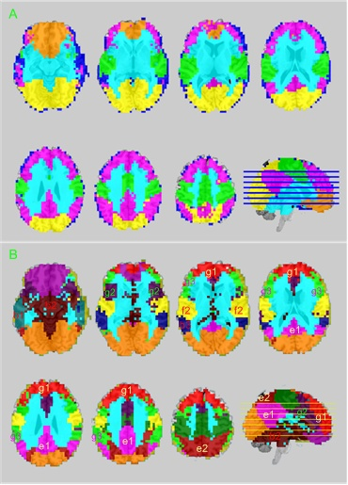
Fig. S6. A) six brain subdivisions and B) fourteen brain subdivisions derived from 1049 subjects’ rBEN maps. These clusters were identified using the same spectral clustering procedure as described in the main article. The prior specified cluster number k of 6 and 14 were located in the two suboptimal peak locations adjacent to the optimal one k=8 as shown in Fig. S4.

