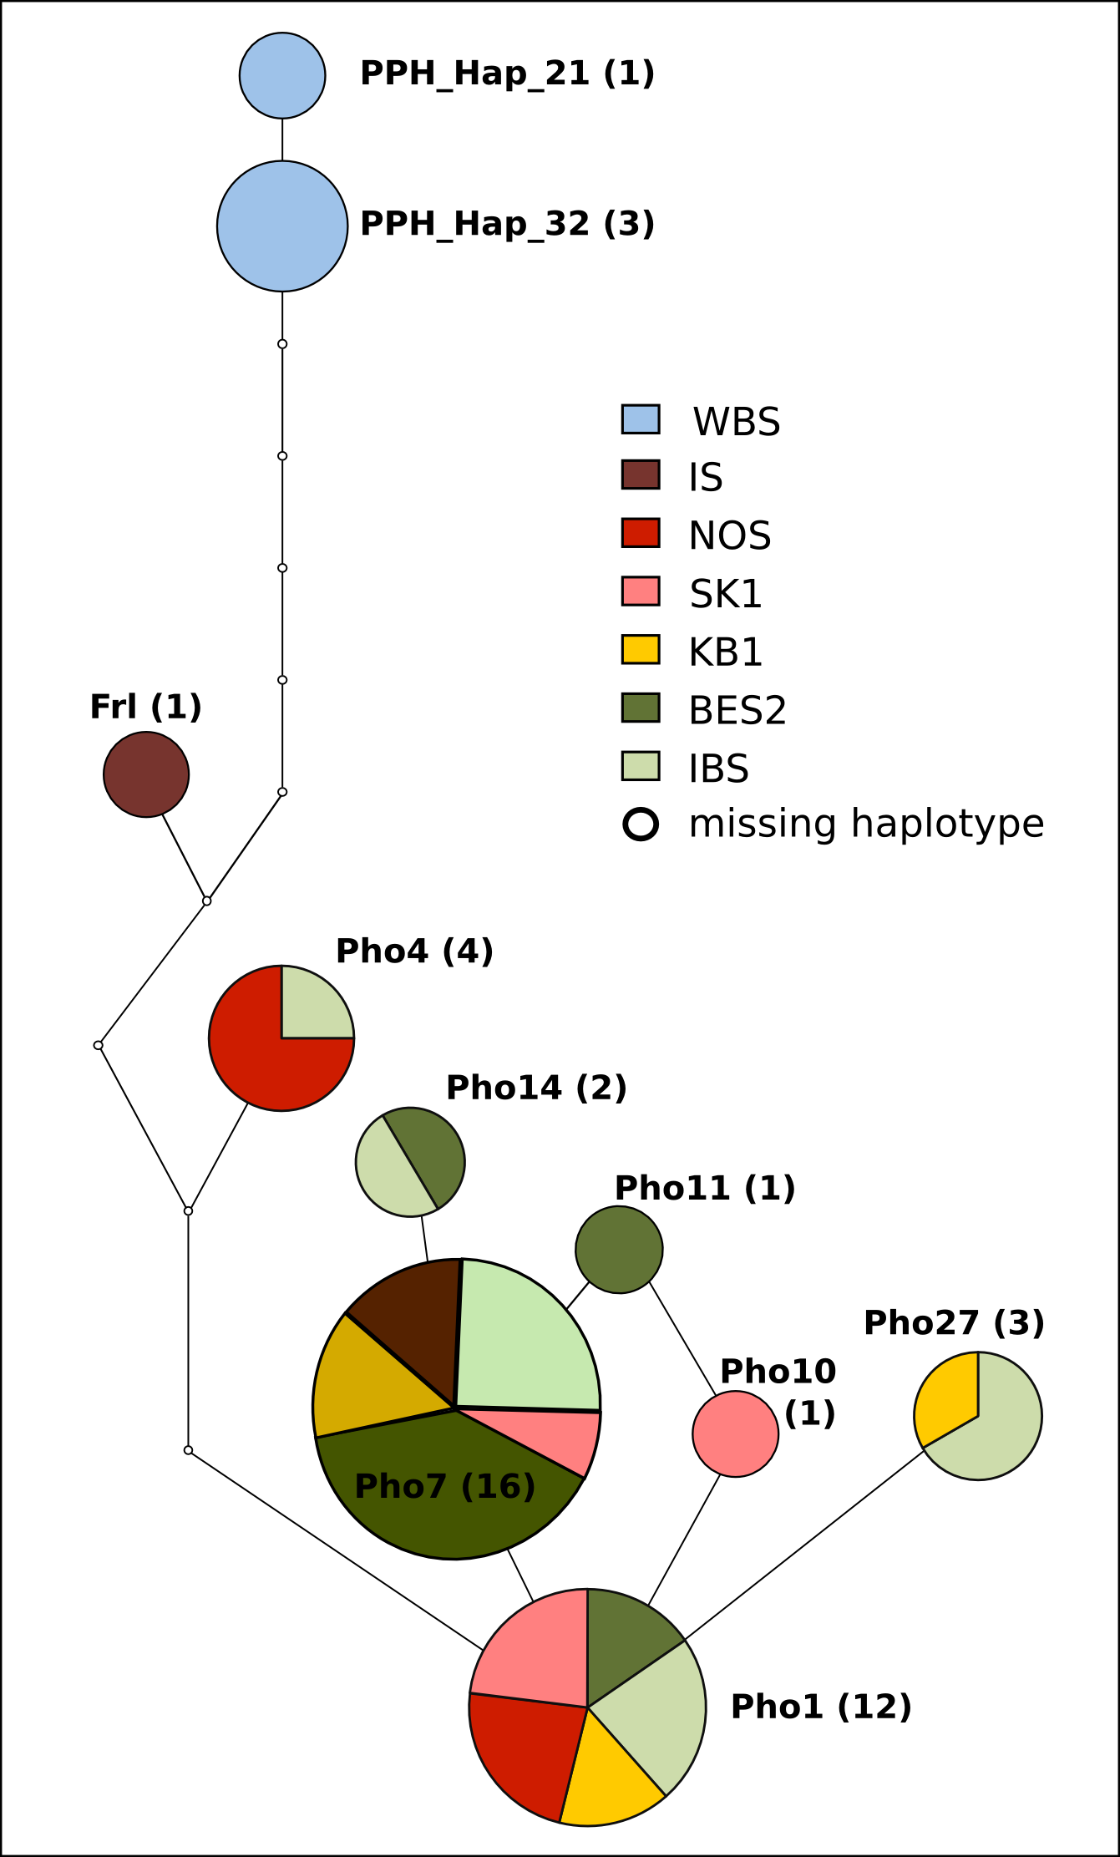
Figure S3. Mitochondrial haplotype network. P. phocoena mitochondrial haplotypes from the Western Black Sea (WBS), Iceland (IS), North Sea (NOS) in Skagerrak-northern Kattegat (SK1), Kattegat-Belt Sea 1 (KB1), Belt Sea 2 (BES2), and the Inner Baltic Sea (IBS). Circle diameter is proportional to relative frequency of haplotypes. Numbers in parentheses give absolute frequency of occurrence.

