Supporting Information: Grauer’s gorilla population crash

Table A. Covariables used for the analysis of occupancy across the landscape.

Covariable Name | Measures | Source
Climate variables
bio2 | Mean diurnal temperature range | WorldClim interpolated climate surfaces  http://www.worldclim.org/
bio12 | Mean annual precipitation
bio17 | Precipitation of driest quarter
Topographic and forest variables
dem | Elevation above sea level | SRTM data at University of Maryland  http://glcf.umd.edu/data/srtm/
rugged | Ruggedness of topography | Available at http://diegopuga.org/data/rugged/#grid
slope | Slope – calculated from DEM layer | SRTM data at University of Maryland  http://glcf.umd.edu/data/srtm/
stslopdis | Distance to steep slopes | Calculated by Lilian Pintea, Jane Goodall Institute, from SRTM data
treecov | Percentage tree cover | Calculated by Lilian Pintea, Jane Goodall Institute, from Hansen et al. (2013)*
Human impact variables
disforlos | Distance to forest recently lost | Calculated by Lilian Pintea, Jane Goodall Institute, from Hansen et al. (2013)*
minedist | Distance to artisanal mines | Data from International Peace Information Service and mine location data from SMART
rivdis | Distance to rivers | Calculated from
roaddis | Distance to roads | Data from UNOCHA in eastern DRC
villdis | Distance to villages | Date from UNOCHA in eastern DRC

*M.C. Hansen et al., High-resolution global maps of 21st-century forest cover change. Science 342: 850–53 (2013). Data available online from: http://earthenginepartners.appspot.com/science-2013-global-forest

Model A: Model for occupancy analysis:
The occupancy analysis was performed using a zero-inflated binomial model with spatial autocorrelation (hSDM.ZIB.iCAR() function in the hSDM R package¹⁵). This model is hierarchical and structured as follows:
There is an ecological process – the suitability of the habitat:
z_{i} ~ Bernoulli (Ɵ_{i})
Logit (Ɵ_{i}) = X_{i}B + p_{i}
Where z_{i} = habitat suitability at site i; Ɵ_{i} = probability that habitat is suitable at site i. Habitat at site i is described by environmental variables X_{i} with coefficients B and spatial random effect p_{i}. p_{i} is the spatial random effect for cell i.
Secondly, there is a spatial auto-correlation component:
An intrinsic conditional autoregressive model (iCAR) is assumed:
p_{i}= Normal (u_{i}, V_{p}/n_{i})
Where u_{i} = mean of p_{i} in the neighbourhood of cell i; V_{p} = variance of the spatial random effects; n_{i}= number of neighbours for cell i
Thirdly, there is an observation process:
y_{i} = Binomial (z_{i} * d_{i},t_{i})
Logit (d_{i}) = W_{i}ϒ
Where y_{i} = presence of a species at site i; d_{i} = probability of detecting the species at site i; W_{i} = covariables explaining the observation process with parameters ϒ. t_{i} is the number of visits (trials) at site i.
Non-informative normal priors were used for parameters B and ϒ (mean=0 and variance=10⁶). For the variance of the spatial random effects (V_{p}), we used an informative uniform prior on the interval [0,10].
Gorilla model
In the final hSDM.ZIB.iCAR model for gorillas, the following coefficients for each covariable that was statistically significant and biologically relevant were obtained:
Covariable | Mean | SD | Significance
beta.(Intercept) | -4.074 | 0.449 | P<0.05
beta.dem | 1.237 | 0.313 | P<0.05
beta.disforlos | 1.233 | 0.419 | P<0.05
beta.treecov | 0.794 | 0.243 | P<0.05
gamma.(Intercept) | -2.082 | 0.068 | P<0.05
Vrho | 9.391 | 0.563
Deviance | 798.779 | 15.572
Gorillas tend to be found at higher elevations, where tree cover is high, and away from active deforestation. Posterior mean detection probability (d_{i}) was 0.111 and the posterior mean probability of occupancy (Ɵ_{i}) was 0.073.

TSS: Computation of TSS and gorilla numbers
We obtained a probability threshold of 0.35 (Fig A) and a maximal TSS of 0.88. This is a relatively high TSS value, indicating a good correspondence between our species distribution area and observed suitable and unsuitable sites. The species distribution area, defined as the 5x5 km cells with a presence probability value of 0.35 or greater, was 19,700 km². The weighted mean density of gorillas across all sites, applying the regression of encounter rate on density (Fig B) to sites with encounter rate data, was 0.193 per km². When multiplied by the surface of the species distribution area, we estimated a total population of 3,800 Grauer’s gorillas across the range.

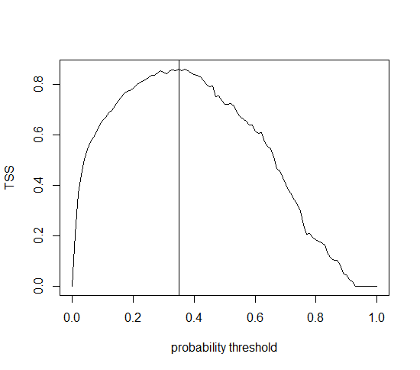

Figure A. Plot of the True Skill Statistic against probability threshold identifying p=0.35 as the probability threshold for a maximum TSS of 0.88.

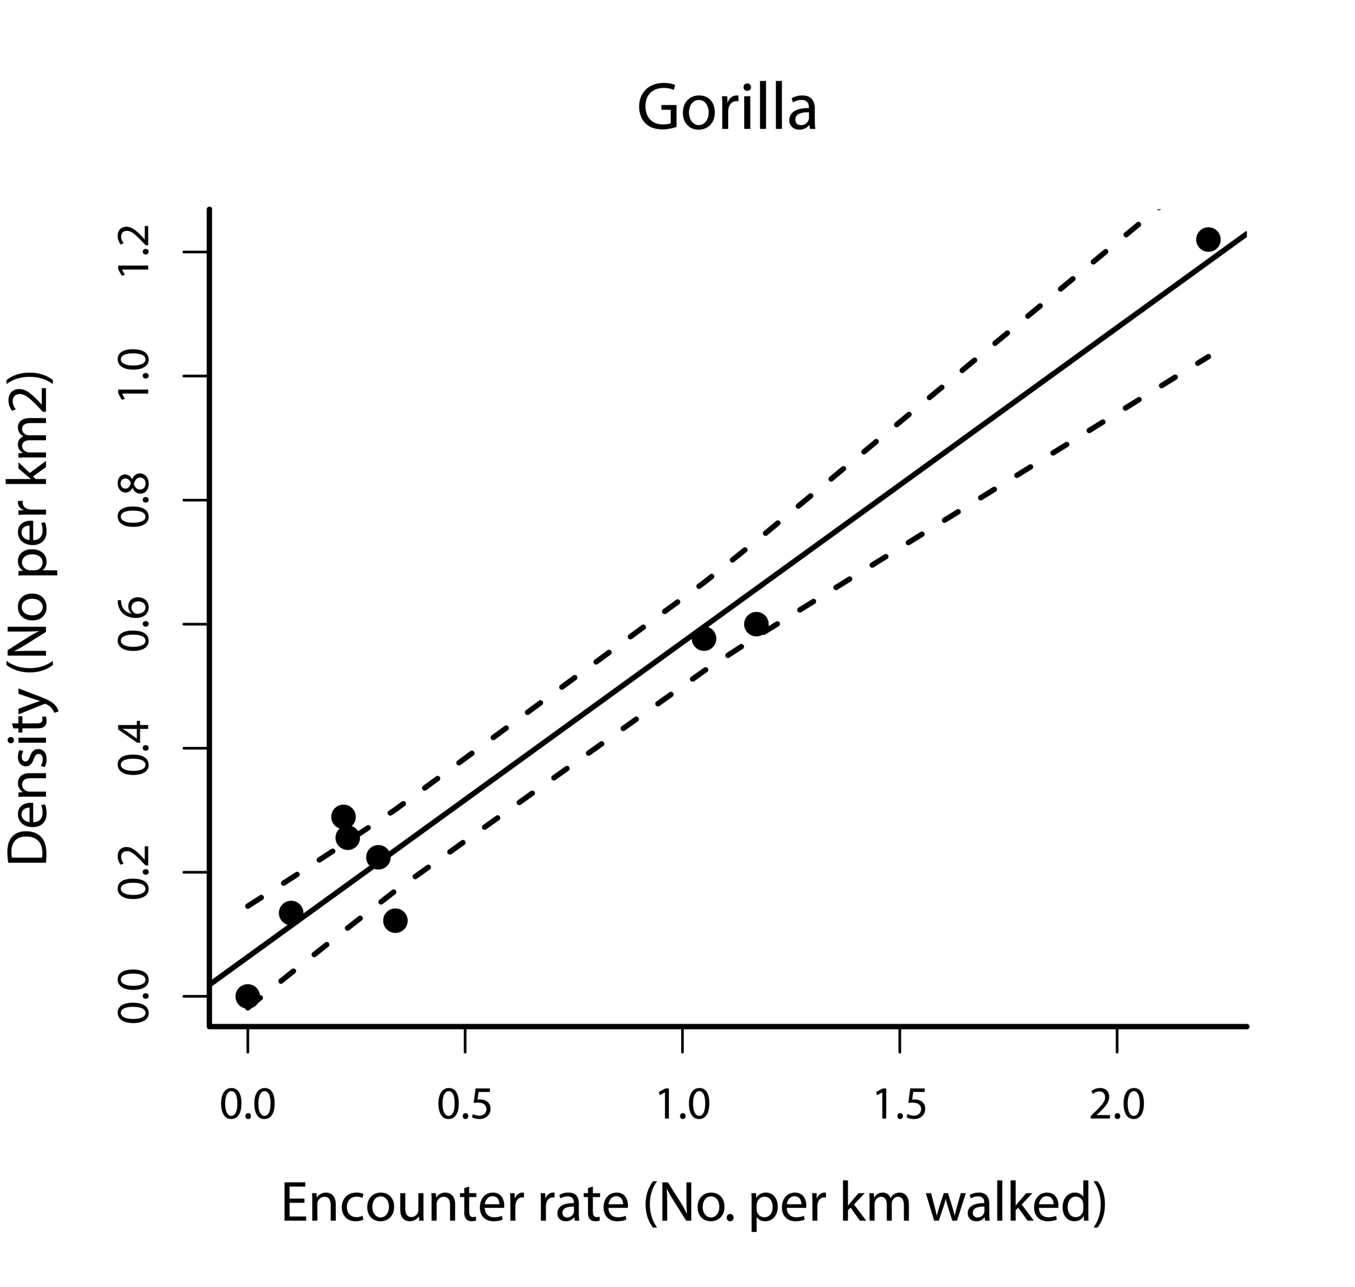

Figure B. Correlation of encounter rate of nests (No. per km walked) and calculated densities (No. per km²) with 95% confidence intervals (dashed lines). Density = 0.507 x e-rate +0.064 (R²_{adj}=0.96). Densities were calculated for nine sites for which transect data were available.

R-Code
A project has been established at GitHub, which is open access: https://github.com/ghislainv/gorillas

