SUPPORTING FIGURE S1 for

A template-free, ultra-adsorbing, high surface area carbonate nanostructure

Johan Forsgren, Sara Frykstrand, Kathryn Grandfield, Albert Mihranyan, and Maria Strømme

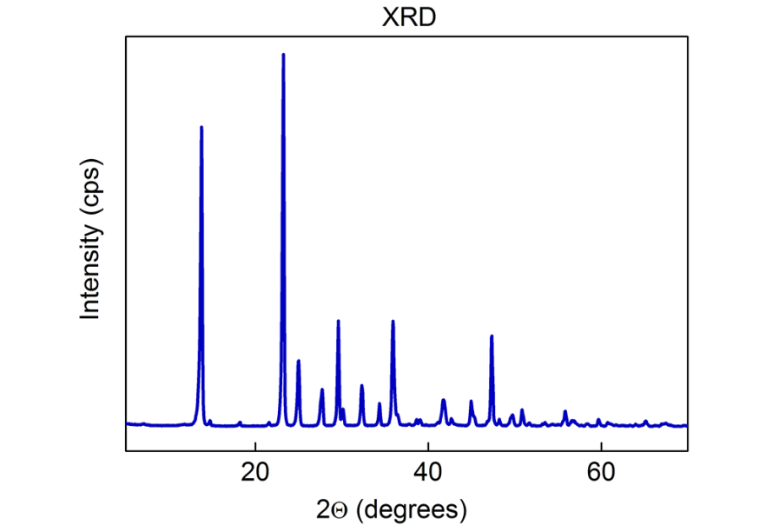
Figure S1. X-ray pattern of the material obtained when water was deliberately added to the synthesis. All peaks in the pattern corresponds to nesquehonite, Mg(HCO₃)(OH)·2H₂O, (PDF# 00-020-0669). No signs of residual MgO can be detected in the pattern.

