Figure S2A. Nanostring log2 gene count distributions of fresh-frozen (FROZ) and FFPE samples before and after quantile normalization.
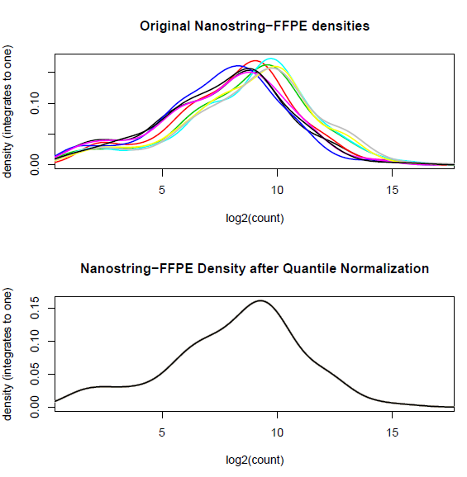
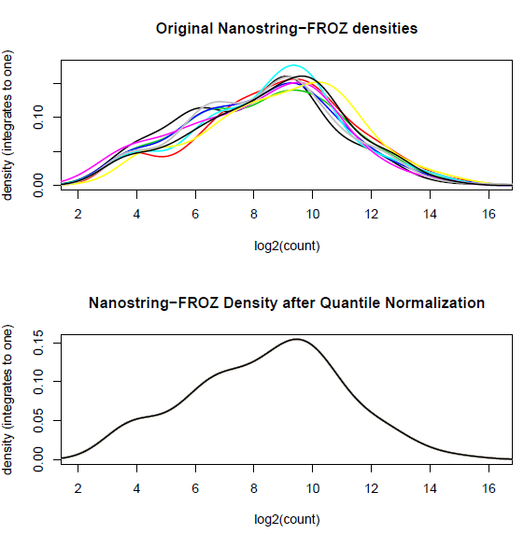

Figure S2B. RiboZeroGold ScriptSeq log2 gene count distributions of fresh-frozen (FROZ) and FFPE samples before and after quantile normalization.
