CYPRUS

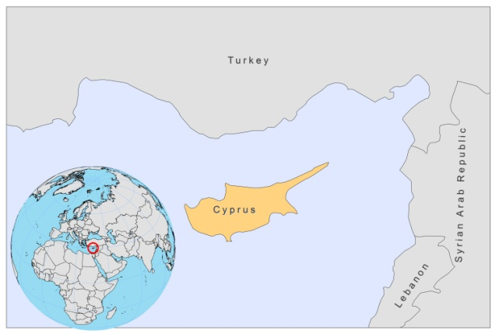
BASIC COUNTRY DATA
Total Population: 1,103,647
Population 0-14 years: 18%
Rural population: 30%
Population living under USD 1.25 a day: no data
Population living under the national poverty line: no data
Income status: High income economy
Ranking: Very high human development (ranking 31)
Per capita total expenditure on health at average exchange rate (US dollar): 1,747
Life expectancy at birth (years): 79
Healthy life expectancy at birth (years): 68

BACKGROUND INFORMATION
Canine VL was highly prevalent in the southern part of Cyprus before 1945, but after extensive insecticide spraying in the 1950s and a reduction of the dog population from 46,000 to 6,000 dogs during the echinococcosis campaign between 1970 and 1975, it was thought to be eradicated. However, the dog population steadily increased again and entomological surveys of 1944 and 1985 showed that the sandfly fauna remained essentially unchanged, despite regular and widespread insecticide use. As a consequence, canine VL reemerged in 1996 [1].

A survey, carried out in 2005-2006, showed a 9-fold increase in dog seroprevalence (from 1.7% to 14.9%) in 10 years [2]. However, paradoxically, only 2 cases of human VL by L.infantum have been reported in the southern part of Cyprus since 1935. As a number of tourists developed VL after visiting the southern part of Cyprus, it is thought that indigenous -the southern part- Cypriots may have a protective mechanism against L.infantum. Controversially, in the northern part of Cyprus, the number of CL cases increased from 2 to 36 between 1985 and 1990 and one case of VL was reported.

CL had not been reported since 1935, but in 2006, 6 cases of leishmaniasis by L.donovani were reported in the southern part of Cyprus, making it the first Mediterranean country where this occurred [3]. It is not known if the strain was imported. As in Sri Lanka, L.donovani caused CL in healthy individuals, but 2 cases of VL occurred in an immunosuppressed and an elderly patient. The spread of L.donovani along the Mediterranean coast is of concern, as this could have a profound effect on the epidemiology of leishmaniasis.
PARASITOLOGICAL INFORMATION

Leishmania species | Clinical form | Vector species | Reservoirs
L infantum | ZVL, CL | P. tobbi | Canis familiaris
L. donovani | VL, CL | Unknown

MAPS AND TRENDS

Cutaneous and visceral leishmaniais
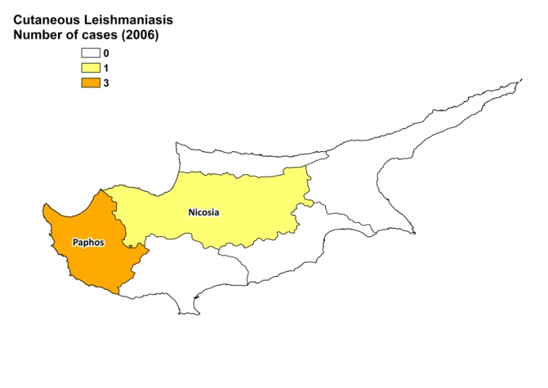
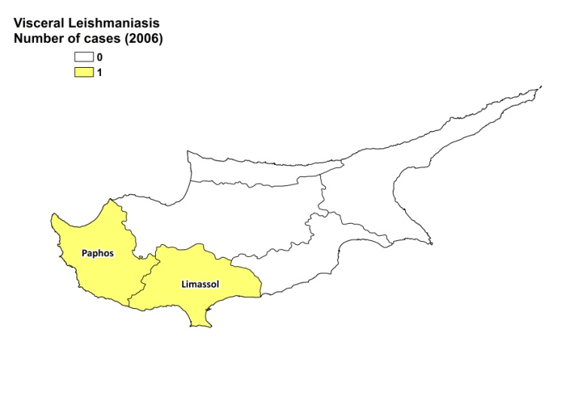

Leishmaniasis trend

 | 2006 | 2007 | 2008
CL cases | 4 | 0 | 0
VL cases | 2 | 0 | 0

CONTROL

The notification of leishmaniasis in humans and dogs is mandatory in the country. There is no national leishmaniasis control program. There is no leishmaniasis vector control program, although regular insecticide spraying is done, and no leishmaniasis reservoir control program.

DIAGNOSIS, TREATMENT
Diagnosis:
CL and VL: microscopy, serological tests and PCR.

Treatment:
VL: amphotericin B lipid complex or liposomal amphotericin B, 3 mg/kg/day, day 1-5 and day 10. Cure rate is >95%.

ACCESS TO CARE
All patients are believed to have access to care.

ACCESS TO DRUGS

Lipid formulations of amphotericin B are registered. No antimonials are registered. Miltefosine is only registered for dogs.

SOURCES OF INFORMATION

1. Deplazes P, Grimm F, Papaprodromou M, Cavaliero T, Gramiccia M et al (1998). Canine leishmaniosis in Cyprus due to Leishmania infantum MON 1. Acta Trop 71(2):169-78.

2. Mazeris A, Soteriadou K, Dedet JP, Haralambous C, Tsatsaris A et al (2010). Leishmaniases and the Cyprus paradox. Am J Trop Med Hyg 82(3):441-8.

3. Antoniou M, Haralambous C, Mazeris A, Pratlong F, Dedet JP et al (2008) Leishmania donovani leishmaniasis in Cyprus. Lancet Infect Dis 8(1):6-7.

