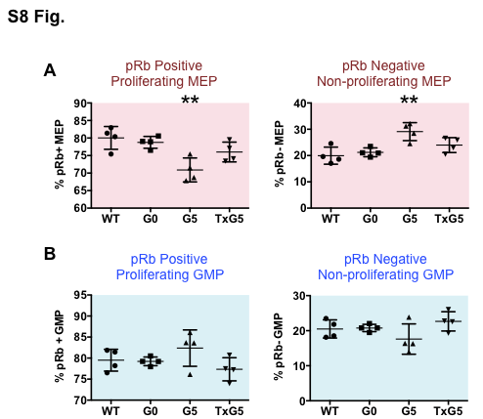

S8 Fig. Cell Cycle Analysis in MEP, GMP and HSC Populations as Determined by Mass Cytometry.
(A-B) Scatter plots showing percentage of proliferating pRb positive cells and non- proliferating pRb negative cells in (A) MEP and (B) GMP populations in WT Tert+/+ (n=4), G0 Tert+/- (n=4), G5 Tert-/- (n=4) and TxG5 Tert-/- (n=4) mice. Bars indicate standard deviation and the p values are based on a 2-tailed t test. Statistically significant differences between WT and G5 Tert-/- mice are indicated by ** (p value < 0.01). There were no significant differences between WT, G0 Tert+/- and TxG5 Tert-/- mice.

