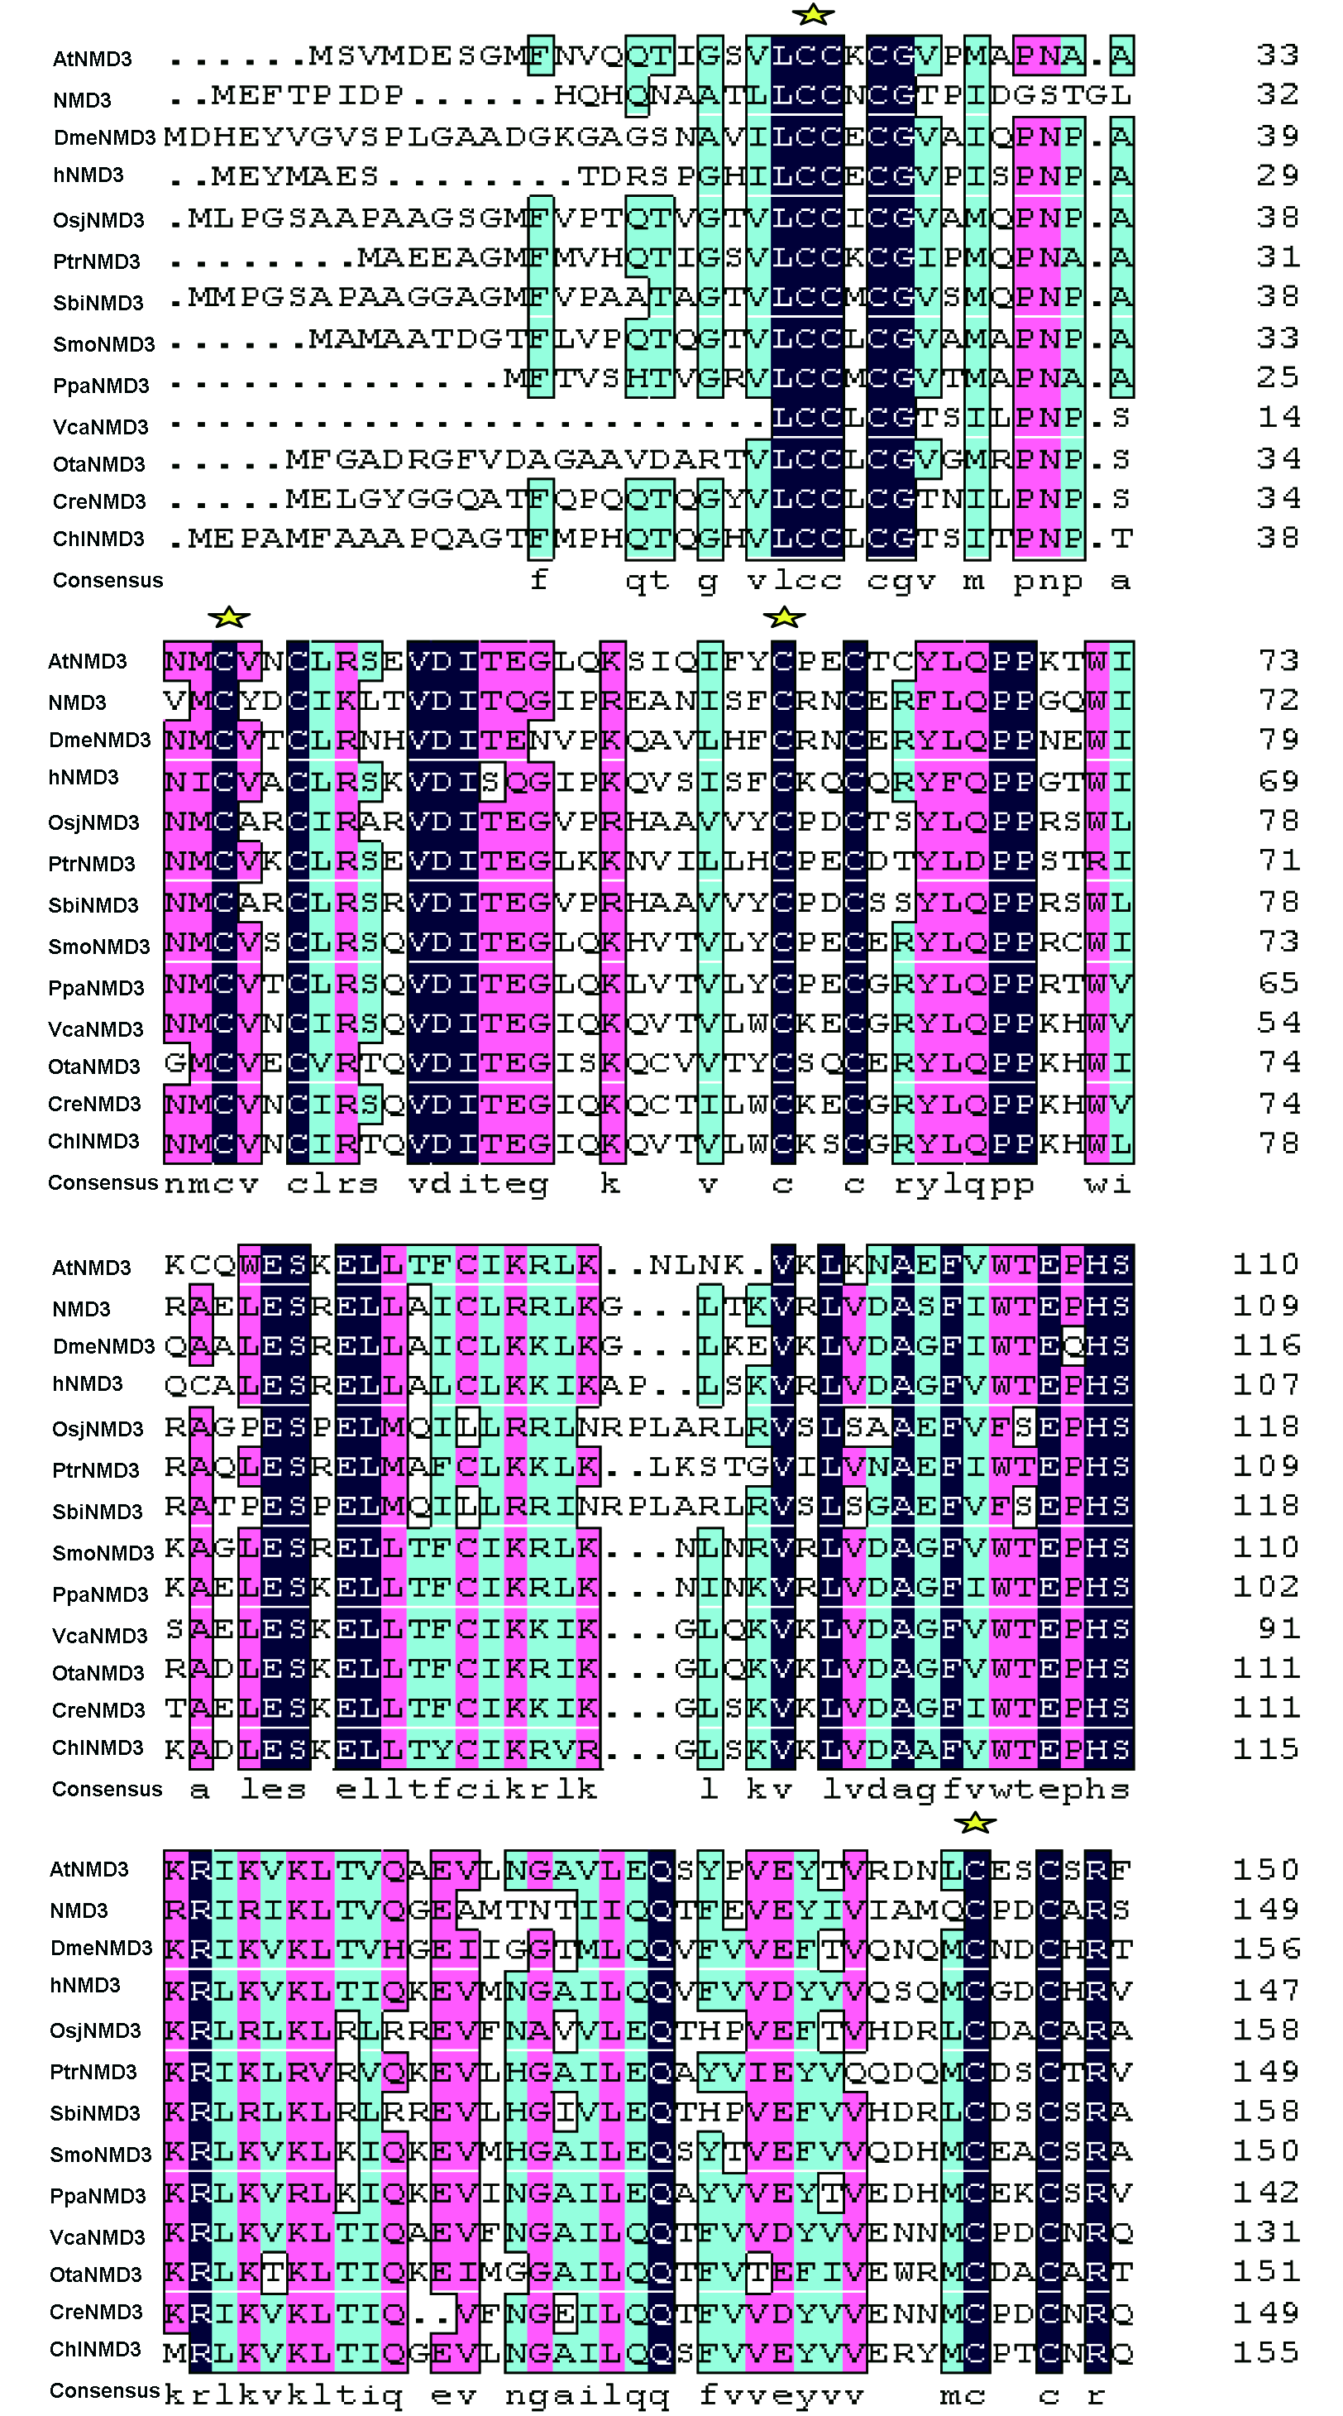

Figure S1 Sequence conservation of AtNMD3 with other NMD3 proteins
NMD3 is conserved in photosynthetic organisms. Sequence alignment of the N-terminal domains of Arabidopsis and other 12 species (refer to Figure 1) NMD3 proteins by ClustalW algorithm (Feng-Doolittle and Thompson, http://www.lynnon.com/pc/alignm.html) for Optimal Alignment and graphical view output by DNAMAN. Conserved (black) and similar amino acid residues (pink: >75%; greenish blue: >50%) were indicated. Yellow stars show the four conserved Cx2C repeats.

