Figure S1. Experimental setup. A. Setup to test the robustness of metaproteomic analysis pipeline, resulting in 15 AMP LC-MS/MS measurements used for analysis. B. Setup to test for individual and temporal differences, resulting in 22 AMP LC-MS/MS measurements.

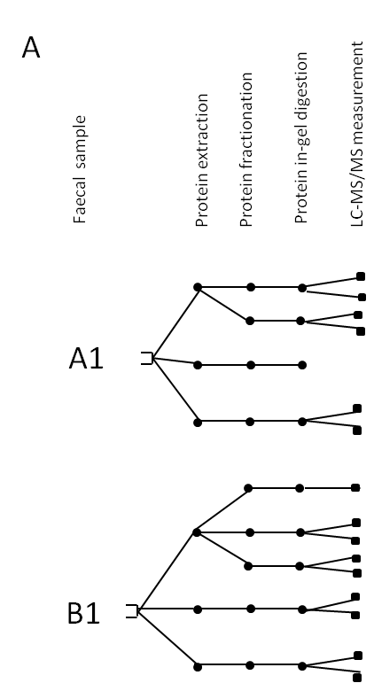

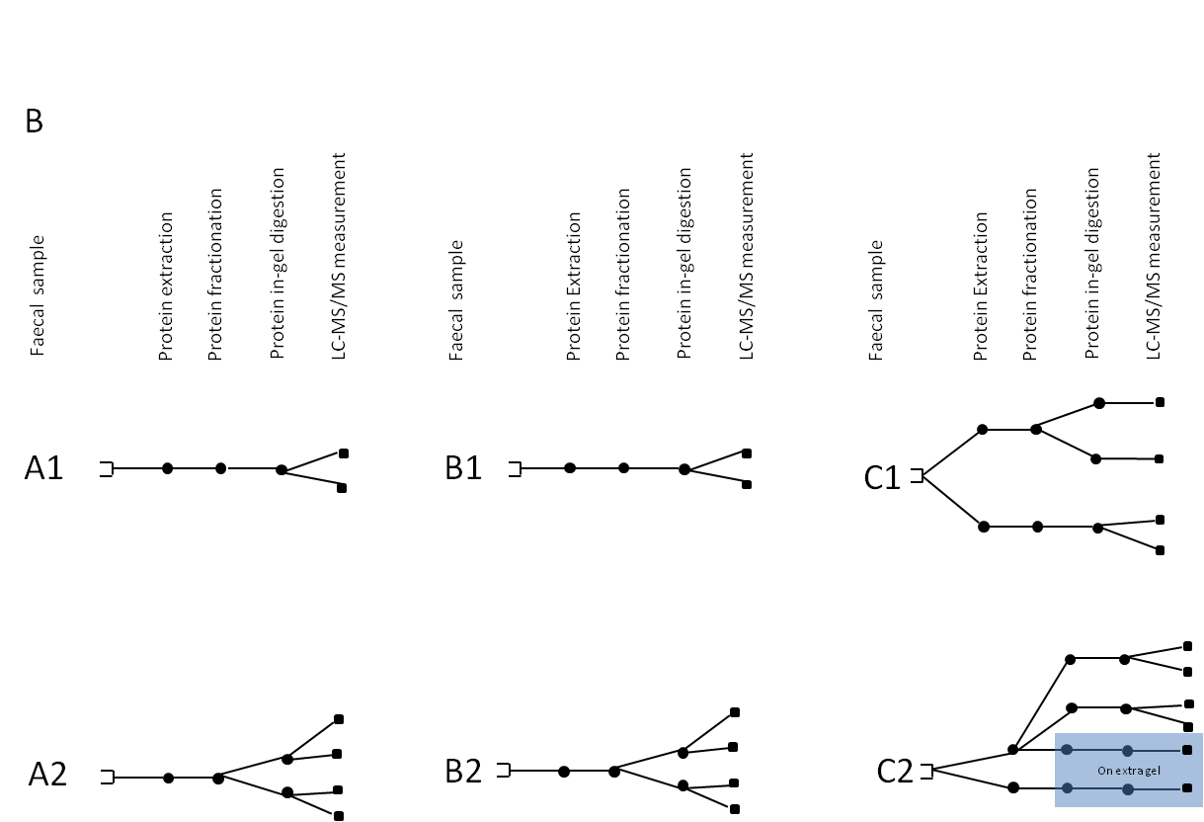

A1, A2, B1, B2, C1, C2: Faecal material from subjects A, B, and C at sampling time point 1 or 2; Open square: starting material; dot represents a procession step (protein extraction, protein fractionation and in-gel digestion); branch indicates splitting of the sample after the respective sample preparation step; filled square represents LC-MS/MS measurements.

