S3 Appendix. Online survey: Results of standardised questionnaires.

Acceptance (TAM)
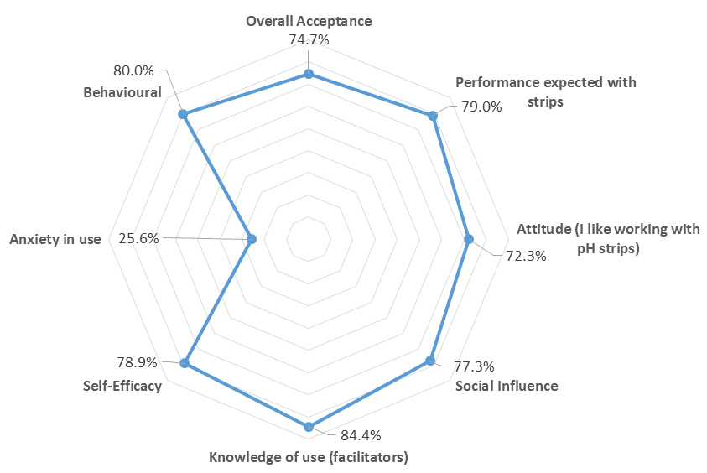

Acceptance Factors  Items from 1 to 13 - Appendix 2B | Score (%) | Standard deviation
Performance expected with strips | 79 | 20.4
Attitude (I like working with pH strips) | 72.3 | 27.3
Social Influence | 77.3 | 23.5
Knowledge of use (facilitators) | 84.4 | 14.1
Self-Efficacy | 78.9 | 17.4
Anxiety in use | 29.7 | 29.9
Behavioural | 80 | 28.5
Overall Acceptance | 74.71 | 14.7
Availability of correct pH strips in the clinical field  Item14 - Appendix 2B | 48.4 | 35

Professional trust (TIU)

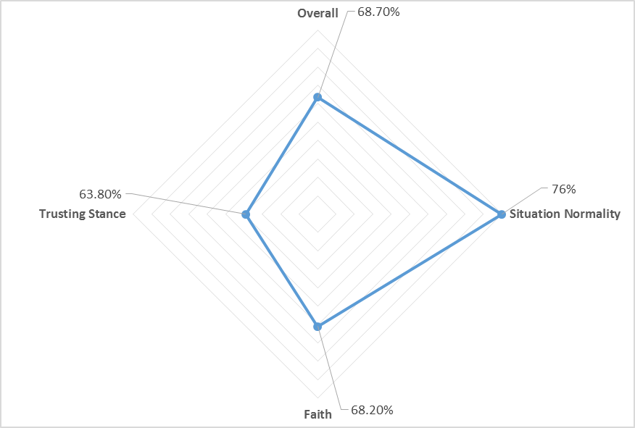
Trust factors  Items from 1 to 9 - Appendix 2B | Score (%) | Standard deviation
Situation Normality | 76 | 16.1
Faith | 68.2 | 18.8
Trusting Stance | 63.8 | 18.1
Overall Trust | 68.7 | 13.9
Use of alternative methods  Item 10 - Appendix 2B | 49.1 | 38

