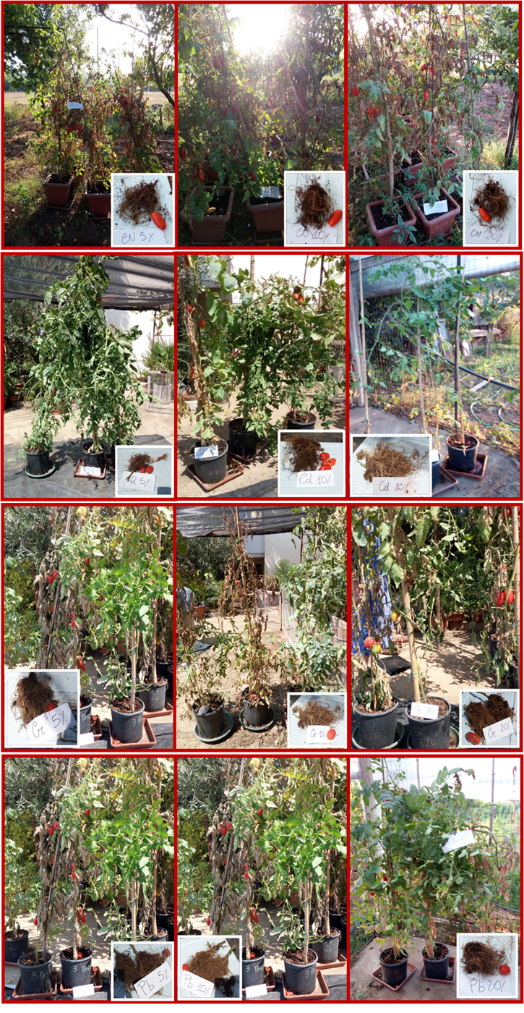
Fig. S2. San Marzano Cirio 3 plants, grown in experimental contaminated soils. San Marzano Cirio 3 plants, grown in experimental soils contaminated with Cd, Cr and Pb at increasing levels (5, 10 and 20%) in relation to soil CEC values. From the top to the bottom, untreated tomato plants (CN = Negative Control) and plants treated with Cd, Cr and Pb.

