Results of secondary probabilistic economic analysis [beneficial effect up to 3-months post-treatment]

Intervention | Mean per person |  |  | NMB (£/ person) | Mean rank | Prob*
 | QALY | Intervention cost (£) | Total cost (£) |  | (at a threshold of £20,000/QALY)
EMDR | 1.80 | 746 | 2,042 | 33,906 | 3.20 | 0.14
Combined somatic/cognitive therapies | 1.78 | 360 | 1,781 | 33,884 | 3.20 | 0.31
SH with support | 1.77 | 265 | 1,799 | 33,614 | 3.51 | 0.27
SH without support | 1.75 | 98 | 1,780 | 33,286 | 4.19 | 0.35
SSRI | 1.75 | 146 | 1,848 | 33,198 | 4.33 | 0.47
Psychoeducation | 1.74 | 108 | 1,904 | 32,979 | 4.91 | 0.60
TF-CBT | 1.74 | 1,061 | 2,890 | 31,932 | 7.39 | 0.32
non-TF-CBT | 1.73 | 709 | 2,673 | 31,863 | 7.47 | 0.51
TF-CBT + SSRI | 1.73 | 1,208 | 3,177 | 31,344 | 8.80 | 0.43
Counselling | 1.70 | 785 | 3,018 | 30,938 | 9.66 | 0.40
No treatment | 1.67 | 0 | 2,494 | 30,917 | 9.35 | 1.00
EMDR: eye movement desensitisation reprocessing; NMB: net monetary benefit; Prob: probability of cost-effectiveness; SSRIs: selective serotonin reuptake inhibitors; TF-CBT: trauma-focused cognitive behavioural therapy
*estimated in a step-wise approach, according to which the most cost-effective intervention is omitted at each step, and the probability of cost-effectiveness of the next most cost-effective intervention amongst the remaining treatment options is re-calculated

Cost-effectiveness plane
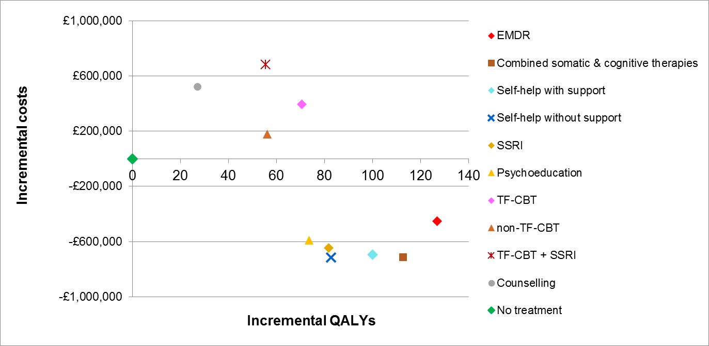

Cost-effectiveness acceptability frontier

