Supplemental Data

Dispensing Processes Impact Apparent Biological Activity as Determined by Computational and Statistical Analyses

Sean Ekins^{*1}, Joe Olechno² and Antony J. Williams³
¹ Collaborations in Chemistry, 5616 Hilltop Needmore Road, Fuquay-Varina, NC 27526, U.S.A.
² Labcyte Inc., 1190 Borregas Avenue, Sunnyvale, CA 94089, U.S.A.
³ Royal Society of Chemistry, 904 Tamaras Circle, Wake Forest, NC 27587, U.S.A.

Supplemental Results

Showing pharmacophore model information for acoustic-based liquid handling with direct dilution and tip-based liquid handling with serial dilution.

Pharmacophore information developed using Accelrys Discovery Studio (v2.5.5. San Diego, CA) for each dataset.

Acoustic-based liquid handling with direct dilution
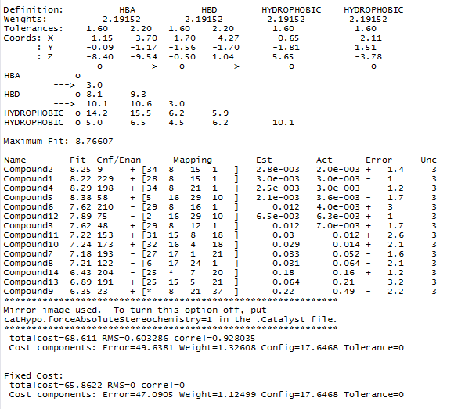
Null cost = 64.7

Tip-based liquid handling with serial dilution
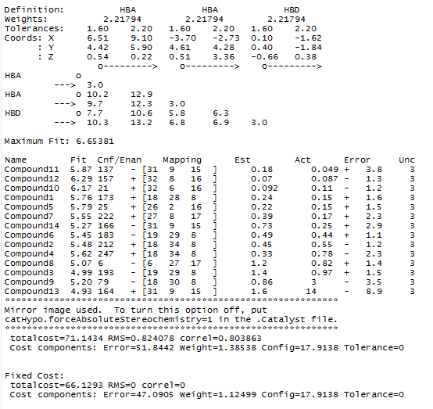
Null cost = 59.54

