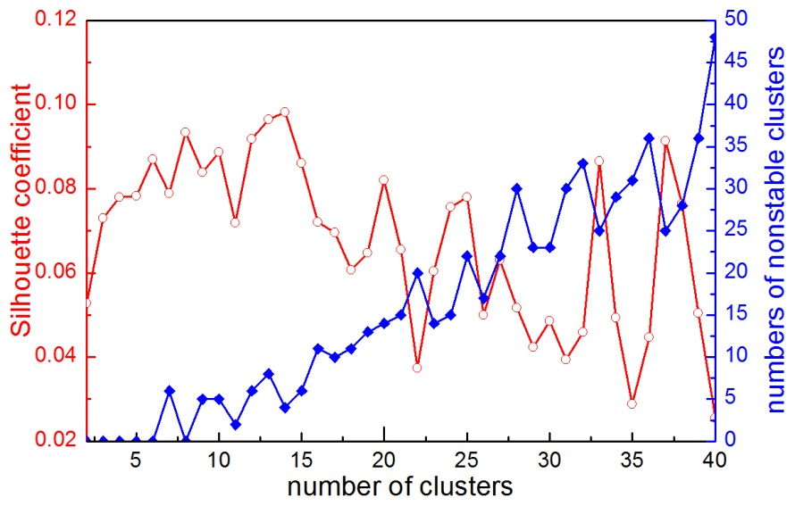
Fig. S4. Silhouette coefficient (red line) and the number of non-reproducible clusters (blue line) of BEN clustering using different pre-specified cluster numbers.

