Animal movement analysis through residence in space and time, Torres et al.
S2 Appendix: Temporal sub-sampling of gray-headed albatross GPS tracks using Residence in Space and Time (RST) method.

Because the GPS loggers did not acquire a fix every 5 min (5.63 ± 0.59 min, n=24), tracks were linearly interpolated between short gaps greater than 8 minutes to aid in temporal subsampling. We chose this option to retain the original GPS data points. Regardless, intervals are not exact but approximate.

Table 1. Sample intervals ± SD and radii ± SD applied in the Residence in Space and Time (RST) method of all albatross tracks using the dynamic scaling approach for subsampled tracks.

Sample Interval (min) | Radius (km)
5.29 ± 0.43 | 2.40 ± 0.36
10.58 ± 0.85 | 4.47 ± 0.72
21.16 ± 1.71 | 8.43 ± 1.70
31.75 ± 2.56 | 13.23 ± 2.79
63.50 ± 5.13 | 23.04 ± 5.33
127.01 ± 10.26 | 41.52 ± 11.43
190.5 ± 15.39 | 60.43 ± 20.28

Figure 1. Comparison between one grey-headed albatross GPS track (Bird 23059) at (A) the 5 min interval resolution (lineally interpolated across short gaps, 4.96 ± 0.48 min) and subsamples (B) 10 min (9.91 ± 0.87 min), (C) 20 min (19.83 ± 1.49 min), (D) 30 min (29.75 ± 2.03), (E) 60 min (59.49 ± 3.49 min), (F) 120 min (118.99 ± 5.45), and (G) 180 min (178.48 ± 6.78).
A) 5 min
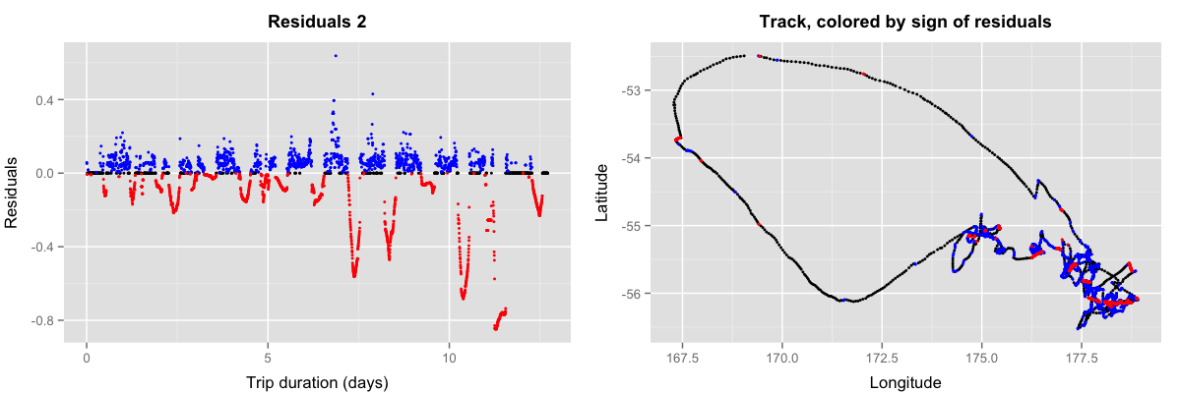
B) 10 min
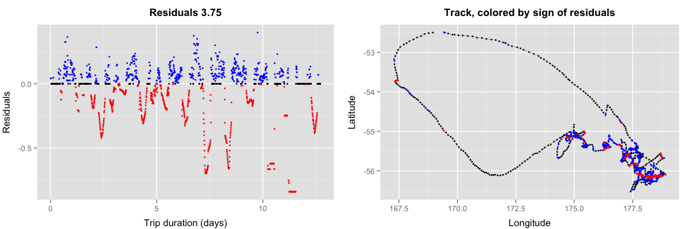
C) 20 min
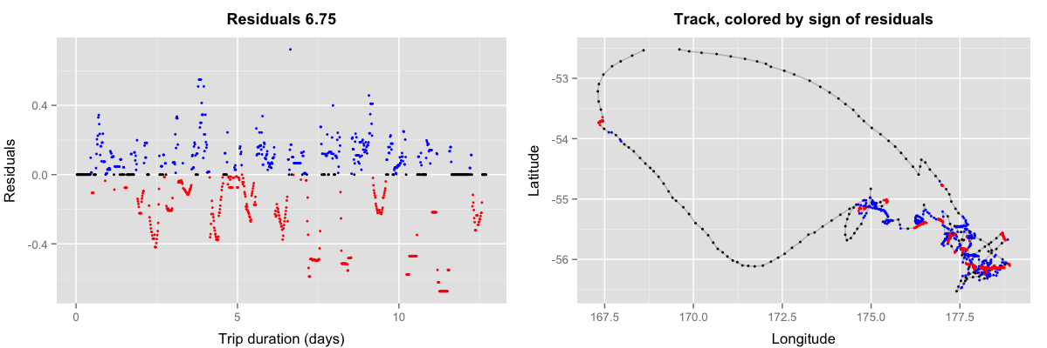

D) 30 min
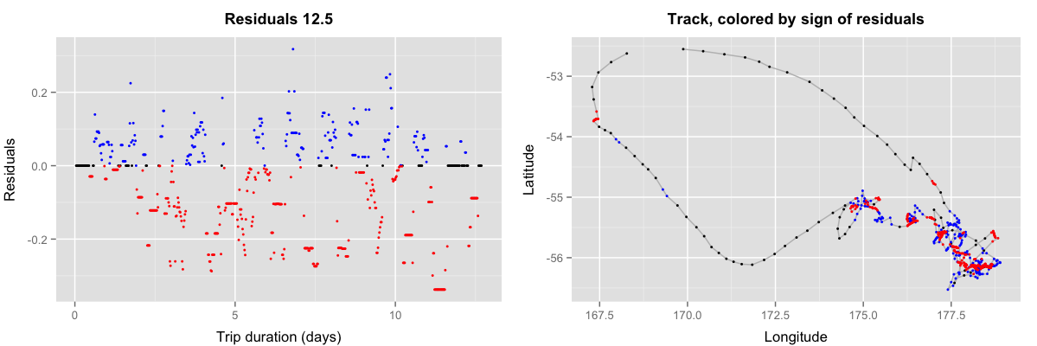
E) 60 min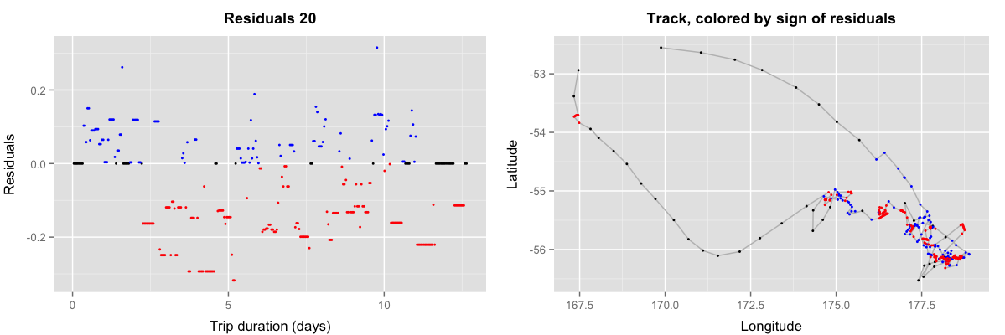
F) 120 min
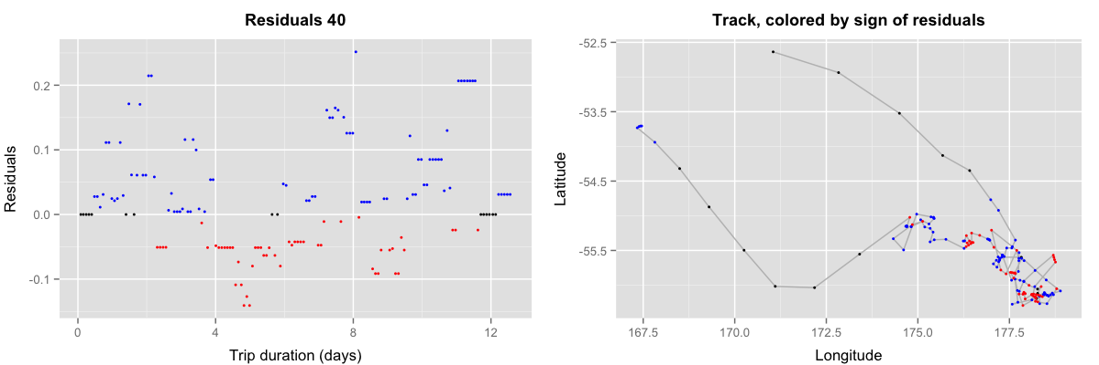
G) 180 min
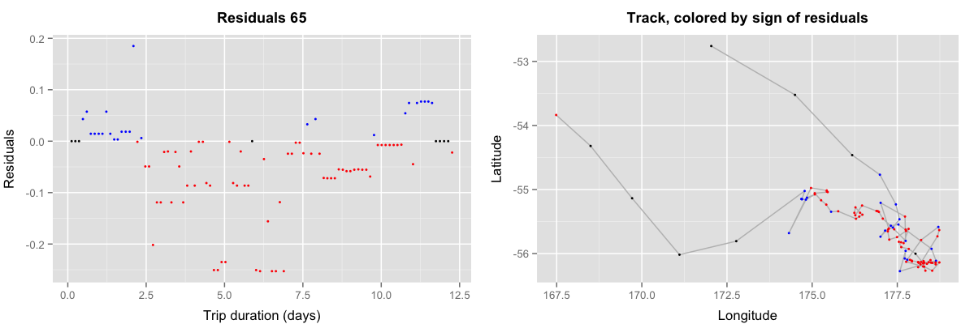
Figure 2. Original 5 min grey-headed albatross track (Bird 23059; lineally interpolated across short gaps) compared to three examples of simulated satellite telemetry data by stochastically sampling 1/3 of locations along the 60 min interval track (see Figure 1E).
