S3 Appendix: Pairwise Diversity Differentiation & Spatial Autocorrelation Results

 | Mornington | Wyndham | Bradshaw | Delamere | Yinberrie Hills
Mornington |  | 0.574 | 0.360 | 0.578 | 0.036
Wyndham | 0.53 |  | 0.680 | 0.583 | 0.345
Bradshaw | 0.63 | 1 |  | 0.765 | 0.502
Delamere | 0.71 | 0.82 | 0.86 |  | 0.579
Yinberrie Hills | 0.32 | 0.63 | 0.82 | 0.82
Chidna | 0.32 | 0.53 | 0.53 | 0.40 | 0.40
Table A: P-values for pairwise Wilcox sign-rank tests on microsatellite allelic richness between each of the sampling localities. Below the diagonal reflects the difference in richness on the data rarefied to match the sample size of Chidna. Above the diagonal, is the pairwise p-values between the five major sampling localities of the same sample size. Bolded P-values are significant before Bonferroni correction, but none were significant after Bonferroni correction.

Table B: P-values for pairwise Wilcox sign-rank tests on microsatellite heterozygosities between each of the sampling localities. Below the diagonal is the difference in observed heterozygosity. Above the diagonal is for expected heterozygosity. All P-values presented are the raw (not Bonferroni corrected) values, but none were significant before or after correction.
 | Mornington | Wyndham | Bradshaw | Delamere | Yinberrie Hills | Chidna
Mornington |  | 0.90 | 1.00 | 0.94 | 0.94 | 0.46
Wyndham | 0.83 |  | 0.78 | 0.86 | 0.80 | 0.78
Bradshaw | 0.74 | 0.84 |  | 0.63 | 0.94 | 0.82
Delamere | 0.59 | 0.53 | 0.38 |  | 0.98 | 0.60
Yinberrie Hills | 0.86 | 0.93 | 0.75 | 0.31 |  | 0.94
Chidna | 0.59 | 0.78 | 0.60 | 0.86 | 0.52

 | Mornington | Wyndham | Bradshaw | Delamere | Yinberrie Hills | Chidna
Mornington |  | 0.0078 | 0.0286 | 0.0158 | 0.0215 | 0.0268
Wyndham | 0.0006 |  | 0.0198 | 0.0112 | 0.0097 | 0.0392
Bradshaw | 0.0042 | 0.0018 |  | 0.0287 | 0.0000 | 0.0000
Delamere | 0.0020 | 0.0012 | 0.0029 |  | 0.0003 | 0.0000
Yinberrie Hills | 0.0024 | 0.0003 | 0.0000 | 0.0000 |  | 0.0247
Chidna | 0.0139 | 0.0116 | 0.0040 | 0.0009 | 0.0074
Table C: Estimates of differentiation (F_{ST} and Jost’s D) from sixteen microsatellite markers from the six sampling localities. Below the diagonal is pairwise F_{ST}, where p-values are bolded at p<0.05, but no comparison was significant after Bonferroni correction (p<0.0051). Above the diagonal are Jost’s D, emboldened are p-values calculated by 1000 bootstrap resamples in DEMEtics, but none were significant after Bonferroni correction. Negative F_{ST} and D estimates are corrected to zero.

Table D: Pairwise F-ST based on mitochondrial control region haplotype frequencies (below diagonal); Pairwise Φst based on nucleotide diversity in each population using the Kimura 2 Parameter model above the diagonal. Values in bold are significant at p=0.05, but no comparison was significant after Bonferroni correction (p<0.0033). All negative F_{ST} results were corrected zero.

 | Mornington | Wyndham | Bradshaw | Delamere | Yinberrie Hills | Chidna
Mornington |  | 0.00000 | 0.00000 | 0.00000 | 0.00924 | 0.19371
Wyndham | 0.01233 |  | 0.00000 | 0.00000 | 0.02324 | 0.33265
Bradshaw | 0.00570 | 0.0000 |  | 0.00000 | 0.00000 | 0.15414
Delamere | 0.00127 | 0.0000 | 0.00000 |  | 0.01939 | 0.30028
Yinberrie Hills | 0.03224 | 0.0000 | 0.00000 | 0.00000 |  | 0.09665
Chidna | 0.15141 | 0.26941 | 0.16275 | 0.20683 | 0.19471

Table E: Below diagonal: Pairwise F_{ST} from Arlequin resulting from 3839 SNP dataset, negative values are corrected to zero. Significant differences (p<0.05) are emboldened, but after Bonferonni correction (p<0.0033), no result was statistically significant against 10100 permutations.

 | Mornington | Wyndham | Bradshaw | Delamere | Yinberrie Hills
Mornington
Wyndham | 0.000
Bradshaw | 0.000 | 0.000
Delamere | 0.000 | 0.000 | 0.000
Yinberrie Hills | 0.000 | 0.000 | 0.000 | 0.000
Chidna | 0.007 | 0.011 | 0.005 | 0.009 | 0.005

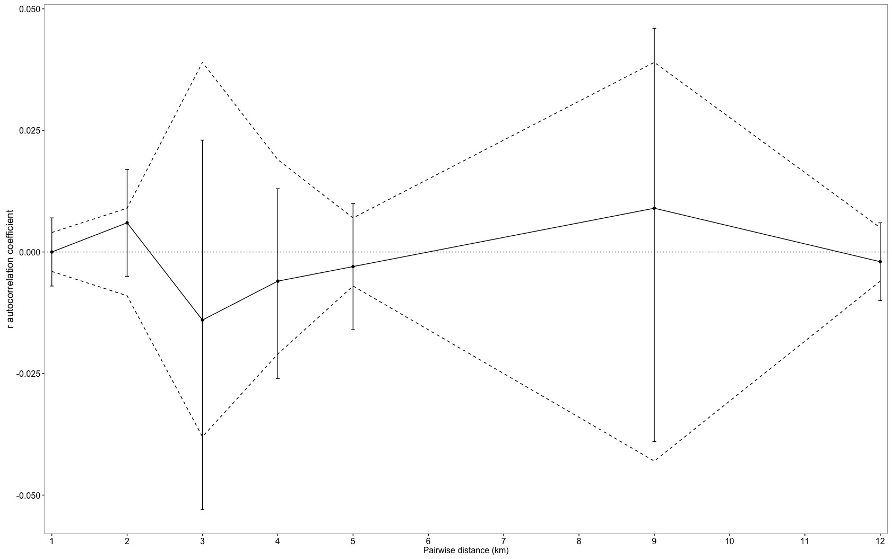

Figure A: Correlogram from spatial autocorrelation analysis, showing no spatial structure at the local scale within the Wyndham population. As there were no sex differences only the pooled results are presented. The unbroken line (r) represents the autocorrelation coefficient from the comparison between genetic and geographic distance matrices, and error bars are the bootstrap 95% confidence intervals about the r estimate for that distance class. The dashed lines represent the upper and lower 95% confidence intervals for the null hypothesis of no spatial structure (around r=0, dotted line) generated by permutation of samples across the distance classes

