UKRAINE

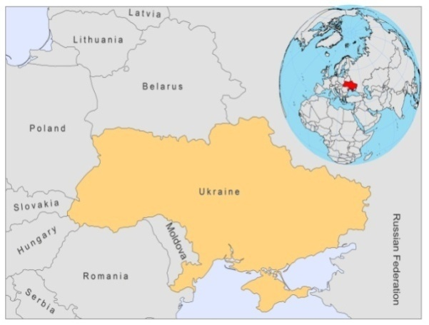
BASIC COUNTRY DATA
Total Population: 45,870,700
Population 0-14 years: 14%
Rural population: 32%
Population living under USD 1.25 a day: 0.1%
Population living under the national poverty line: no data
Income status: Lower middle income economy
Ranking: High human development (ranking 76)
Per capita total expenditure on health at average exchange rate (US dollar): 180
Life expectancy at birth (years): 69
Healthy life expectancy at birth (years): 59

BACKGROUND INFORMATION
From 1990 to 2007, 24 CL and 7 VL cases were reported in Ukraine. All cases were imported, mainly from Tajikistan and Armenia. 3 CL and 3 VL cases were diagnosed in 2008-2009 and 2 of the VL cases were fatal in 2008.

CL and VL are likely to be largely underreported as there is no awareness among doctors, and no provisions for diagnosis and treatment.

One case of HIV/Leishmania co-infection was diagnosed in 2009.

PARASITOLOGICAL INFORMATION

Leishmania species | Clinical form | Vector species | Reservoirs
L. infantum | ZVL | P. neglectus,  P. longiductus, | Canis familiaris
L. donovani | VL | unknown

MAPS AND TRENDS

Visceral leishmaniasis
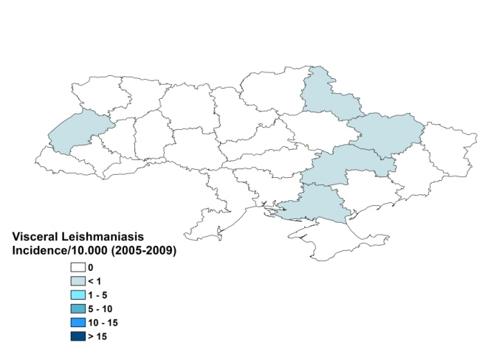
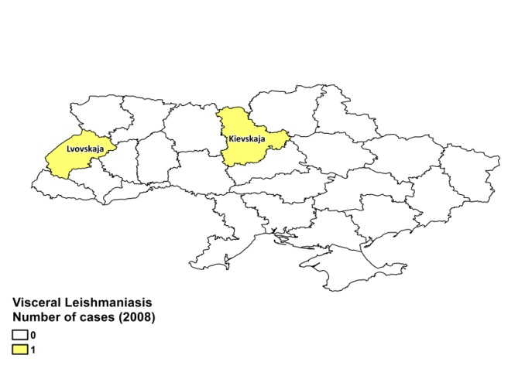

Cutaneous leishmaniasis
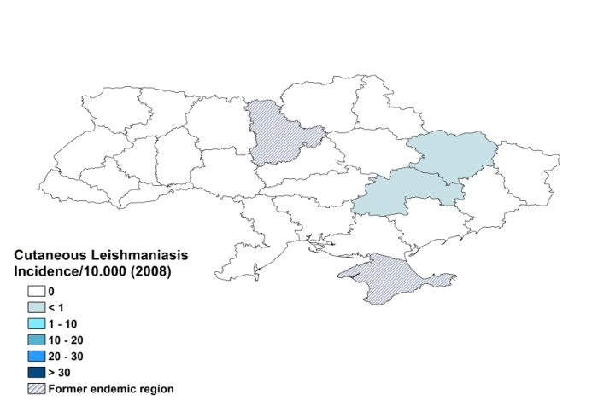
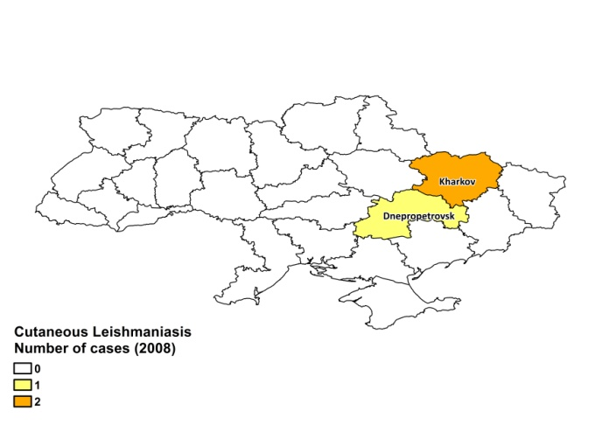

Cases of visceral leishmaniasis

2005 | 2006 | 2007 | 2008
1 | 3 | 3 | 2

Cutaneous leishmaniasis trend

CONTROL

The notification of leishmaniasis is mandatory in the country. There is no national leishmaniasis control program, no leishmaniasis vector control program and no bednet distribution program. Insecticide spraying is not done. There is no leishmaniasis reservoir control program.

DIAGNOSIS, TREATMENT

There are no protocols for diagnosis and treatment of leishmaniasis in Ukraine. Antimonials are used if available.

ACCESS TO CARE

Care for leishmaniasis is not provided for free in Ukraine. There is very problematic access to treatment. Drugs can only be obtained by hospitals and with great difficulties. In 2008, 2 cases of VL were fatal due to a lack of specific drugs. Diagnosis, if at all, is mostly very late, due to a lack of awareness of the disease among doctors and patients.

ACCESS TO DRUGS

There are no drugs registered for leishmaniasis and they are not available in the country. No drugs for leishmaniasis are included in the National Essential Drug List. Meglumine antimoniate (Glucantime, Sanofi) can sometimes be obtained, with difficulty, through private import.

SOURCES OF INFORMATION
- Dr Tamara Pavlikovska, Central Sanitary and Epidemiological Station of the Ministry of Health, Kiev. Leishmaniasis in the European Region, a WHO consultative intercountry meeting, Istanbul, Turkey, 17–19 November 2009.

