S1 Fig: Insulin secretion in subjects with NEUROD1 mutation.

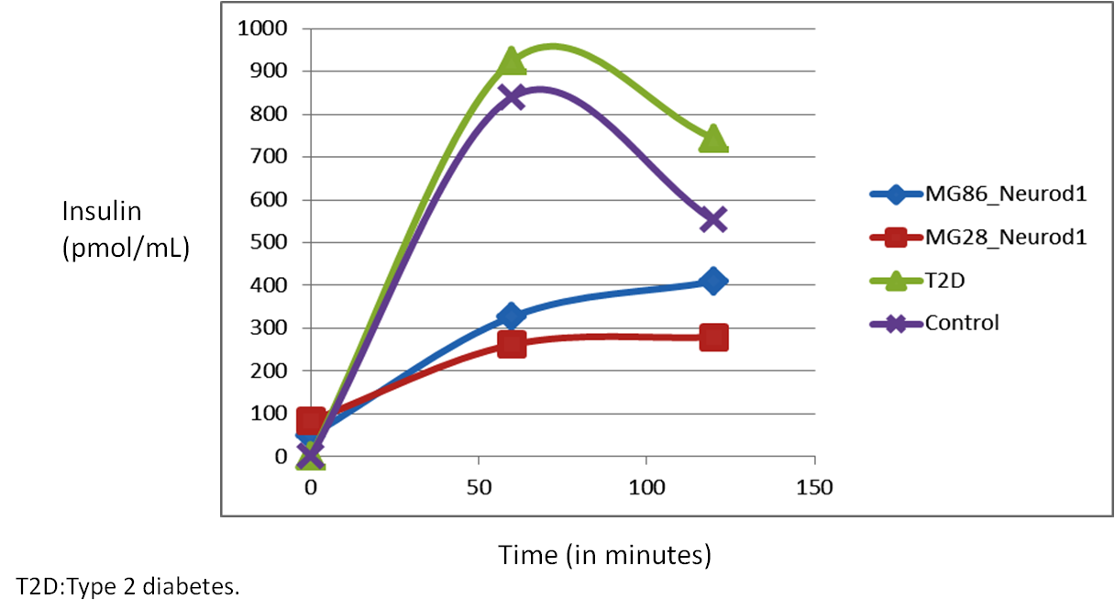
On OGTT, subjects MG28 and MG86 showed a significant reduction in insulin release at 60 and 120 min when compared with controls and Type 2 diabetes (T2D) subjects.

Supplementary figure 2: Suggested algorithm to screen for mutations in
MODY genes in pregnant women with diabetes
