S3 Fig. Predictive interval plots
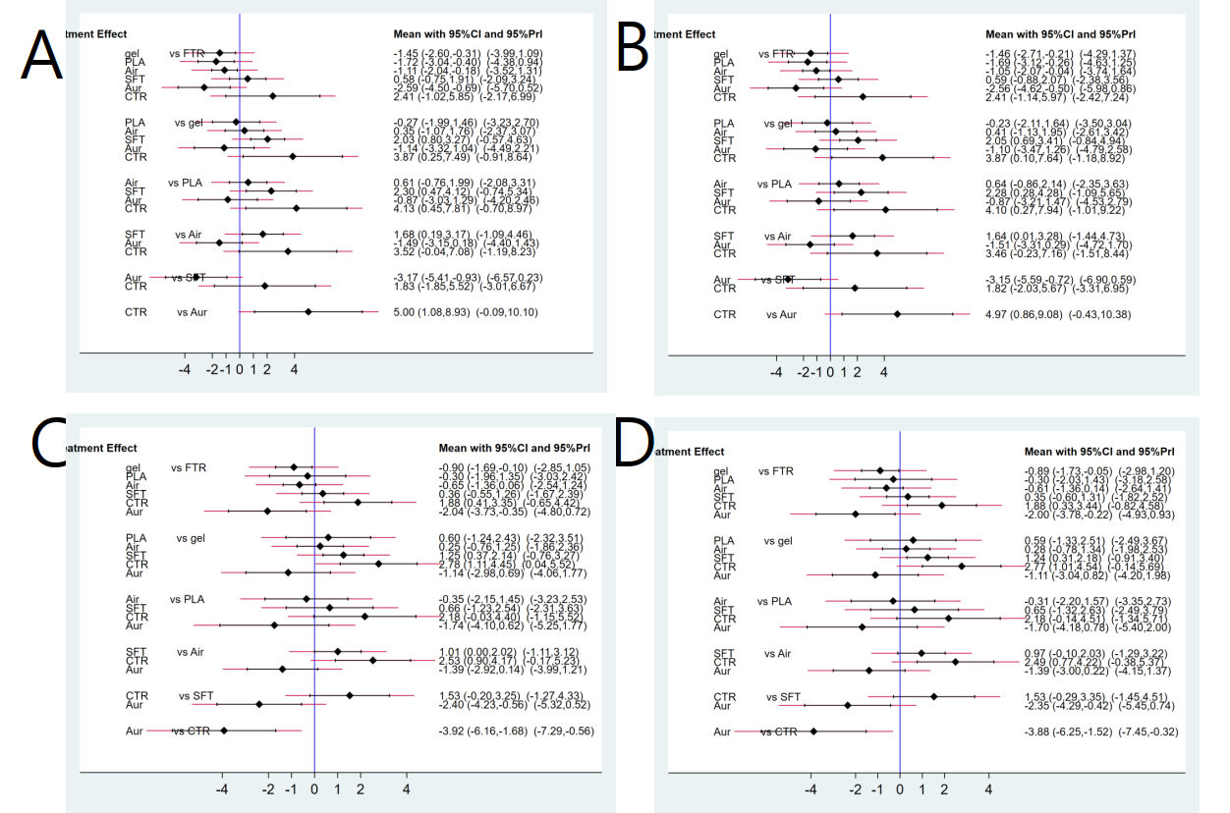
S3 Fig. The confidence intervals and predictive intervals of log estimates of the success rate of unassisted intubation. Black corresponds to 95% confidence interval and red corresponds to 95% predictive interval. A. Overall success rate of unassisted intubation by ITT; B. Overall success rate of unassisted intubation by PP; C. Success rate of first attempt by ITT; D. Success rate of first attempt by PP. ITT, intention to treat; PP, per protocol

