Table S1. Table shows performance (composite scores based on z-scores) on cognitive domains of modified Harmonization protocol after controlling for age, education, BMI and duration of diabetes using ANCOVA.
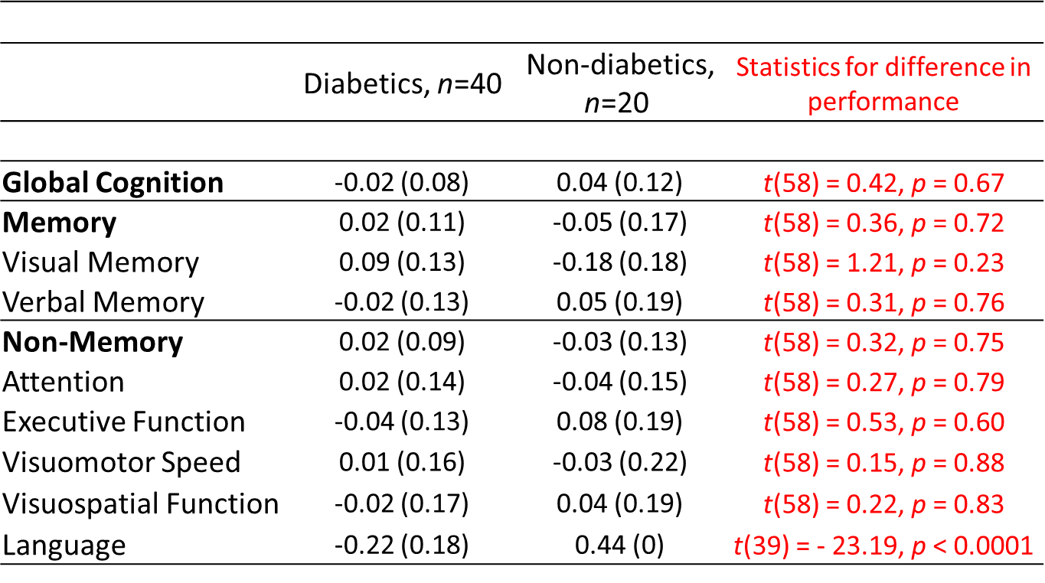

Note: Standard error in parentheses.

