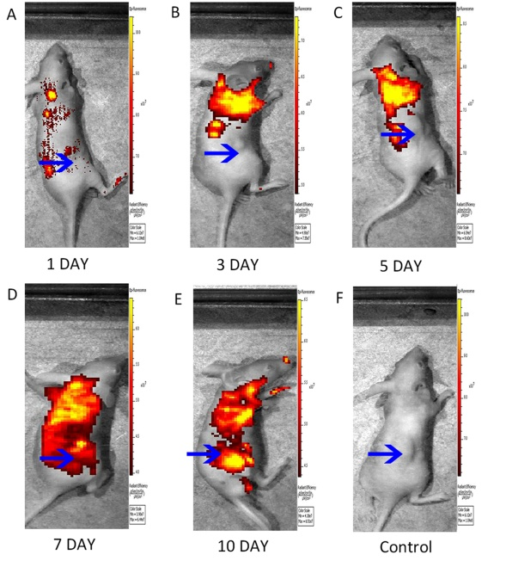
S1 Fig. Macroscopic fluorescence imaging of mice injected with EGFP-MSCs. (A-E) The movement of strong fluorescent signals was observed in subcutaneous xenograft models at 1, 3, 5, 7, and 10 days after intravenous injection of EGFP-MSCs (5×10⁶ cells in suspension in 100 ml of PBS，n=3). The blue arrows show the tumor locations. (F) No significant fluorescence signals were observed around tumor sites in the mice injected with MSCs (n=3) as the control group.

