Figure S1
(A)
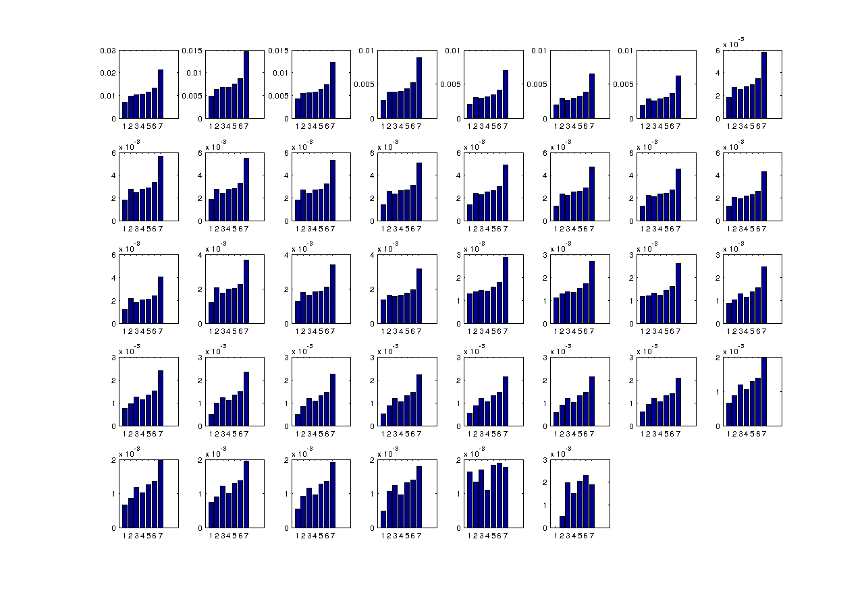
Fraction of non-synonymous mutations

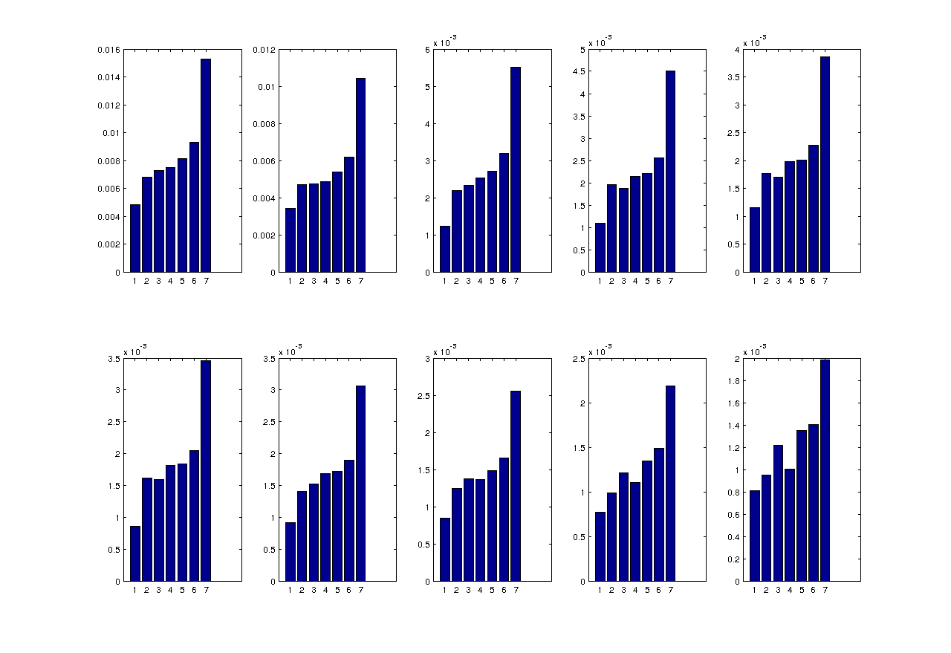(B)
Fraction of non-synonymous mutations

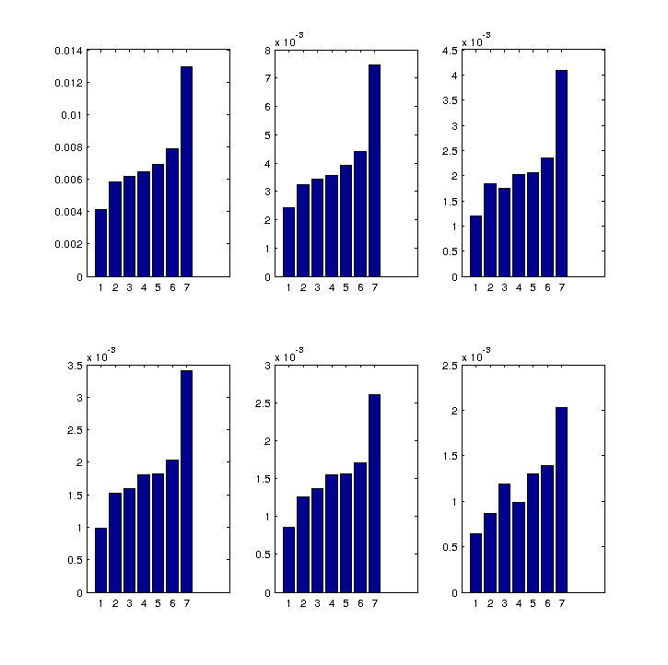(C)
Fraction of non-synonymous mutations

Fraction of non-synonymous mutations in each resolution level, using thresholds for SNP determination (i.e. a position is determined as having a SNP if a mutation occurs in a number of strains that exceeds the threshold). Only proteins with at least one position that is determined as having a SNP according to the relevant threshold were taken into consideration.
Resolution levels are as in the main text: (1) Residues/codons involved in the protein interactions. (2) All residues/codons in yeast domains that are involved in the protein interactions. (3) Residues/codons in domain-pairs inferred from other solved structures. (4) Residues/codons in domains documented in yeast as interacting. (5) Residues/codons in domains that were documented in yeast and other organisms as interacting domains (6) Residues/codons in domains, and (7) Residues/codons in whole proteins.

(A) Using all 39 strains. (B) Using as representatives the ten most distant strains. (C) Using as representatives the six most distant strains.

Axes: X-axis – the seven resolution levels. Y-axis – fraction of non-synonymous mutations in the residues defined by the resolution level (not uniformly scaled).

Each panel from left to right represents an increasing threshold. i.e: the upper left panel represents the results using the threshold of 1; the second panel represents the results using the threshold of 2, etc.

