S2 Appendix
Environmental DNA sampling reveals high occupancy rates of invasive Burmese pythons at wading bird breeding aggregations in the central Everglades

Contents
Table A. Model Comparison Results 2
Table B. Parameter estimates of model (1) 2
Table C. Monte Carlo standard errors of model (1) 2
Table D. Occupancy and detection estimates of model (1) 2
Fig A. Convergence assessment of model (1) 4
Table E. Parameter estimates of model (2) 5
Table F. Monte Carlo standard errors of model (2) 6
Table G. Occupancy and detection estimates of model (2) 6
Fig B. Convergence assessment of model (2) 7
Table H. Parameter estimates of model (3) 8
Table I. Monte Carlo standard errors of model (3) 8
Table J. Occupancy and detection estimates of model (3) 8
Fig C. Convergence assessment of model (3) 9
Table K. Parameter estimates of model (4) 10
Table L. Monte Carlo standard errors of model (4) 10
Table M. Occupancy and detection estimates of model (4) 10
Fig D. Convergence assessment of model (4) 11
Table N. Parameter estimates of model (5) 13
Table O. Monte Carlo standard errors of model (5) 13
Table P. Occupancy and detection estimates of model (5) 13
Fig E. Convergence assessment of model (5) 14
Table Q. Parameter estimates of model (6) 15
Table R. Monte Carlo standard errors of model (6) 16
Table S. Occupancy and detection estimates of model (6) 16
Fig F. Convergence assessment of model (6) 17
Table T. Parameter estimates of model (7) 18
Table U. Monte Carlo standard errors of model (7) 19
Table V. Occupancy and detection estimates of model (7) 19
Fig G. Convergence assessment of model (7) 20

Table A. Model Comparison Results
model |  |  | WAIC | pv_WAIC | lof_WAIC | PPLC | pv_PPLC | lof_PPLC
(1) | psi(type )theta(.)p(time) | fit5 | 0.1579424 | 0.0262778 | 0.1316646 | 56.42474 | 32.60200 | 23.82273
(2) | psi(type )theta(.)p(.) | fit1 | 0.1590091 | 0.0226442 | 0.1363649 | 60.29959 | 31.72063 | 28.57896
(3) | psi(.)theta(.)p(.) | fit0 | 0.1591138 | 0.0227473 | 0.1363665 | 60.29477 | 31.68553 | 28.60923
(4) | psi(type )theta(date)p(.) | fit2 | 0.1593524 | 0.0229701 | 0.1363823 | 60.39224 | 31.74374 | 28.64850
(5) | psi(type )theta(date)p(time) | fit6 | 0.1598945 | 0.0276861 | 0.1322084 | 56.95733 | 33.04711 | 23.91021
(6) | psi(type )theta(.)p(time + depth) | fit7 | 0.1611367 | 0.0303499 | 0.1307868 | 56.20681 | 33.70191 | 22.50490
(7) | psi(type )theta(.)p(depth) | fit4 | 0.1620399 | 0.0280571 | 0.1339828 | 59.26194 | 32.92642 | 26.33551

Table B. Parameter estimates of model (1)
 | Mean | 50% | 2.5% | 97.5%
beta.typeColony | 1.2332830 | 1.1768750 | 0.2173247 | 2.5894240
beta.typeControl | -0.1662295 | -0.1919745 | -0.9965819 | 0.8456073
alpha..Intercept. | -1.0905391 | -1.0900530 | -1.3549260 | -0.8270371
delta..Intercept. | 0.2968854 | 0.2973767 | 0.0569795 | 0.5373420
delta.Time | -0.3359791 | -0.3343232 | -0.6423076 | -0.0353745

Table C. Monte Carlo standard errors of model (1)
 | Mean | 50% | 2.5% | 97.5%
beta.typeColony | 0.0097273 | 0.0065954 | 0.0049570 | 0.0713249
beta.typeControl | 0.0049777 | 0.0050683 | 0.0064133 | 0.0198486
alpha..Intercept. | 0.0008435 | 0.0009628 | 0.0014076 | 0.0013911
delta..Intercept. | 0.0004364 | 0.0005491 | 0.0010730 | 0.0011532
delta.Time | 0.0006226 | 0.0007711 | 0.0015739 | 0.0012765

Table D. Occupancy and detection estimates of model (1)
 | ψ | ψ 95% CI | θ̅ | θ̅ 95% CI | p̅ | p̅ 95% CI
B1 | 0.88 | (0.59-1) | 0.14 | (0.09-0.2) | 0.69 | (0.58-0.78)
C1 | 0.42 | (0.16-0.8) | 0.14 | (0.09-0.2) | 0.46 | (0.29-0.63)
B2 | 0.88 | (0.59-1) | 0.14 | (0.09-0.2) | 0.76 | (0.61-0.88)
C2 | 0.42 | (0.16-0.8) | 0.14 | (0.09-0.2) | 0.44 | (0.26-0.62)
B3 | 0.88 | (0.59-1) | 0.14 | (0.09-0.2) | 0.73 | (0.6-0.84)
C3 | 0.42 | (0.16-0.8) | 0.14 | (0.09-0.2) | 0.49 | (0.33-0.64)
B4 | 0.88 | (0.59-1) | 0.14 | (0.09-0.2) | 0.75 | (0.61-0.87)
C4 | 0.42 | (0.16-0.8) | 0.14 | (0.09-0.2) | 0.69 | (0.58-0.79)
B5 | 0.88 | (0.59-1) | 0.14 | (0.09-0.2) | 0.41 | (0.21-0.62)
C5 | 0.42 | (0.16-0.8) | 0.14 | (0.09-0.2) | 0.68 | (0.58-0.78)
B6 | 0.88 | (0.59-1) | 0.14 | (0.09-0.2) | 0.67 | (0.57-0.76)
C6 | 0.42 | (0.16-0.8) | 0.14 | (0.09-0.2) | 0.65 | (0.55-0.74)
B7 | 0.88 | (0.59-1) | 0.14 | (0.09-0.2) | 0.64 | (0.55-0.73)
C7 | 0.42 | (0.16-0.8) | 0.14 | (0.09-0.2) | 0.57 | (0.46-0.67)
B8 | 0.88 | (0.59-1) | 0.14 | (0.09-0.2) | 0.63 | (0.53-0.71)
C8 | 0.42 | (0.16-0.8) | 0.14 | (0.09-0.2) | 0.54 | (0.42-0.66)
B9 | 0.88 | (0.59-1) | 0.14 | (0.09-0.2) | 0.66 | (0.56-0.75)
C9 | 0.42 | (0.16-0.8) | 0.14 | (0.09-0.2) | 0.77 | (0.61-0.89)
B10 | 0.88 | (0.59-1) | 0.14 | (0.09-0.2) | 0.6 | (0.5-0.69)
C10 | 0.42 | (0.16-0.8) | 0.14 | (0.09-0.2) | 0.79 | (0.62-0.9)
B11 | 0.88 | (0.59-1) | 0.14 | (0.09-0.2) | 0.4 | (0.21-0.62)
C11 | 0.42 | (0.16-0.8) | 0.14 | (0.09-0.2) | 0.75 | (0.6-0.86)
B12 | 0.88 | (0.59-1) | 0.14 | (0.09-0.2) | 0.78 | (0.62-0.9)
C12 | 0.42 | (0.16-0.8) | 0.14 | (0.09-0.2) | 0.66 | (0.56-0.75)
B13 | 0.88 | (0.59-1) | 0.14 | (0.09-0.2) | 0.82 | (0.63-0.94)
C13 | 0.42 | (0.16-0.8) | 0.14 | (0.09-0.2) | 0.79 | (0.62-0.91)
B14 | 0.88 | (0.59-1) | 0.14 | (0.09-0.2) | 0.58 | (0.47-0.67)
C14 | 0.42 | (0.16-0.8) | 0.14 | (0.09-0.2) | 0.73 | (0.6-0.83)
B15 | 0.88 | (0.59-1) | 0.14 | (0.09-0.2) | 0.76 | (0.61-0.87)
C15 | 0.42 | (0.16-0.8) | 0.14 | (0.09-0.2) | 0.78 | (0.61-0.89)

Fig A. Convergence assessment of model (1)
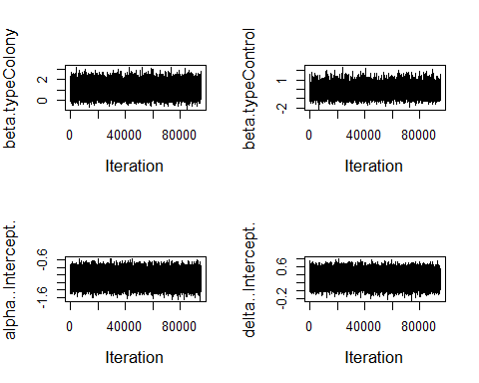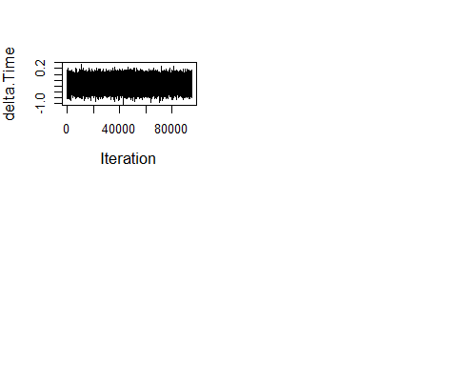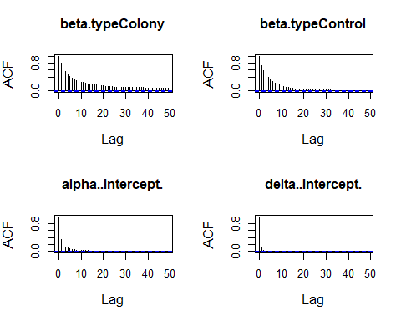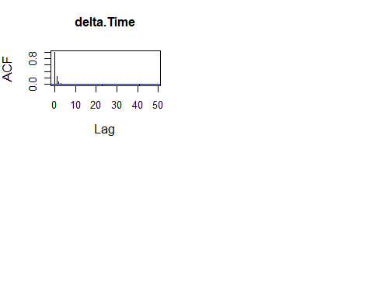

Table E. Parameter estimates of model (2)
 | Mean | 50% | 2.5% | 97.5%
beta.typeColony | 1.2064540 | 1.1435580 | 0.1879462 | 2.6067240
beta.typeControl | -0.1399229 | -0.1791517 | -0.9779238 | 0.9591011
alpha..Intercept. | -1.1024696 | -1.1017200 | -1.3693840 | -0.8404213
delta..Intercept. | 0.2999452 | 0.3004391 | 0.0655214 | 0.5331526

Table F. Monte Carlo standard errors of model (2)
 | Mean | 50% | 2.5% | 97.5%
beta.typeColony | 0.0111382 | 0.0074612 | 0.0045983 | 0.0734692
beta.typeControl | 0.0072250 | 0.0050398 | 0.0058346 | 0.0636266
alpha..Intercept. | 0.0010401 | 0.0010526 | 0.0023697 | 0.0014411
delta..Intercept. | 0.0004079 | 0.0004775 | 0.0010357 | 0.0009579

Table G. Occupancy and detection estimates of model (2)
 | ψ | ψ 95% CI | θ̅ | θ̅ 95% CI | p̅ | p̅ 95% CI
B1 | 0.87 | (0.57-1) | 0.14 | (0.09-0.2) | 0.62 | (0.53-0.7)
C1 | 0.43 | (0.16-0.83) | 0.14 | (0.09-0.2) | 0.62 | (0.53-0.7)
B2 | 0.87 | (0.57-1) | 0.14 | (0.09-0.2) | 0.62 | (0.53-0.7)
C2 | 0.43 | (0.16-0.83) | 0.14 | (0.09-0.2) | 0.62 | (0.53-0.7)
B3 | 0.87 | (0.57-1) | 0.14 | (0.09-0.2) | 0.62 | (0.53-0.7)
C3 | 0.43 | (0.16-0.83) | 0.14 | (0.09-0.2) | 0.62 | (0.53-0.7)
B4 | 0.87 | (0.57-1) | 0.14 | (0.09-0.2) | 0.62 | (0.53-0.7)
C4 | 0.43 | (0.16-0.83) | 0.14 | (0.09-0.2) | 0.62 | (0.53-0.7)
B5 | 0.87 | (0.57-1) | 0.14 | (0.09-0.2) | 0.62 | (0.53-0.7)
C5 | 0.43 | (0.16-0.83) | 0.14 | (0.09-0.2) | 0.62 | (0.53-0.7)
B6 | 0.87 | (0.57-1) | 0.14 | (0.09-0.2) | 0.62 | (0.53-0.7)
C6 | 0.43 | (0.16-0.83) | 0.14 | (0.09-0.2) | 0.62 | (0.53-0.7)
B7 | 0.87 | (0.57-1) | 0.14 | (0.09-0.2) | 0.62 | (0.53-0.7)
C7 | 0.43 | (0.16-0.83) | 0.14 | (0.09-0.2) | 0.62 | (0.53-0.7)
B8 | 0.87 | (0.57-1) | 0.14 | (0.09-0.2) | 0.62 | (0.53-0.7)
C8 | 0.43 | (0.16-0.83) | 0.14 | (0.09-0.2) | 0.62 | (0.53-0.7)
B9 | 0.87 | (0.57-1) | 0.14 | (0.09-0.2) | 0.62 | (0.53-0.7)
C9 | 0.43 | (0.16-0.83) | 0.14 | (0.09-0.2) | 0.62 | (0.53-0.7)
B10 | 0.87 | (0.57-1) | 0.14 | (0.09-0.2) | 0.62 | (0.53-0.7)
C10 | 0.43 | (0.16-0.83) | 0.14 | (0.09-0.2) | 0.62 | (0.53-0.7)
B11 | 0.87 | (0.57-1) | 0.14 | (0.09-0.2) | 0.62 | (0.53-0.7)
C11 | 0.43 | (0.16-0.83) | 0.14 | (0.09-0.2) | 0.62 | (0.53-0.7)
B12 | 0.87 | (0.57-1) | 0.14 | (0.09-0.2) | 0.62 | (0.53-0.7)
C12 | 0.43 | (0.16-0.83) | 0.14 | (0.09-0.2) | 0.62 | (0.53-0.7)
B13 | 0.87 | (0.57-1) | 0.14 | (0.09-0.2) | 0.62 | (0.53-0.7)
C13 | 0.43 | (0.16-0.83) | 0.14 | (0.09-0.2) | 0.62 | (0.53-0.7)
B14 | 0.87 | (0.57-1) | 0.14 | (0.09-0.2) | 0.62 | (0.53-0.7)
C14 | 0.43 | (0.16-0.83) | 0.14 | (0.09-0.2) | 0.62 | (0.53-0.7)
B15 | 0.87 | (0.57-1) | 0.14 | (0.09-0.2) | 0.62 | (0.53-0.7)
C15 | 0.43 | (0.16-0.83) | 0.14 | (0.09-0.2) | 0.62 | (0.53-0.7)

Fig B. Convergence assessment of model (2)
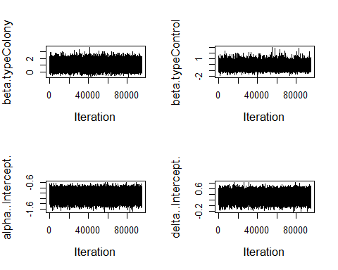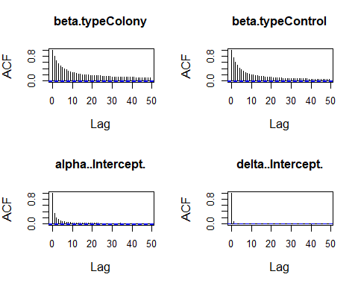

Table H. Parameter estimates of model (3)
 | Mean | 50% | 2.5% | 97.5%
beta..Intercept. | 0.6928197 | 0.6120563 | -0.1275129 | 1.9870290
alpha..Intercept. | -1.1577396 | -1.1604720 | -1.4371910 | -0.8664892
delta..Intercept. | 0.3003242 | 0.3004222 | 0.0646858 | 0.5331508

Table I. Monte Carlo standard errors of model (3)
 | Mean | 50% | 2.5% | 97.5%
beta..Intercept. | 0.0052029 | 0.0048701 | 0.0036051 | 0.0141004
alpha..Intercept. | 0.0010885 | 0.0012469 | 0.0013872 | 0.0017344
delta..Intercept. | 0.0004143 | 0.0005205 | 0.0010909 | 0.0010804

Table J. Occupancy and detection estimates of model (3)
 | ψ | ψ 95% CI | θ̅ | θ̅ 95% CI | p̅ | p̅ 95% CI
B1 | 0.73 | (0.45-0.98) | 0.12 | (0.08-0.19) | 0.62 | (0.53-0.7)
C1 | 0.73 | (0.45-0.98) | 0.12 | (0.08-0.19) | 0.62 | (0.53-0.7)
B2 | 0.73 | (0.45-0.98) | 0.12 | (0.08-0.19) | 0.62 | (0.53-0.7)
C2 | 0.73 | (0.45-0.98) | 0.12 | (0.08-0.19) | 0.62 | (0.53-0.7)
B3 | 0.73 | (0.45-0.98) | 0.12 | (0.08-0.19) | 0.62 | (0.53-0.7)
C3 | 0.73 | (0.45-0.98) | 0.12 | (0.08-0.19) | 0.62 | (0.53-0.7)
B4 | 0.73 | (0.45-0.98) | 0.12 | (0.08-0.19) | 0.62 | (0.53-0.7)
C4 | 0.73 | (0.45-0.98) | 0.12 | (0.08-0.19) | 0.62 | (0.53-0.7)
B5 | 0.73 | (0.45-0.98) | 0.12 | (0.08-0.19) | 0.62 | (0.53-0.7)
C5 | 0.73 | (0.45-0.98) | 0.12 | (0.08-0.19) | 0.62 | (0.53-0.7)
B6 | 0.73 | (0.45-0.98) | 0.12 | (0.08-0.19) | 0.62 | (0.53-0.7)
C6 | 0.73 | (0.45-0.98) | 0.12 | (0.08-0.19) | 0.62 | (0.53-0.7)
B7 | 0.73 | (0.45-0.98) | 0.12 | (0.08-0.19) | 0.62 | (0.53-0.7)
C7 | 0.73 | (0.45-0.98) | 0.12 | (0.08-0.19) | 0.62 | (0.53-0.7)
B8 | 0.73 | (0.45-0.98) | 0.12 | (0.08-0.19) | 0.62 | (0.53-0.7)
C8 | 0.73 | (0.45-0.98) | 0.12 | (0.08-0.19) | 0.62 | (0.53-0.7)
B9 | 0.73 | (0.45-0.98) | 0.12 | (0.08-0.19) | 0.62 | (0.53-0.7)
C9 | 0.73 | (0.45-0.98) | 0.12 | (0.08-0.19) | 0.62 | (0.53-0.7)
B10 | 0.73 | (0.45-0.98) | 0.12 | (0.08-0.19) | 0.62 | (0.53-0.7)
C10 | 0.73 | (0.45-0.98) | 0.12 | (0.08-0.19) | 0.62 | (0.53-0.7)
B11 | 0.73 | (0.45-0.98) | 0.12 | (0.08-0.19) | 0.62 | (0.53-0.7)
C11 | 0.73 | (0.45-0.98) | 0.12 | (0.08-0.19) | 0.62 | (0.53-0.7)
B12 | 0.73 | (0.45-0.98) | 0.12 | (0.08-0.19) | 0.62 | (0.53-0.7)
C12 | 0.73 | (0.45-0.98) | 0.12 | (0.08-0.19) | 0.62 | (0.53-0.7)
B13 | 0.73 | (0.45-0.98) | 0.12 | (0.08-0.19) | 0.62 | (0.53-0.7)
C13 | 0.73 | (0.45-0.98) | 0.12 | (0.08-0.19) | 0.62 | (0.53-0.7)
B14 | 0.73 | (0.45-0.98) | 0.12 | (0.08-0.19) | 0.62 | (0.53-0.7)
C14 | 0.73 | (0.45-0.98) | 0.12 | (0.08-0.19) | 0.62 | (0.53-0.7)
B15 | 0.73 | (0.45-0.98) | 0.12 | (0.08-0.19) | 0.62 | (0.53-0.7)
C15 | 0.73 | (0.45-0.98) | 0.12 | (0.08-0.19) | 0.62 | (0.53-0.7)

Fig C. Convergence assessment of model (3)
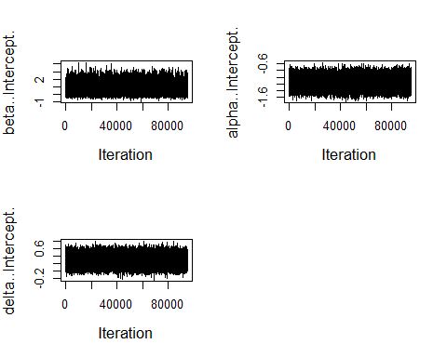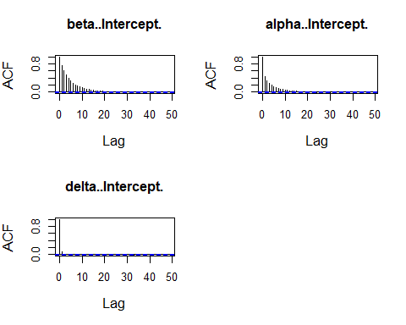

Table K. Parameter estimates of model (4)
 | Mean | 50% | 2.5% | 97.5%
beta.typeColony | 1.1391529 | 1.0825130 | 0.1559283 | 2.3868490
beta.typeControl | -0.0571652 | -0.1049781 | -0.9429032 | 1.1236780
alpha..Intercept. | -1.1359795 | -1.1357190 | -1.4152690 | -0.8601033
alpha.jdatecollected | -0.1136163 | -0.1141605 | -0.3647246 | 0.1362993
delta..Intercept. | 0.2996026 | 0.2998048 | 0.0634458 | 0.5324163

Table L. Monte Carlo standard errors of model (4)
 | Mean | 50% | 2.5% | 97.5%
beta.typeColony | 0.0074389 | 0.0056927 | 0.0045012 | 0.0328044
beta.typeControl | 0.0054696 | 0.0047571 | 0.0055996 | 0.0238362
alpha..Intercept. | 0.0009234 | 0.0009789 | 0.0016576 | 0.0014490
alpha.jdatecollected | 0.0005735 | 0.0006786 | 0.0011871 | 0.0012505
delta..Intercept. | 0.0004222 | 0.0005053 | 0.0010613 | 0.0010922

Table M. Occupancy and detection estimates of model (4)
 | ψ | ψ 95% CI | θ̅ | θ̅ 95% CI | p̅ | p̅ 95% CI
B1 | 0.86 | (0.56-0.99) | 0.19 | (0.08-0.37) | 0.62 | (0.53-0.7)
C1 | 0.46 | (0.17-0.87) | 0.13 | (0.09-0.2) | 0.62 | (0.53-0.7)
B2 | 0.86 | (0.56-0.99) | 0.18 | (0.08-0.32) | 0.62 | (0.53-0.7)
C2 | 0.46 | (0.17-0.87) | 0.18 | (0.08-0.32) | 0.62 | (0.53-0.7)
B3 | 0.86 | (0.56-0.99) | 0.14 | (0.09-0.2) | 0.62 | (0.53-0.7)
C3 | 0.46 | (0.17-0.87) | 0.13 | (0.08-0.19) | 0.62 | (0.53-0.7)
B4 | 0.86 | (0.56-0.99) | 0.16 | (0.09-0.25) | 0.62 | (0.53-0.7)
C4 | 0.46 | (0.17-0.87) | 0.13 | (0.08-0.19) | 0.62 | (0.53-0.7)
B5 | 0.86 | (0.56-0.99) | 0.14 | (0.09-0.2) | 0.62 | (0.53-0.7)
C5 | 0.46 | (0.17-0.87) | 0.06 | (0.01-0.29) | 0.62 | (0.53-0.7)
B6 | 0.86 | (0.56-0.99) | 0.15 | (0.09-0.22) | 0.62 | (0.53-0.7)
C6 | 0.46 | (0.17-0.87) | 0.13 | (0.08-0.2) | 0.62 | (0.53-0.7)
B7 | 0.86 | (0.56-0.99) | 0.14 | (0.09-0.21) | 0.62 | (0.53-0.7)
C7 | 0.46 | (0.17-0.87) | 0.11 | (0.06-0.2) | 0.62 | (0.53-0.7)
B8 | 0.86 | (0.56-0.99) | 0.14 | (0.09-0.21) | 0.62 | (0.53-0.7)
C8 | 0.46 | (0.17-0.87) | 0.11 | (0.05-0.2) | 0.62 | (0.53-0.7)
B9 | 0.86 | (0.56-0.99) | 0.1 | (0.03-0.21) | 0.62 | (0.53-0.7)
C9 | 0.46 | (0.17-0.87) | 0.14 | (0.09-0.21) | 0.62 | (0.53-0.7)
B10 | 0.86 | (0.56-0.99) | 0.16 | (0.09-0.25) | 0.62 | (0.53-0.7)
C10 | 0.46 | (0.17-0.87) | 0.12 | (0.07-0.19) | 0.62 | (0.53-0.7)
B11 | 0.86 | (0.56-0.99) | 0.15 | (0.09-0.22) | 0.62 | (0.53-0.7)
C11 | 0.46 | (0.17-0.87) | 0.11 | (0.06-0.2) | 0.62 | (0.53-0.7)
B12 | 0.86 | (0.56-0.99) | 0.13 | (0.08-0.2) | 0.62 | (0.53-0.7)
C12 | 0.46 | (0.17-0.87) | 0.12 | (0.07-0.19) | 0.62 | (0.53-0.7)
B13 | 0.86 | (0.56-0.99) | 0.13 | (0.08-0.19) | 0.62 | (0.53-0.7)
C13 | 0.46 | (0.17-0.87) | 0.1 | (0.03-0.21) | 0.62 | (0.53-0.7)
B14 | 0.86 | (0.56-0.99) | 0.12 | (0.06-0.19) | 0.62 | (0.53-0.7)
C14 | 0.46 | (0.17-0.87) | 0.12 | (0.06-0.19) | 0.62 | (0.53-0.7)
B15 | 0.86 | (0.56-0.99) | 0.11 | (0.06-0.2) | 0.62 | (0.53-0.7)
C15 | 0.46 | (0.17-0.87) | 0.11 | (0.05-0.2) | 0.62 | (0.53-0.7)

Fig D. Convergence assessment of model (4)
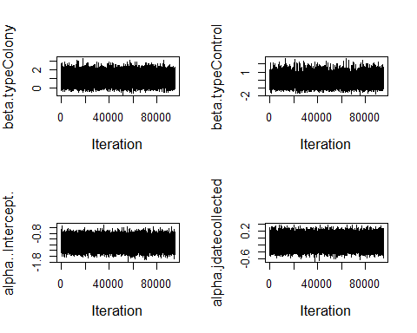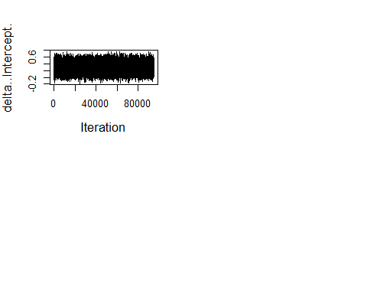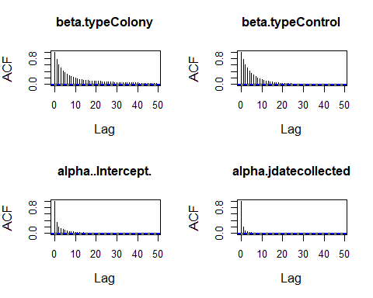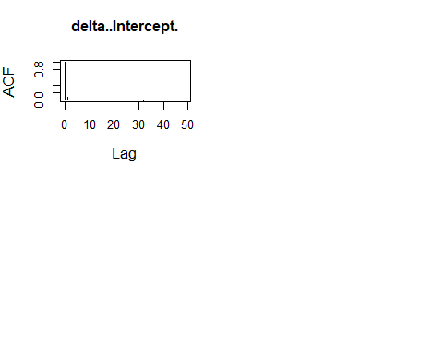

Table N. Parameter estimates of model (5)
 | Mean | 50% | 2.5% | 97.5%
beta.typeColony | 1.1656156 | 1.1097220 | 0.1747365 | 2.4965590
beta.typeControl | -0.0563103 | -0.1007254 | -0.9535205 | 1.1373210
alpha..Intercept. | -1.1260085 | -1.1258360 | -1.4028550 | -0.8519668
alpha.jdatecollected | -0.1255523 | -0.1260310 | -0.3806873 | 0.1279262
delta..Intercept. | 0.2923503 | 0.2926443 | 0.0524307 | 0.5313233
delta.Time | -0.3451045 | -0.3440951 | -0.6597536 | -0.0395745

Table O. Monte Carlo standard errors of model (5)
 | Mean | 50% | 2.5% | 97.5%
beta.typeColony | 0.0074803 | 0.0060284 | 0.0050245 | 0.0434608
beta.typeControl | 0.0054584 | 0.0050050 | 0.0071757 | 0.0248860
alpha..Intercept. | 0.0008692 | 0.0009641 | 0.0015214 | 0.0014107
alpha.jdatecollected | 0.0006306 | 0.0007034 | 0.0013511 | 0.0012258
delta..Intercept. | 0.0004692 | 0.0005652 | 0.0011180 | 0.0010594
delta.Time | 0.0007009 | 0.0008178 | 0.0016933 | 0.0013374

Table P. Occupancy and detection estimates of model (5)
 | ψ | ψ 95% CI | θ̅ | θ̅ 95% CI | p̅ | p̅ 95% CI
B1 | 0.87 | (0.57-0.99) | 0.2 | (0.08-0.39) | 0.69 | (0.58-0.78)
C1 | 0.46 | (0.17-0.87) | 0.14 | (0.09-0.21) | 0.45 | (0.28-0.63)
B2 | 0.87 | (0.57-0.99) | 0.18 | (0.09-0.33) | 0.77 | (0.61-0.88)
C2 | 0.46 | (0.17-0.87) | 0.18 | (0.09-0.33) | 0.43 | (0.25-0.62)
B3 | 0.87 | (0.57-0.99) | 0.14 | (0.09-0.21) | 0.73 | (0.6-0.84)
C3 | 0.46 | (0.17-0.87) | 0.13 | (0.08-0.2) | 0.48 | (0.33-0.63)
B4 | 0.87 | (0.57-0.99) | 0.16 | (0.09-0.26) | 0.75 | (0.61-0.87)
C4 | 0.46 | (0.17-0.87) | 0.13 | (0.08-0.2) | 0.69 | (0.58-0.79)
B5 | 0.87 | (0.57-0.99) | 0.14 | (0.09-0.21) | 0.4 | (0.2-0.61)
C5 | 0.46 | (0.17-0.87) | 0.06 | (0.01-0.29) | 0.68 | (0.58-0.78)
B6 | 0.87 | (0.57-0.99) | 0.15 | (0.09-0.23) | 0.67 | (0.57-0.76)
C6 | 0.46 | (0.17-0.87) | 0.13 | (0.08-0.2) | 0.65 | (0.55-0.74)
B7 | 0.87 | (0.57-0.99) | 0.14 | (0.09-0.21) | 0.64 | (0.55-0.73)
C7 | 0.46 | (0.17-0.87) | 0.11 | (0.06-0.2) | 0.56 | (0.45-0.67)
B8 | 0.87 | (0.57-0.99) | 0.14 | (0.09-0.21) | 0.63 | (0.53-0.71)
C8 | 0.46 | (0.17-0.87) | 0.11 | (0.05-0.2) | 0.54 | (0.42-0.66)
B9 | 0.87 | (0.57-0.99) | 0.1 | (0.03-0.21) | 0.66 | (0.56-0.75)
C9 | 0.46 | (0.17-0.87) | 0.14 | (0.09-0.21) | 0.78 | (0.61-0.89)
B10 | 0.87 | (0.57-0.99) | 0.16 | (0.09-0.26) | 0.59 | (0.5-0.69)
C10 | 0.46 | (0.17-0.87) | 0.13 | (0.07-0.2) | 0.79 | (0.62-0.91)
B11 | 0.87 | (0.57-0.99) | 0.15 | (0.09-0.23) | 0.4 | (0.2-0.61)
C11 | 0.46 | (0.17-0.87) | 0.11 | (0.06-0.2) | 0.75 | (0.61-0.86)
B12 | 0.87 | (0.57-0.99) | 0.13 | (0.08-0.2) | 0.78 | (0.62-0.9)
C12 | 0.46 | (0.17-0.87) | 0.13 | (0.07-0.2) | 0.66 | (0.56-0.75)
B13 | 0.87 | (0.57-0.99) | 0.13 | (0.08-0.2) | 0.83 | (0.63-0.94)
C13 | 0.46 | (0.17-0.87) | 0.1 | (0.03-0.21) | 0.8 | (0.62-0.91)
B14 | 0.87 | (0.57-0.99) | 0.12 | (0.06-0.2) | 0.58 | (0.47-0.67)
C14 | 0.46 | (0.17-0.87) | 0.12 | (0.06-0.2) | 0.73 | (0.6-0.83)
B15 | 0.87 | (0.57-0.99) | 0.11 | (0.06-0.2) | 0.76 | (0.61-0.87)
C15 | 0.46 | (0.17-0.87) | 0.11 | (0.05-0.2) | 0.78 | (0.61-0.9)

Fig E. Convergence assessment of model (5)
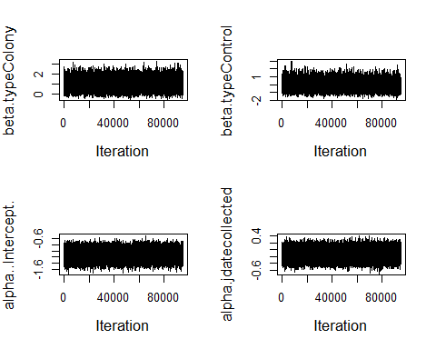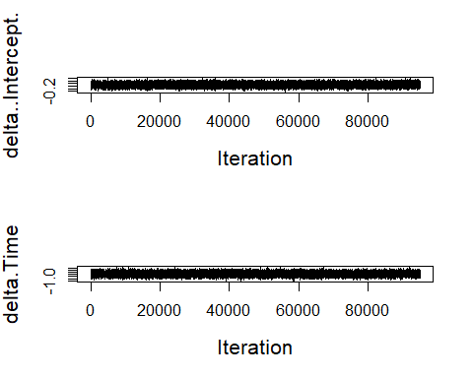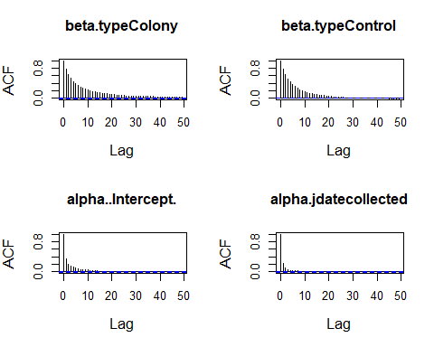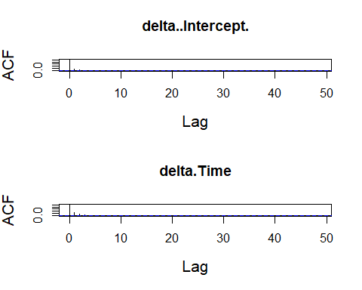

Table Q. Parameter estimates of model (6)
 | Mean | 50% | 2.5% | 97.5%
beta.typeColony | 1.2165220 | 1.1685680 | 0.2102202 | 2.4994370
beta.typeControl | -0.1660051 | -0.1992787 | -0.9972829 | 0.8574730
alpha..Intercept. | -1.0868611 | -1.0867180 | -1.3516430 | -0.8251733
delta..Intercept. | 0.2900161 | 0.2900330 | 0.0485768 | 0.5299441
delta.Time | -0.3069359 | -0.3053794 | -0.6234784 | -0.0008573
delta.Water_depth_in | 0.1811516 | 0.1800296 | -0.1221437 | 0.4892284

Table R. Monte Carlo standard errors of model (6)
 | Mean | 50% | 2.5% | 97.5%
beta.typeColony | 0.0075646 | 0.0059362 | 0.0047738 | 0.0339008
beta.typeControl | 0.0049599 | 0.0046137 | 0.0058860 | 0.0219620
alpha..Intercept. | 0.0007879 | 0.0008899 | 0.0014794 | 0.0014449
delta..Intercept. | 0.0004637 | 0.0005539 | 0.0010211 | 0.0010682
delta.Time | 0.0007348 | 0.0008561 | 0.0017113 | 0.0013998
delta.Water_depth_in | 0.0005692 | 0.0006631 | 0.0014227 | 0.0015464

Table S. Occupancy and detection estimates of model (6)
 | ψ | ψ 95% CI | θ̅ | θ̅ 95% CI | p̅ | p̅ 95% CI
B1 | 0.88 | (0.58-0.99) | 0.14 | (0.09-0.2) | 0.74 | (0.6-0.85)
C1 | 0.42 | (0.16-0.8) | 0.14 | (0.09-0.2) | 0.4 | (0.21-0.6)
B2 | 0.88 | (0.58-0.99) | 0.14 | (0.09-0.2) | 0.67 | (0.4-0.86)
C2 | 0.42 | (0.16-0.8) | 0.14 | (0.09-0.2) | 0.45 | (0.26-0.64)
B3 | 0.88 | (0.58-0.99) | 0.14 | (0.09-0.2) | 0.65 | (0.43-0.82)
C3 | 0.42 | (0.16-0.8) | 0.14 | (0.09-0.2) | 0.56 | (0.36-0.74)
B4 | 0.88 | (0.58-0.99) | 0.14 | (0.09-0.2) | 0.73 | (0.57-0.85)
C4 | 0.42 | (0.16-0.8) | 0.14 | (0.09-0.2) | 0.68 | (0.57-0.79)
B5 | 0.88 | (0.58-0.99) | 0.14 | (0.09-0.2) | 0.38 | (0.19-0.6)
C5 | 0.42 | (0.16-0.8) | 0.14 | (0.09-0.2) | 0.82 | (0.55-0.96)
B6 | 0.88 | (0.58-0.99) | 0.14 | (0.09-0.2) | 0.73 | (0.58-0.84)
C6 | 0.42 | (0.16-0.8) | 0.14 | (0.09-0.2) | 0.59 | (0.44-0.72)
B7 | 0.88 | (0.58-0.99) | 0.14 | (0.09-0.2) | 0.61 | (0.5-0.72)
C7 | 0.42 | (0.16-0.8) | 0.14 | (0.09-0.2) | 0.54 | (0.42-0.65)
B8 | 0.88 | (0.58-0.99) | 0.14 | (0.09-0.2) | 0.56 | (0.42-0.7)
C8 | 0.42 | (0.16-0.8) | 0.14 | (0.09-0.2) | 0.49 | (0.34-0.64)
B9 | 0.88 | (0.58-0.99) | 0.14 | (0.09-0.2) | 0.61 | (0.48-0.74)
C9 | 0.42 | (0.16-0.8) | 0.14 | (0.09-0.2) | 0.72 | (0.52-0.87)
B10 | 0.88 | (0.58-0.99) | 0.14 | (0.09-0.2) | 0.7 | (0.5-0.85)
C10 | 0.42 | (0.16-0.8) | 0.14 | (0.09-0.2) | 0.8 | (0.63-0.92)
B11 | 0.88 | (0.58-0.99) | 0.14 | (0.09-0.2) | 0.35 | (0.15-0.58)
C11 | 0.42 | (0.16-0.8) | 0.14 | (0.09-0.2) | 0.7 | (0.51-0.84)
B12 | 0.88 | (0.58-0.99) | 0.14 | (0.09-0.2) | 0.76 | (0.57-0.89)
C12 | 0.42 | (0.16-0.8) | 0.14 | (0.09-0.2) | 0.73 | (0.57-0.86)
B13 | 0.88 | (0.58-0.99) | 0.14 | (0.09-0.2) | 0.8 | (0.59-0.93)
C13 | 0.42 | (0.16-0.8) | 0.14 | (0.09-0.2) | 0.76 | (0.56-0.9)
B14 | 0.88 | (0.58-0.99) | 0.14 | (0.09-0.2) | 0.74 | (0.44-0.93)
C14 | 0.42 | (0.16-0.8) | 0.14 | (0.09-0.2) | 0.66 | (0.47-0.81)
B15 | 0.88 | (0.58-0.99) | 0.14 | (0.09-0.2) | 0.78 | (0.63-0.89)
C15 | 0.42 | (0.16-0.8) | 0.14 | (0.09-0.2) | 0.88 | (0.63-0.98)

Fig F. Convergence assessment of model (6)
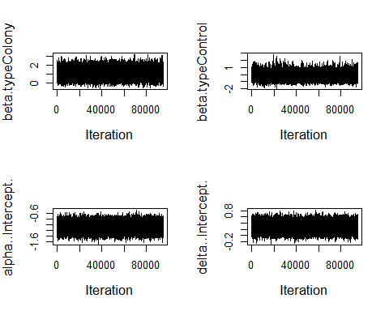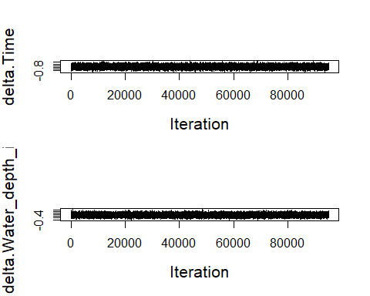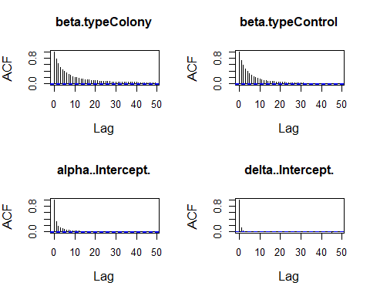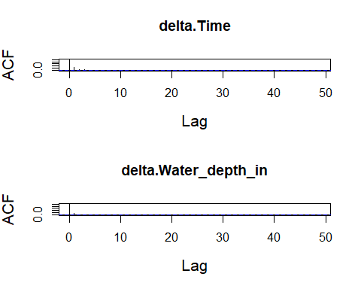

Table T. Parameter estimates of model (7)
 | Mean | 50% | 2.5% | 97.5%
beta.typeColony | 1.2041988 | 1.1429020 | 0.1966178 | 2.5639850
beta.typeControl | -0.1529146 | -0.1848119 | -0.9977688 | 0.8608893
alpha..Intercept. | -1.0978923 | -1.0975230 | -1.3639250 | -0.8354198
delta..Intercept. | 0.2930836 | 0.2936670 | 0.0533185 | 0.5310349
delta.Water_depth_in | 0.2341202 | 0.2322106 | -0.0650612 | 0.5416629

Table U. Monte Carlo standard errors of model (7)
 | Mean | 50% | 2.5% | 97.5%
beta.typeColony | 0.0099877 | 0.0064397 | 0.0046290 | 0.0639701
beta.typeControl | 0.0050593 | 0.0048965 | 0.0062335 | 0.0170495
alpha..Intercept. | 0.0008649 | 0.0009519 | 0.0016207 | 0.0014628
delta..Intercept. | 0.0004366 | 0.0005316 | 0.0010698 | 0.0010361
delta.Water_depth_in | 0.0005771 | 0.0006929 | 0.0013616 | 0.0015571

Table V. Occupancy and detection estimates of model (7)
 | ψ | ψ 95% CI | θ̅ | θ̅ 95% CI | p̅ | p̅ 95% CI
B1 | 0.87 | (0.58-0.99) | 0.14 | (0.09-0.2) | 0.7 | (0.56-0.81)
C1 | 0.43 | (0.16-0.81) | 0.14 | (0.09-0.2) | 0.52 | (0.36-0.67)
B2 | 0.87 | (0.58-0.99) | 0.14 | (0.09-0.2) | 0.49 | (0.3-0.67)
C2 | 0.43 | (0.16-0.81) | 0.14 | (0.09-0.2) | 0.62 | (0.52-0.7)
B3 | 0.87 | (0.58-0.99) | 0.14 | (0.09-0.2) | 0.51 | (0.34-0.67)
C3 | 0.43 | (0.16-0.81) | 0.14 | (0.09-0.2) | 0.69 | (0.56-0.8)
B4 | 0.87 | (0.58-0.99) | 0.14 | (0.09-0.2) | 0.6 | (0.5-0.69)
C4 | 0.43 | (0.16-0.81) | 0.14 | (0.09-0.2) | 0.62 | (0.52-0.7)
B5 | 0.87 | (0.58-0.99) | 0.14 | (0.09-0.2) | 0.56 | (0.43-0.67)
C5 | 0.43 | (0.16-0.81) | 0.14 | (0.09-0.2) | 0.81 | (0.54-0.96)
B6 | 0.87 | (0.58-0.99) | 0.14 | (0.09-0.2) | 0.71 | (0.56-0.83)
C6 | 0.43 | (0.16-0.81) | 0.14 | (0.09-0.2) | 0.54 | (0.4-0.67)
B7 | 0.87 | (0.58-0.99) | 0.14 | (0.09-0.2) | 0.58 | (0.47-0.68)
C7 | 0.43 | (0.16-0.81) | 0.14 | (0.09-0.2) | 0.58 | (0.47-0.68)
B8 | 0.87 | (0.58-0.99) | 0.14 | (0.09-0.2) | 0.54 | (0.4-0.67)
C8 | 0.43 | (0.16-0.81) | 0.14 | (0.09-0.2) | 0.54 | (0.4-0.67)
B9 | 0.87 | (0.58-0.99) | 0.14 | (0.09-0.2) | 0.56 | (0.43-0.67)
C9 | 0.43 | (0.16-0.81) | 0.14 | (0.09-0.2) | 0.56 | (0.43-0.67)
B10 | 0.87 | (0.58-0.99) | 0.14 | (0.09-0.2) | 0.74 | (0.56-0.87)
C10 | 0.43 | (0.16-0.81) | 0.14 | (0.09-0.2) | 0.67 | (0.56-0.77)
B11 | 0.87 | (0.58-0.99) | 0.14 | (0.09-0.2) | 0.52 | (0.36-0.67)
C11 | 0.43 | (0.16-0.81) | 0.14 | (0.09-0.2) | 0.56 | (0.43-0.67)
B12 | 0.87 | (0.58-0.99) | 0.14 | (0.09-0.2) | 0.6 | (0.5-0.69)
C12 | 0.43 | (0.16-0.81) | 0.14 | (0.09-0.2) | 0.72 | (0.56-0.85)
B13 | 0.87 | (0.58-0.99) | 0.14 | (0.09-0.2) | 0.61 | (0.51-0.69)
C13 | 0.43 | (0.16-0.81) | 0.14 | (0.09-0.2) | 0.59 | (0.48-0.68)
B14 | 0.87 | (0.58-0.99) | 0.14 | (0.09-0.2) | 0.81 | (0.54-0.96)
C14 | 0.43 | (0.16-0.81) | 0.14 | (0.09-0.2) | 0.54 | (0.4-0.67)
B15 | 0.87 | (0.58-0.99) | 0.14 | (0.09-0.2) | 0.67 | (0.56-0.77)
C15 | 0.43 | (0.16-0.81) | 0.14 | (0.09-0.2) | 0.81 | (0.54-0.96)

Fig G. Convergence assessment of model (7)
