Table S1. Random data eigenvalues and 95th percentile eigenvalues for parallel analysis of EISI
Component | Initial eigenvalues | Mean | 95th percentile
1 | 6.95 | 1.36 | 1.41
2 | 2.96 | 1.30 | 1.34
3 | 1.81 | 1.26 | 1.30
4 | 1.66 | 1.23 | 1.25
5 | 1.32 | 1.19 | 1.22
6 | .88 | 1.16 | 1.19
7 | .86 | 1.14 | 1.16
8 | .80 | 1.11 | 1.34
9 | .77 | 1.08 | 1.11
10 | .74 | 1.06 | 1.08
11 | .70 | 1.04 | 1.06
12 | .64 | 1.01 | 1.03
13 | .62 | .99 | 1.10
14 | .53 | .97 | .99
15 | .53 | .94 | .96
16 | .49 | .92 | .94
17 | .41 | .90 | .92
18 | .38 | .88 | .90
19 | .36 | .85 | .88
20 | .33 | .83 | .85
21 | .30 | .81 | .83
22 | .27 | .78 | .81
23 | .26 | .76 | .78
24 | .23 | .73 | .75
25 | .22 | .69 | .72

Figure S1: Scatterplots for associations between bipolar risk, mania, and their interaction with EISI subscales
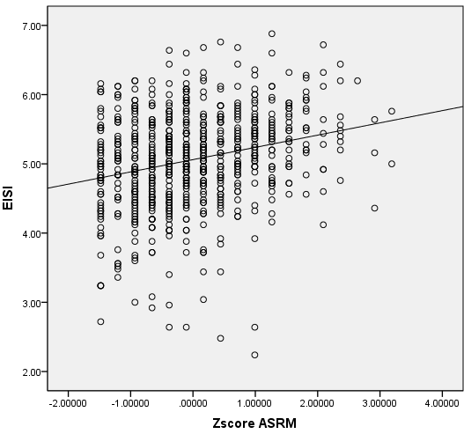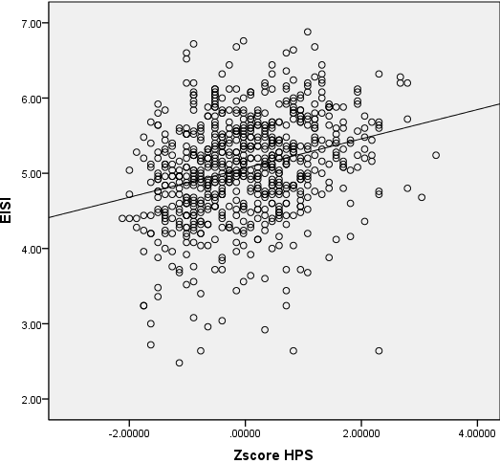

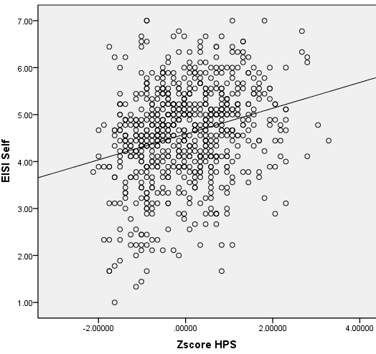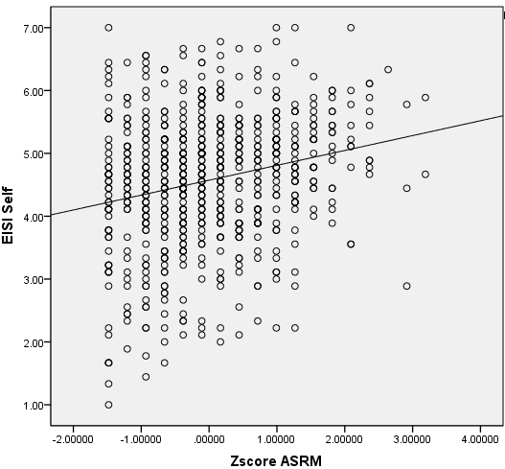

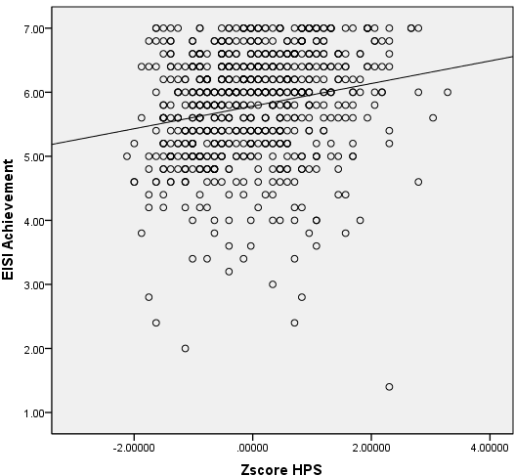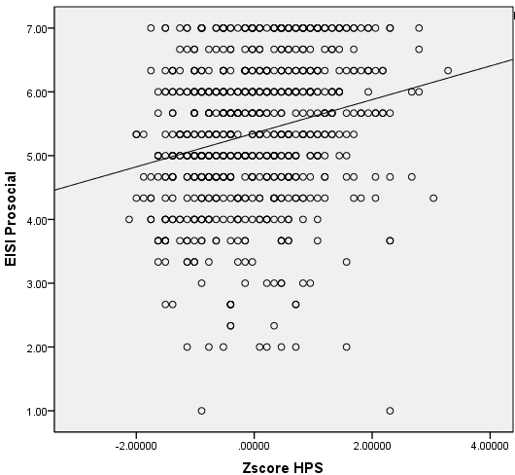

External and Internal Scale of Inspiration (EISI); Altman Self Rating Mania Index (ASRM);Hypomanic Personality Scale (HPS)

Figure S2: Scatterplots for associations between EISI subscales and bipolar risk, when controlling for current mania
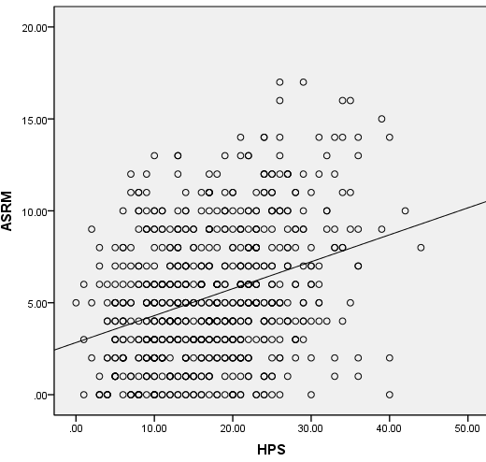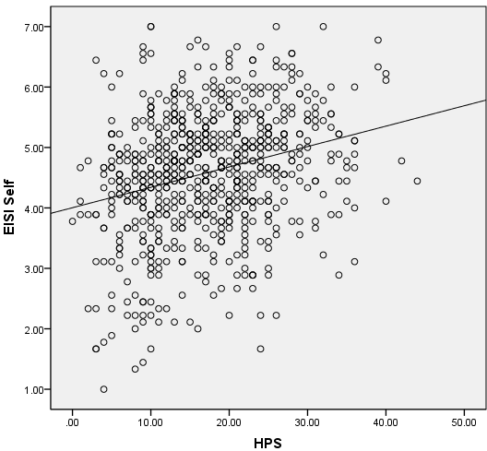

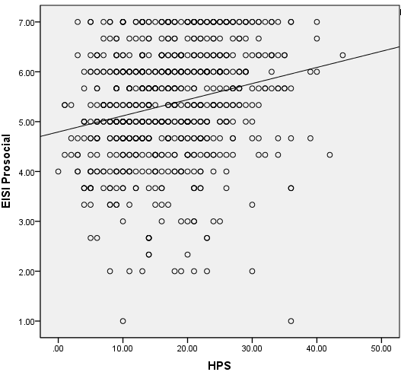
External and Internal Scale of Inspiration (EISI); Hypomanic Personality Scale (HPS)

