Appendix 13: Pairwise sub-analyses

A. Trauma-focused CBT versus waitlist – PTSD symptom scores between baseline and treatment endpoint: Sub-analysis by specific TF-CBT intervention
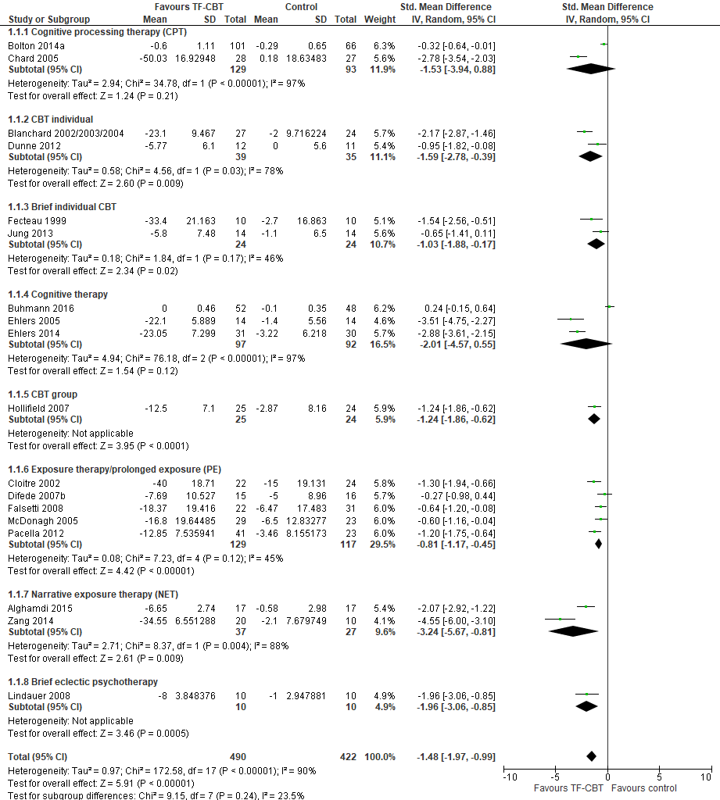

B. Trauma-focused CBT versus waitlist – PTSD symptom scores between baseline and treatment endpoint: Sub-analysis by method of analysis (intention to treat [ITT] or completer)
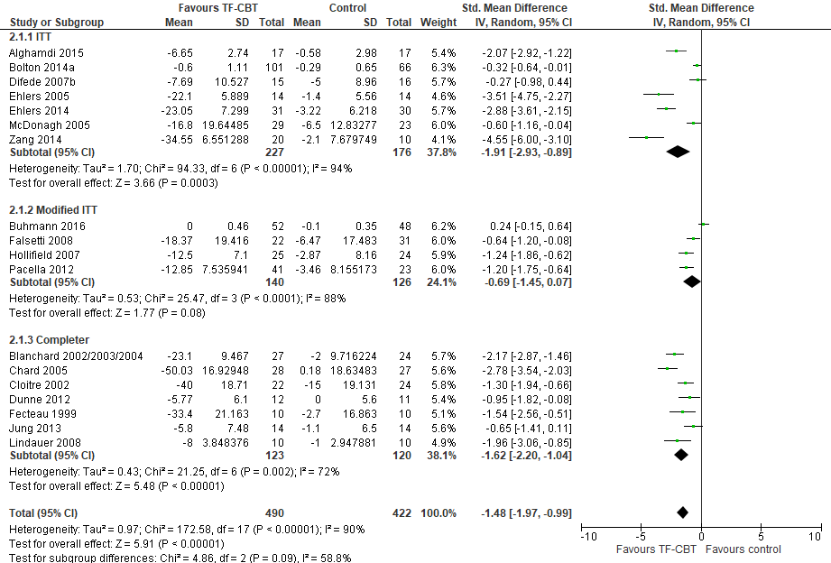

C. Trauma-focused CBT versus waitlist – PTSD symptom scores between baseline and treatment endpoint: Sub-analysis by multiplicity of trauma
