Diastereoselective Synthesis of Chiral 1,3-Cyclohexadienals

Aitor Urosa^{1¶}, Ignacio E. Tobal^{1¶}, Ángela P. de la Granja¹, M. Carmen Capitán¹, R. F. Moro¹, Isidro S. Marcos¹, Narciso M. Garrido¹, Francisca Sanz², Emilio Calle³ and David Díez¹*

¹ Departamento de Química Orgánica, Facultad de Ciencias Químicas, Universidad de Salamanca, Salamanca. Spain.
² Servicio de Difracción de Rayos X, Universidad de Salamanca, Salamanca, Spain.
³Departamento de Química Física, Facultad de Ciencias Químicas, Universidad de Salamanca, Salamanca. Spain.

*E-mail: ddm@usal.es
¶ These authors contributed equally to this work.

SUPPORTING INFORMATION 1
NMR and IR data

TABLE OF CONTENTS
Content | Page
¹H NMR of 3 | S4
¹H NMR and ¹³C NMR of 4a | S5
IR of 4a | S6
¹H NMR and ¹³C NMR of 4b | S7
IR of 4b | S8
¹H NMR and ¹³C NMR of 11 | S9
IR of 11 | S10
¹H NMR and ¹³C NMR of 12 | S11
IR of 12 | S12
ROESY of 12 | S13
¹H NMR of 14a and 14b | S14
¹H NMR of 14 and 15a | S15
¹H NMR of 15b and 15 | S16
¹H NMR of 16a and 16b | S17
¹H NMR of 16 and 17a | S18
¹H NMR of 17b and 17 | S19
¹H NMR of 18a and 18b | S20
¹H NMR of 18 and 19a | S21
¹H NMR of 19b and 19 | S22
¹H NMR and ¹³C NMR of 20a | S23
IR of 20a | S24
¹H NMR and ¹³C NMR of 20b | S25
IR of 20b | S26
¹H NMR and ¹³C NMR of 21a | S27
IR of 21a | S28
¹H NMR and ¹³C NMR of 21b | S29
IR of 21b | S30
¹H NMR and ¹³C NMR of 22a | S31
IR of 22a | S32
¹H NMR and ¹³C NMR of 22b | S33
IR of 22b | S34
¹H NMR and ¹³C NMR of 23a | S35
IR of 23a | S36
¹H NMR and ¹³C NMR of 23b | S37
IR of 23b | S38
¹H NMR and ¹³C NMR of 24a | S39
IR of 24a | S40
¹H NMR and ¹³C NMR of 24b | S41
IR of 24b | S42
¹H NMR and ¹³C NMR of 25a | S43
IR of 25a | S44
¹H NMR and ¹³C NMR of 25b | S45
IR of 25b | S46
¹H NMR and ¹³C NMR of 26 | S47
IR of 26 | S48

¹H NMR of 3

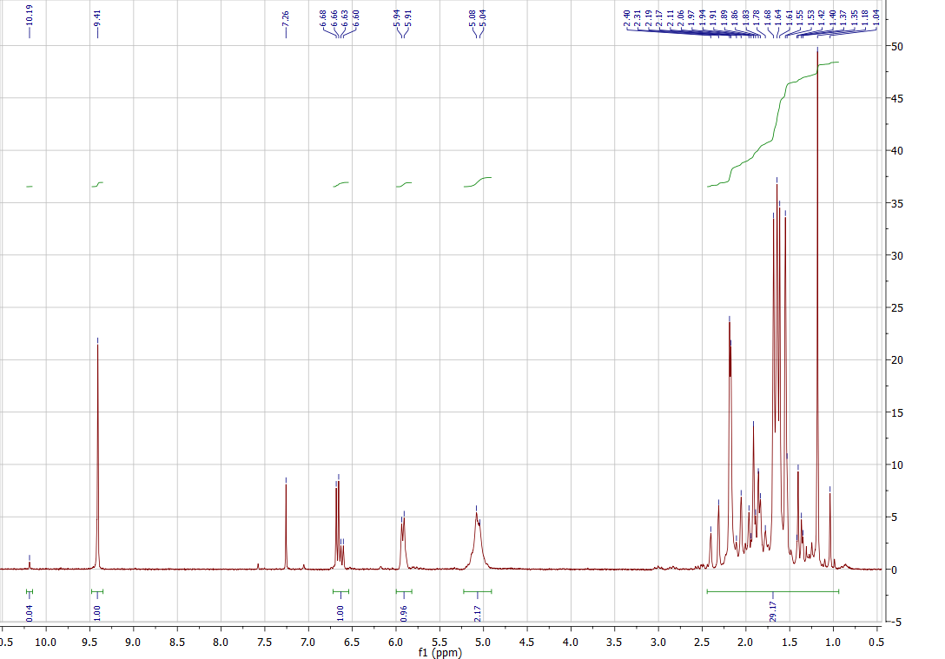

¹H NMR and ¹³C NMR of 4a

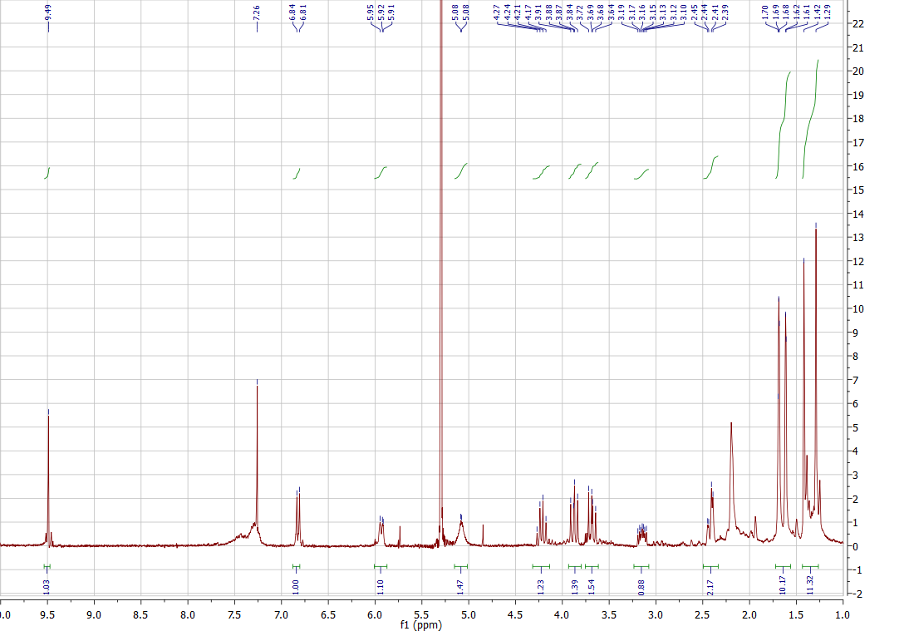

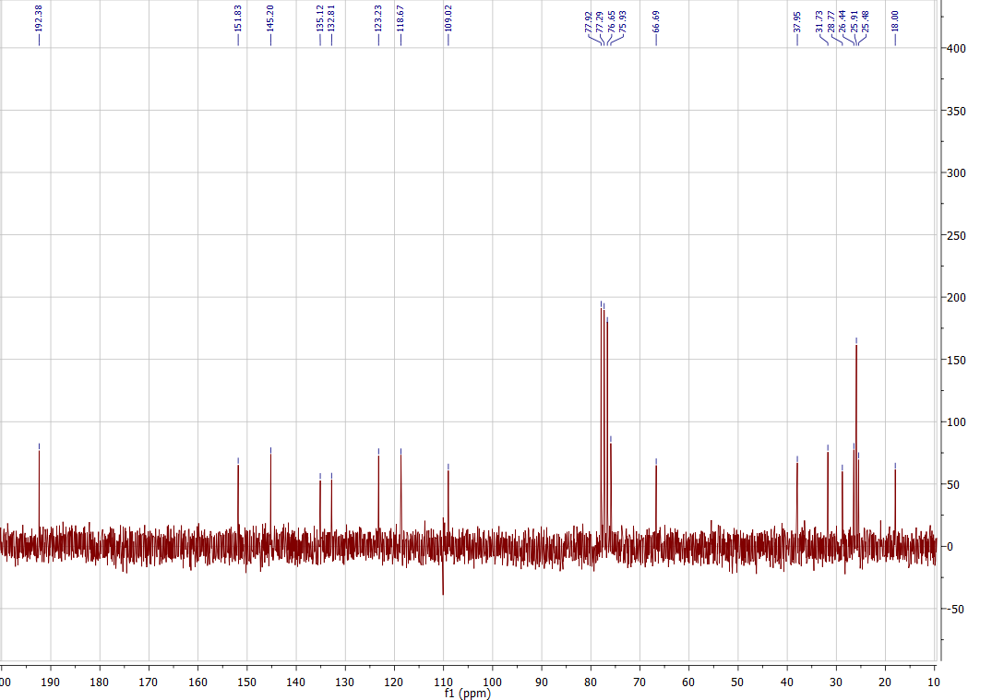

IR of 4a

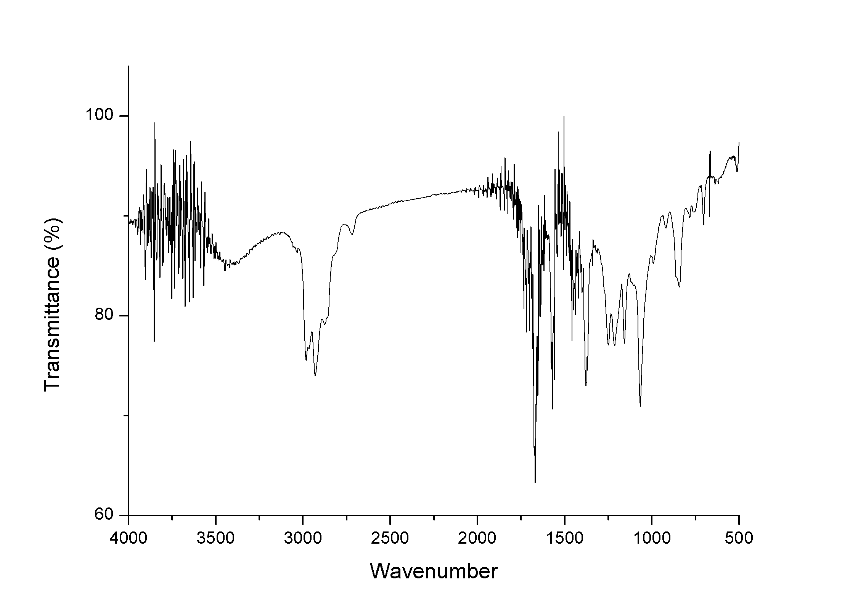

¹H NMR and ¹³C NMR of 4b

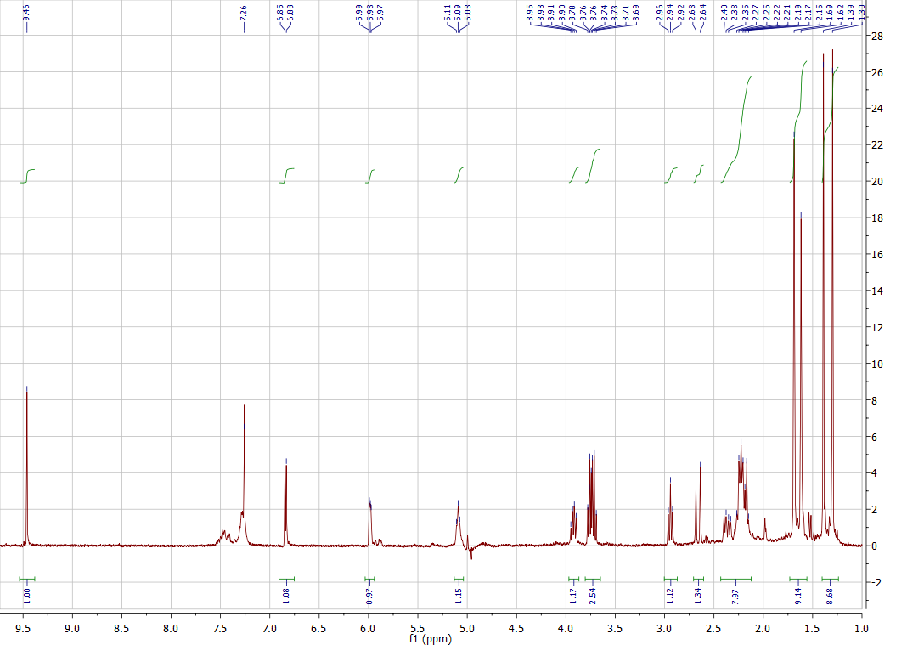

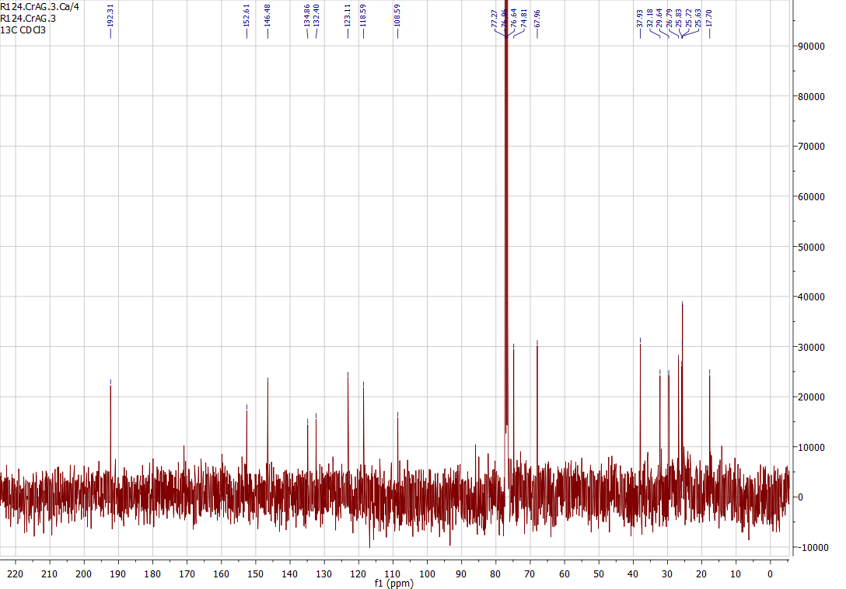

IR of 4b

¹H NMR and ¹³C NMR of 11

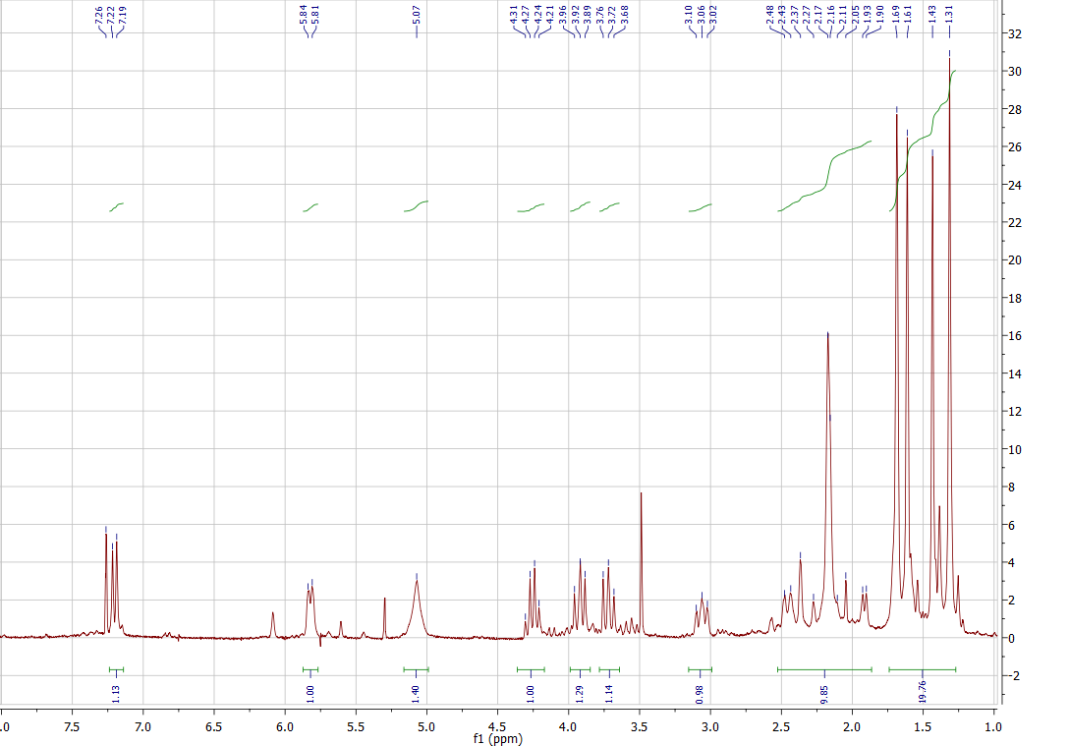

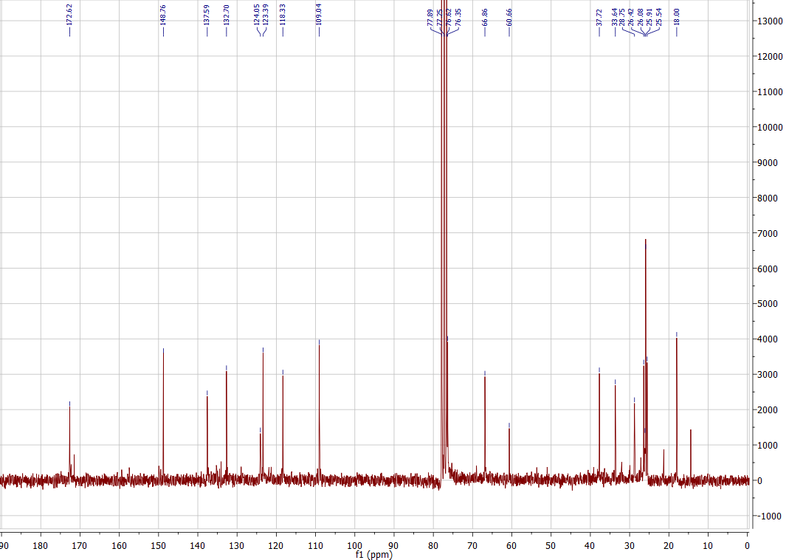

IR of 11

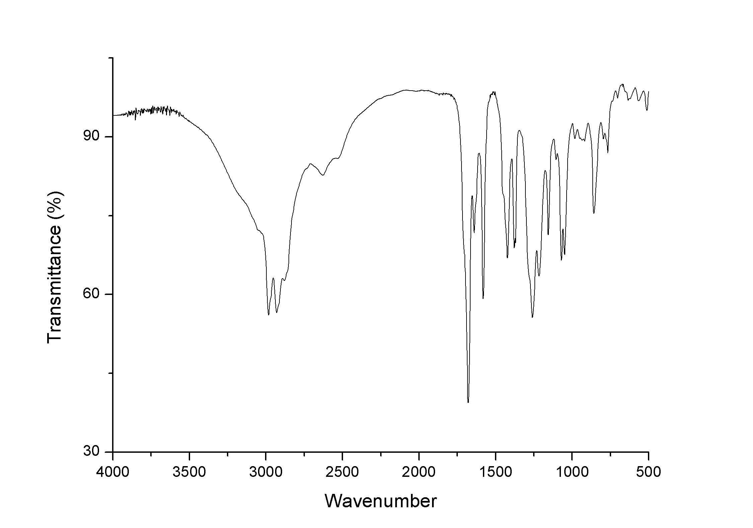

¹H NMR and ¹³C NMR of 12

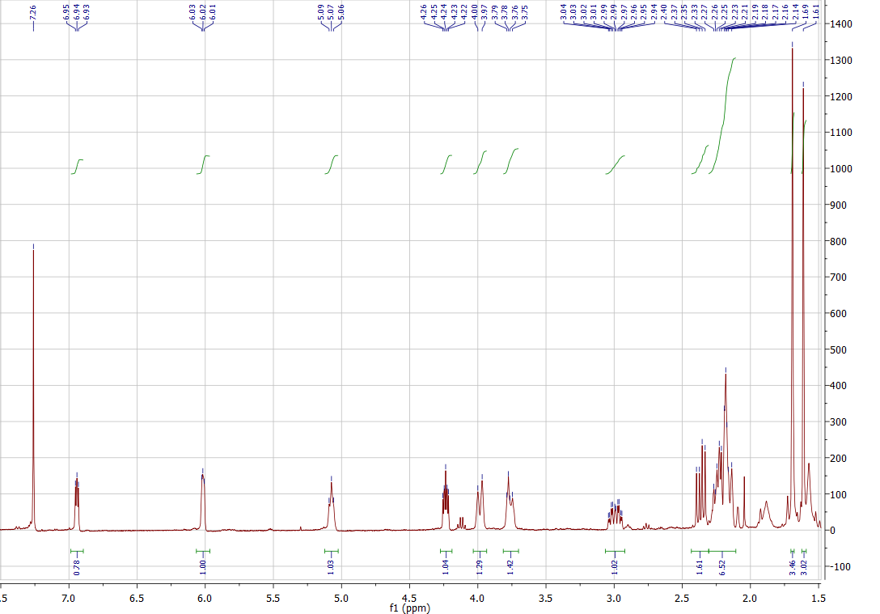

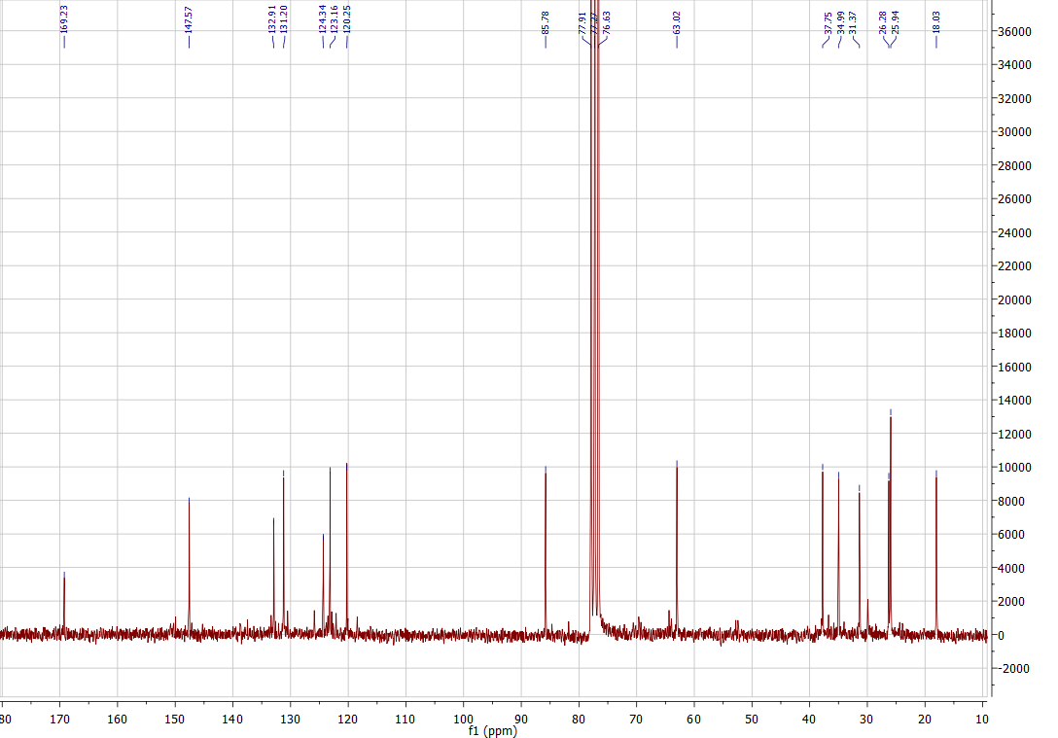

IR of 12

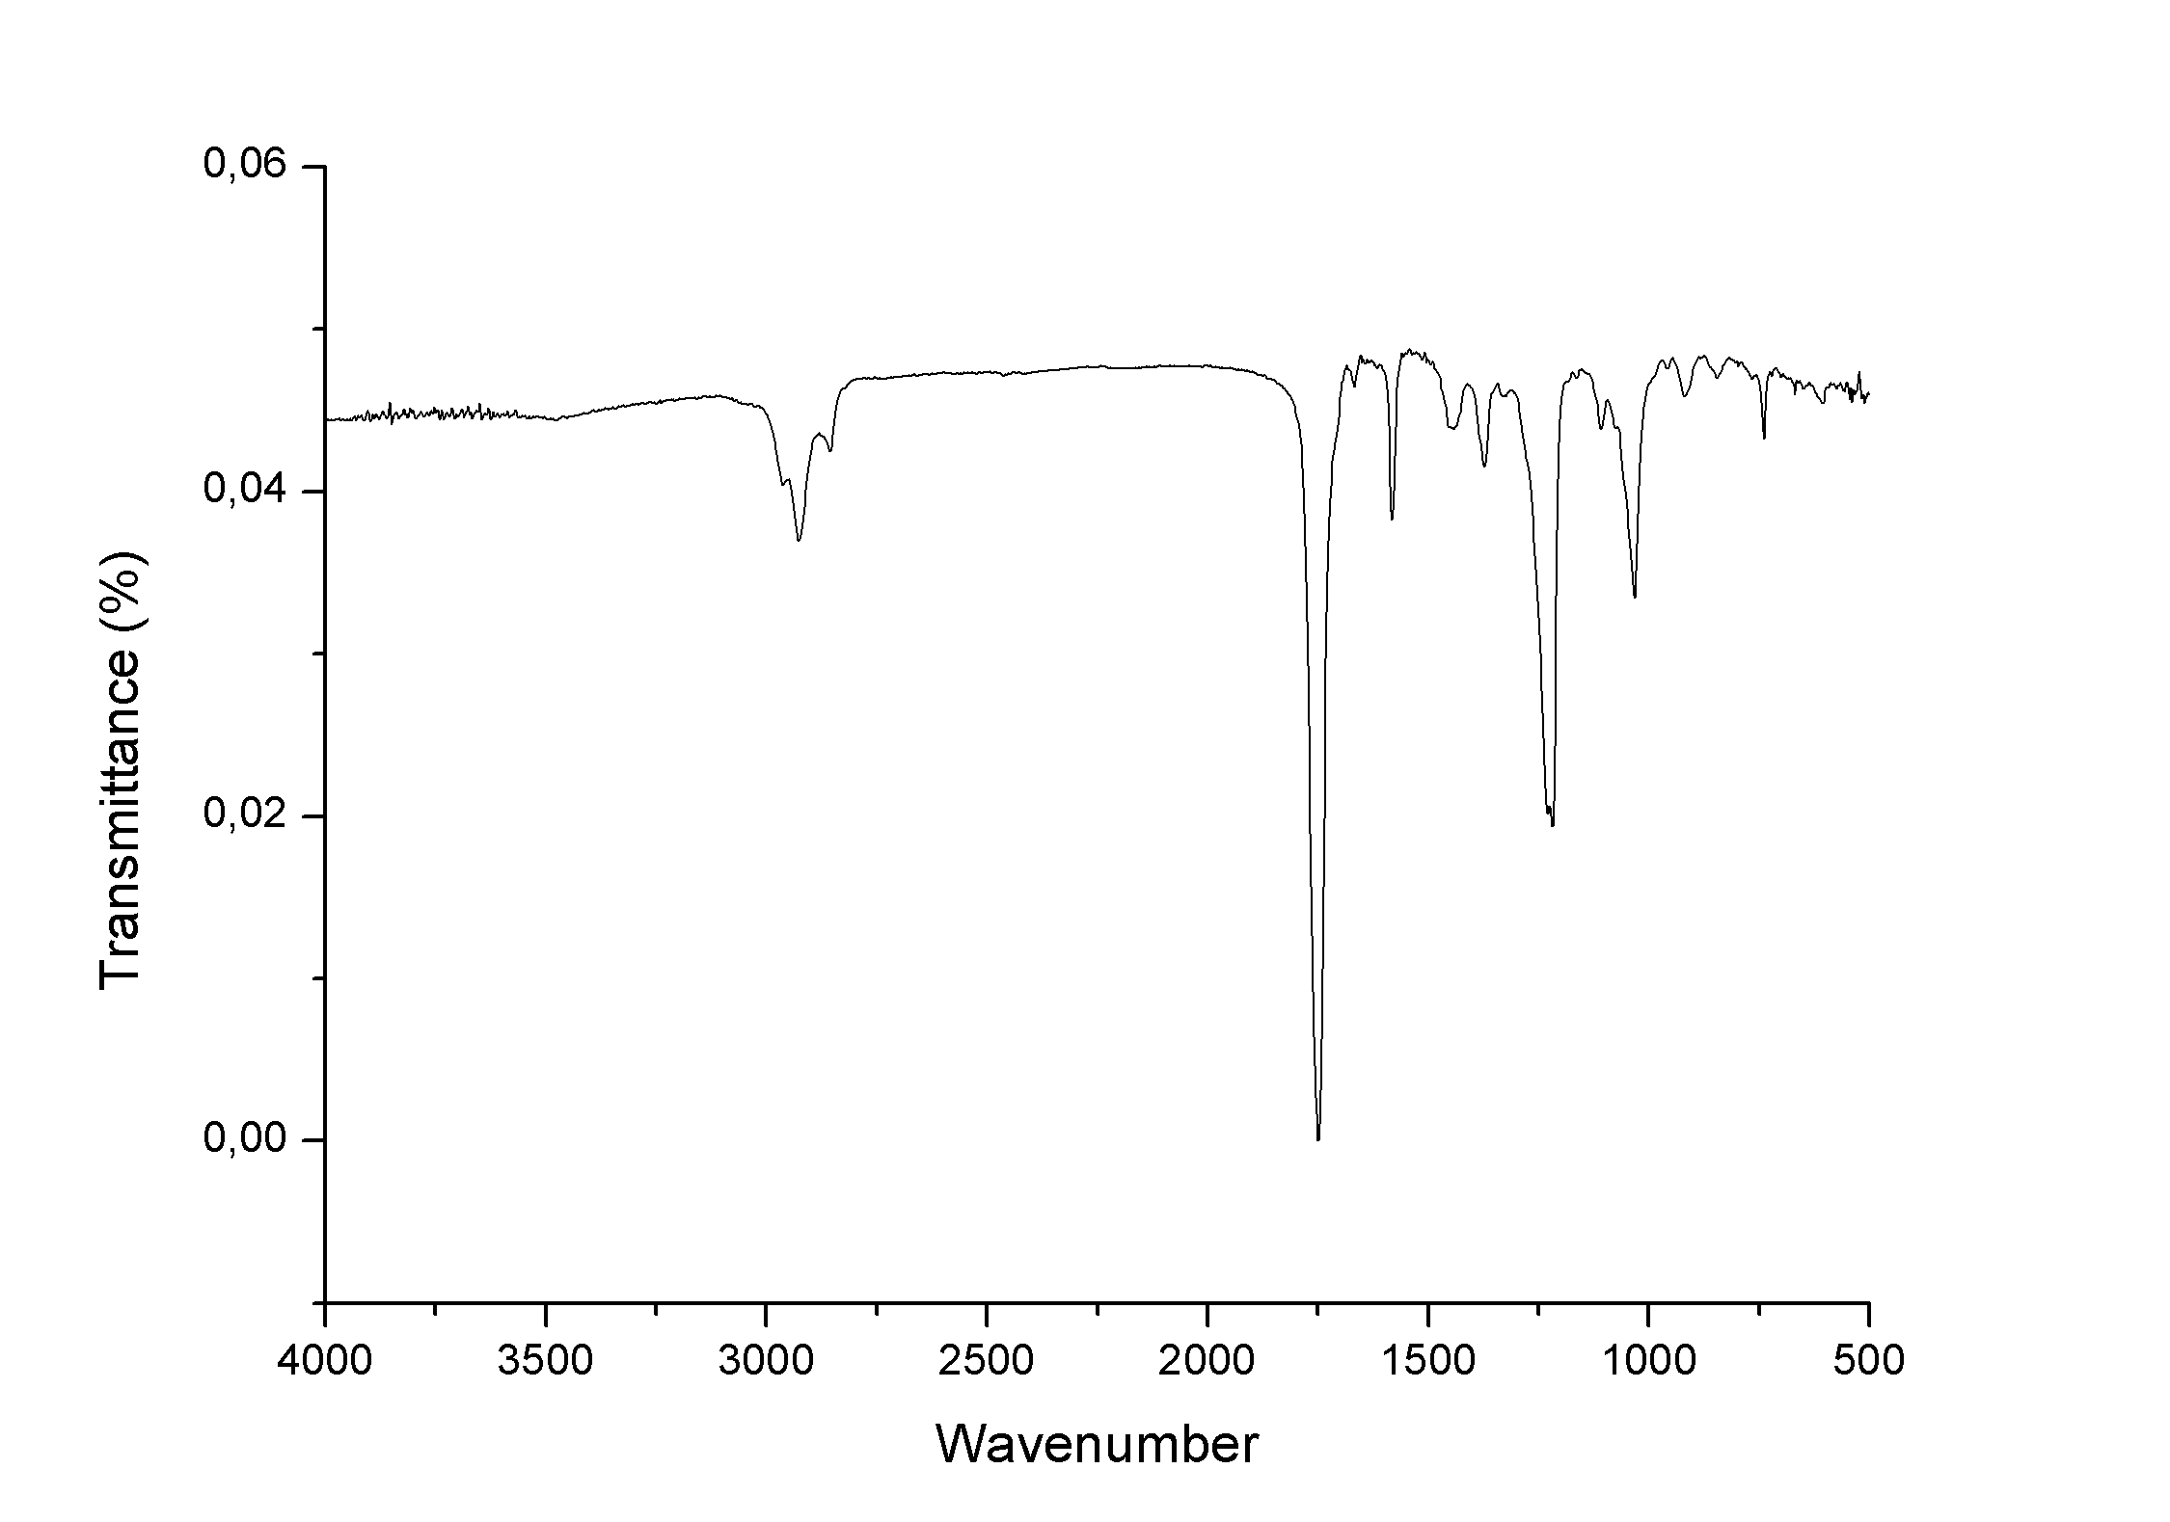

ROESY of 12

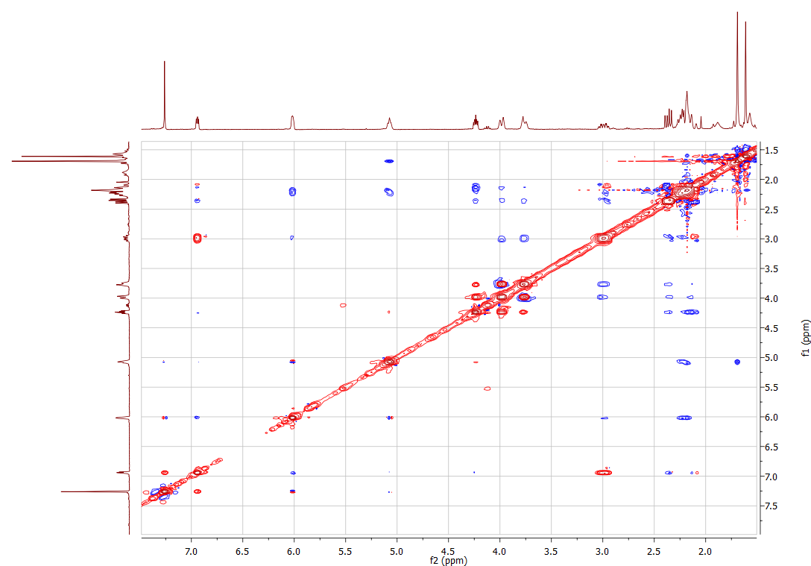

¹H NMR of 14a

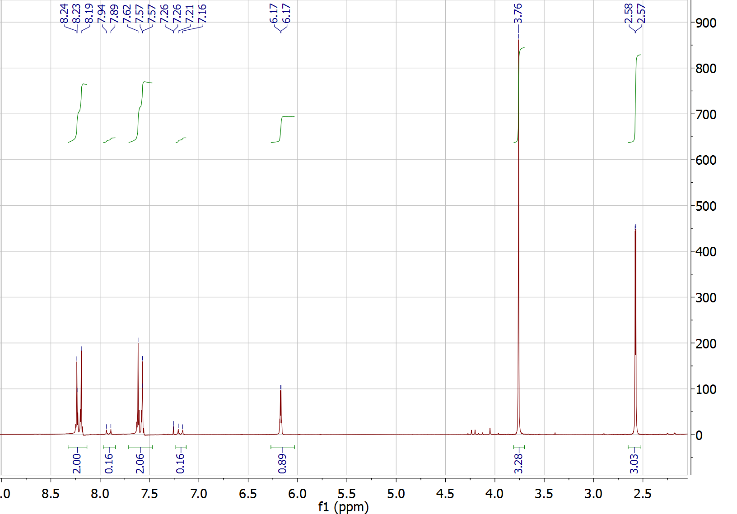

¹H NMR of 14b

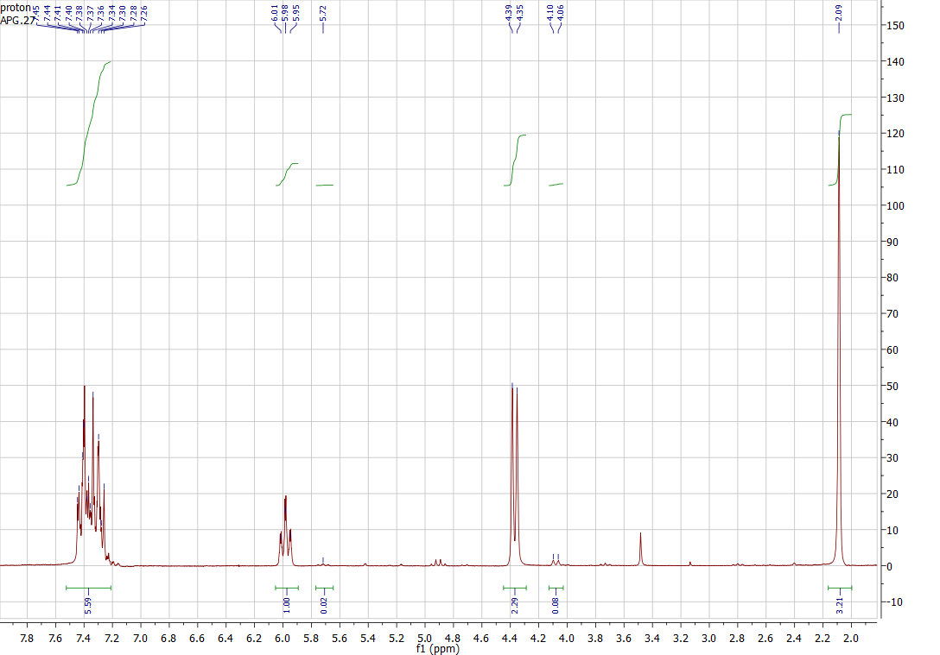

¹H NMR of 14

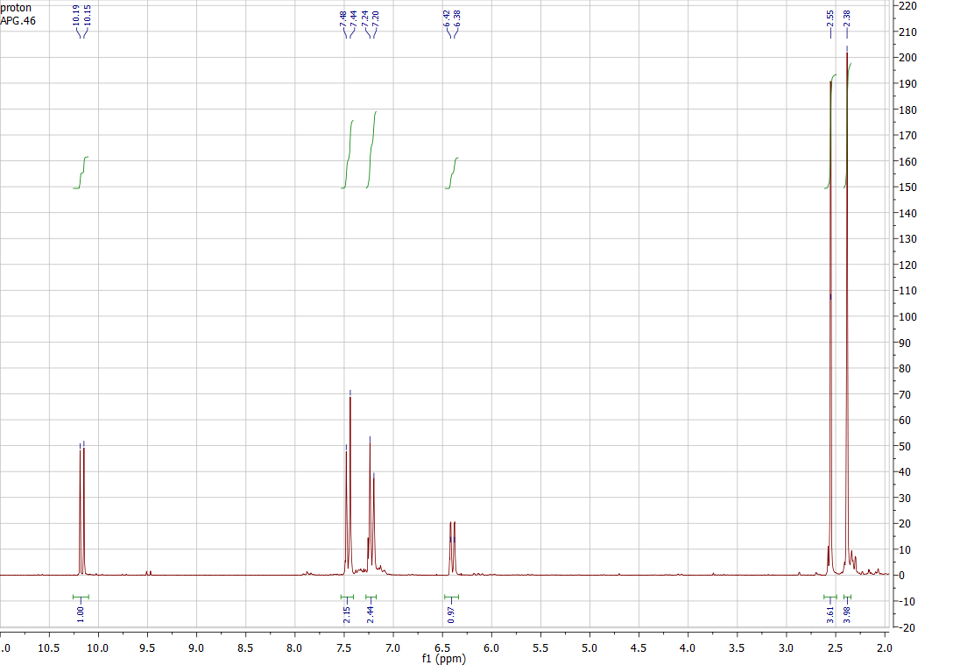

¹H NMR of 15a

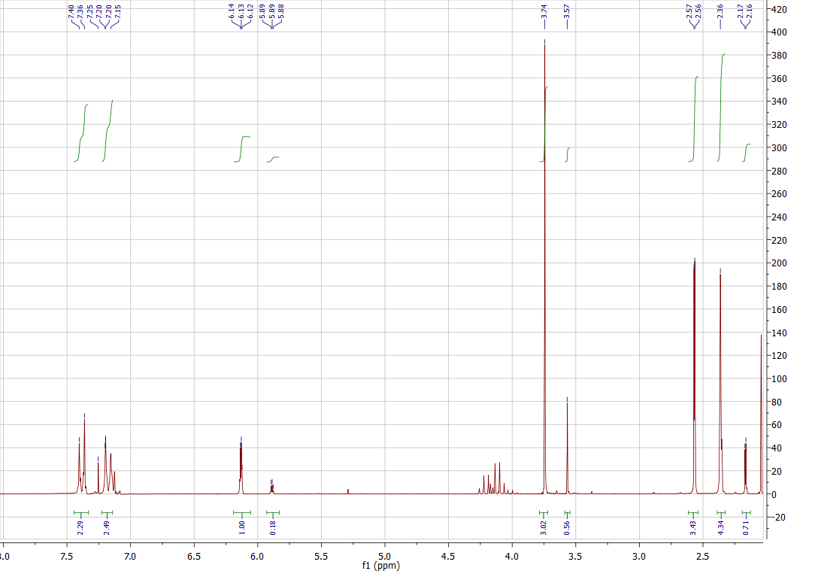

¹H NMR of 15b

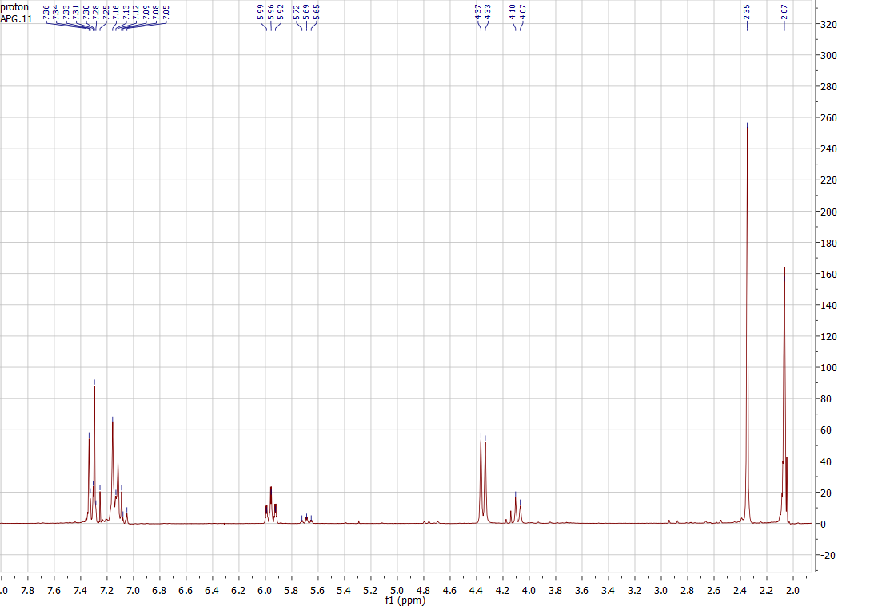

¹H NMR of 15

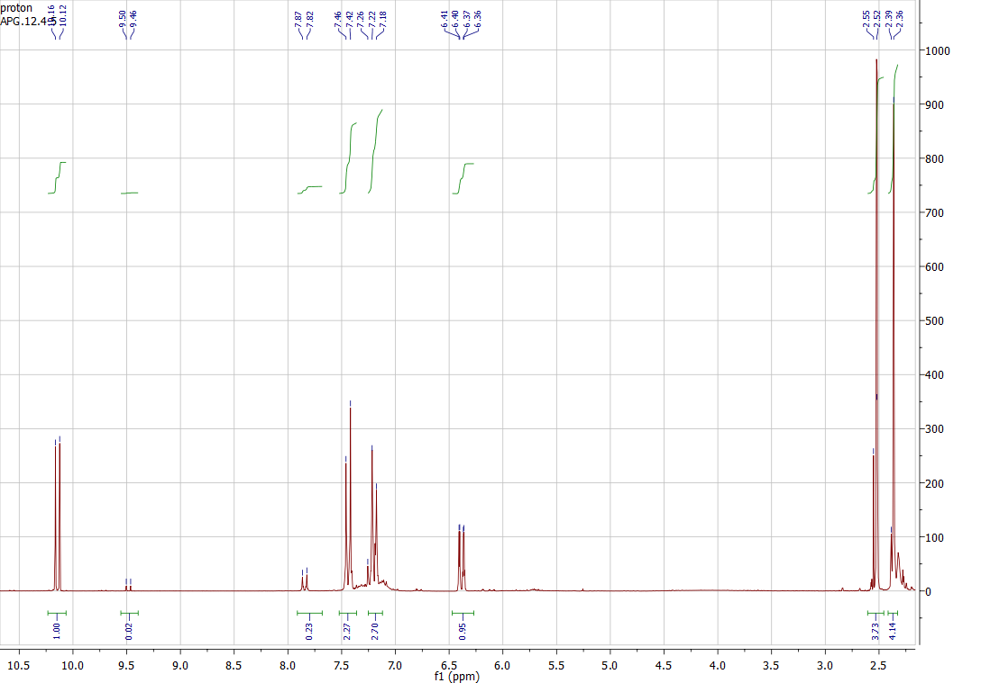

¹H NMR of 16a

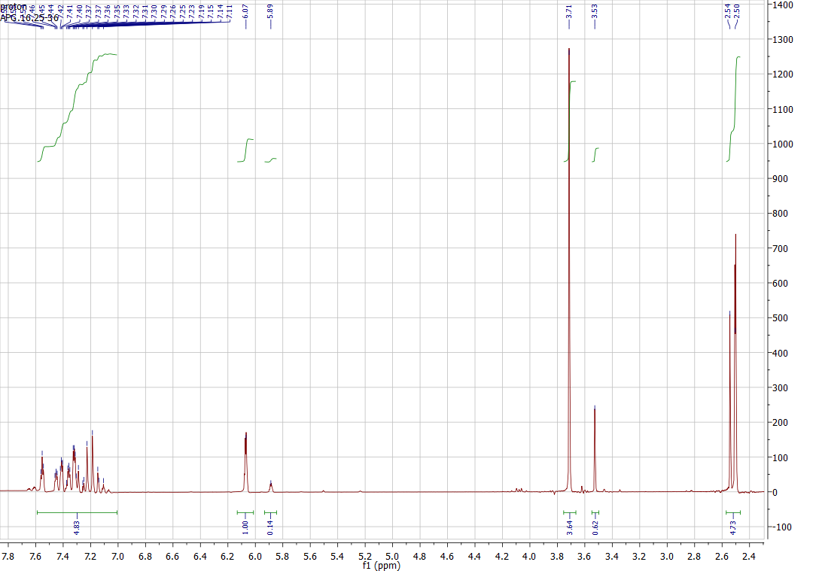

¹H NMR of 16b

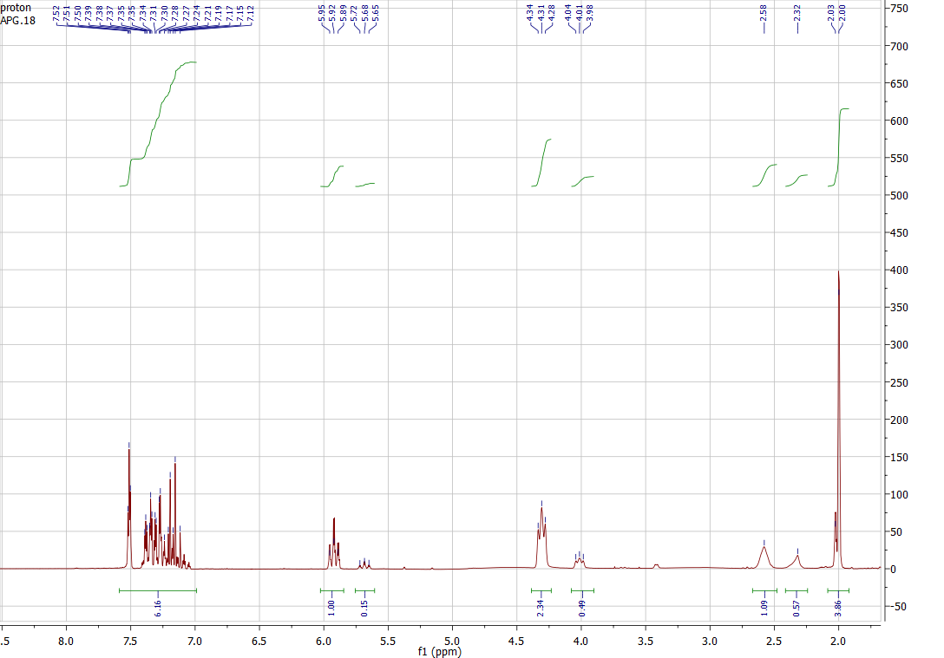

¹H NMR of 16

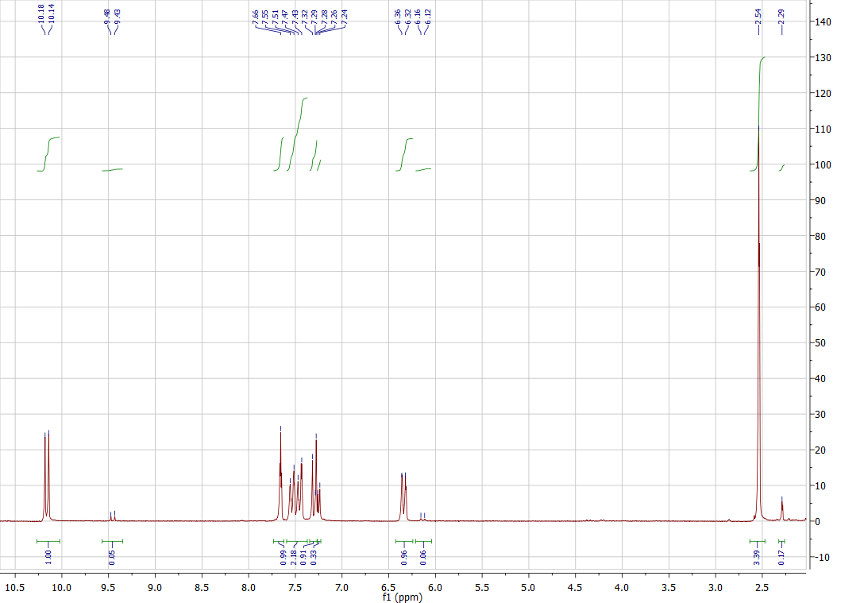

¹H NMR of 17a

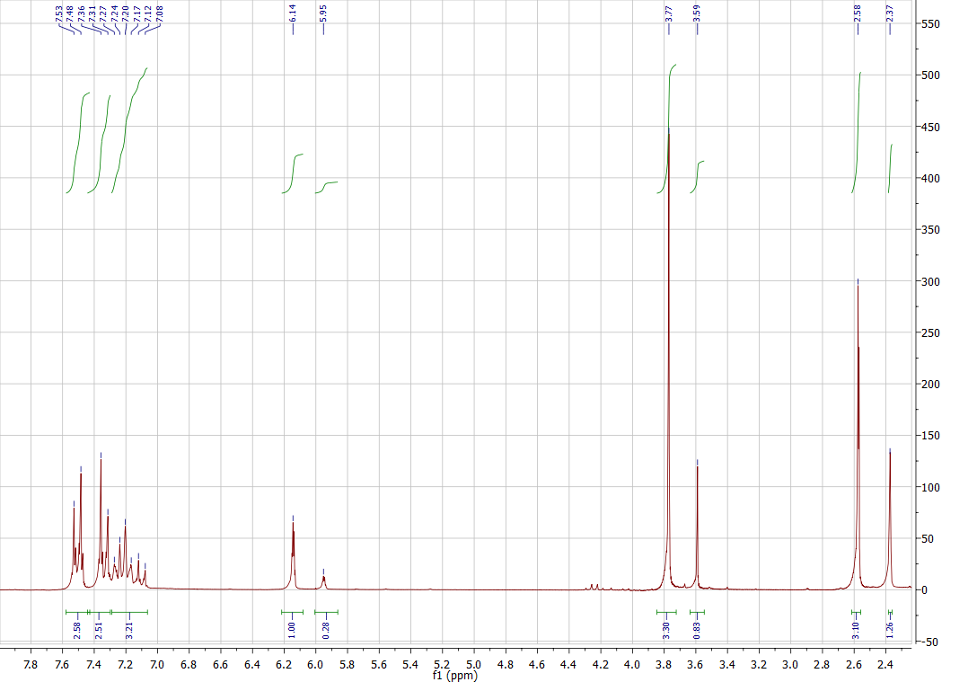

¹H NMR of 17b

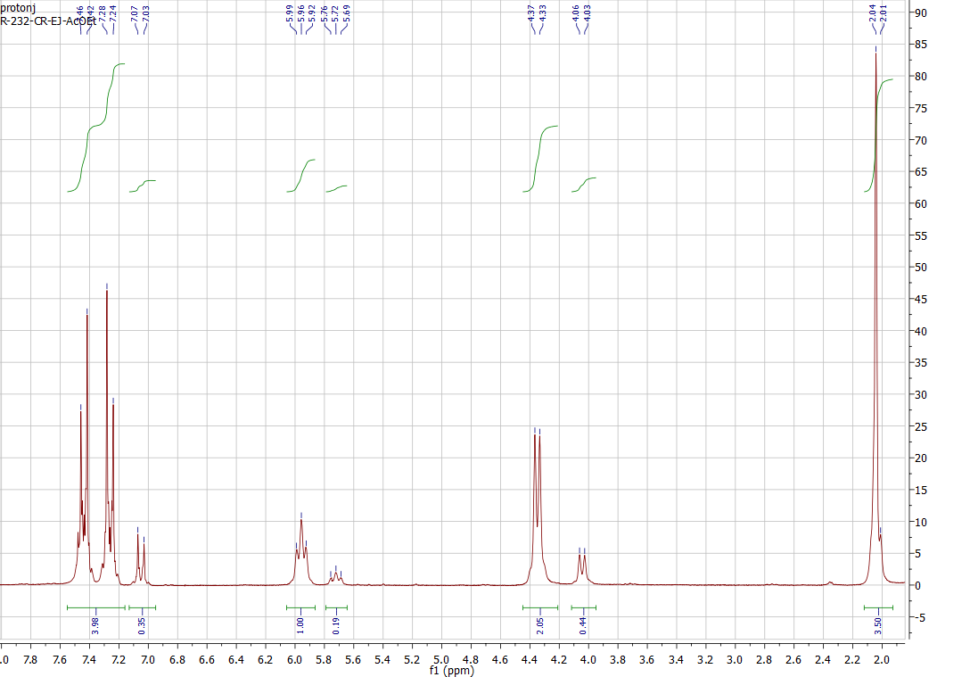

¹H NMR of 17

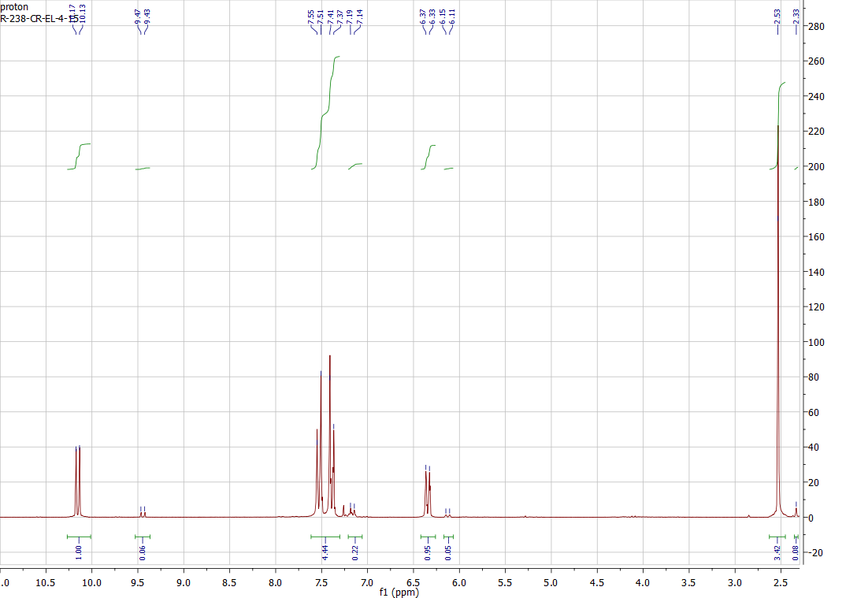

¹H NMR of 18a

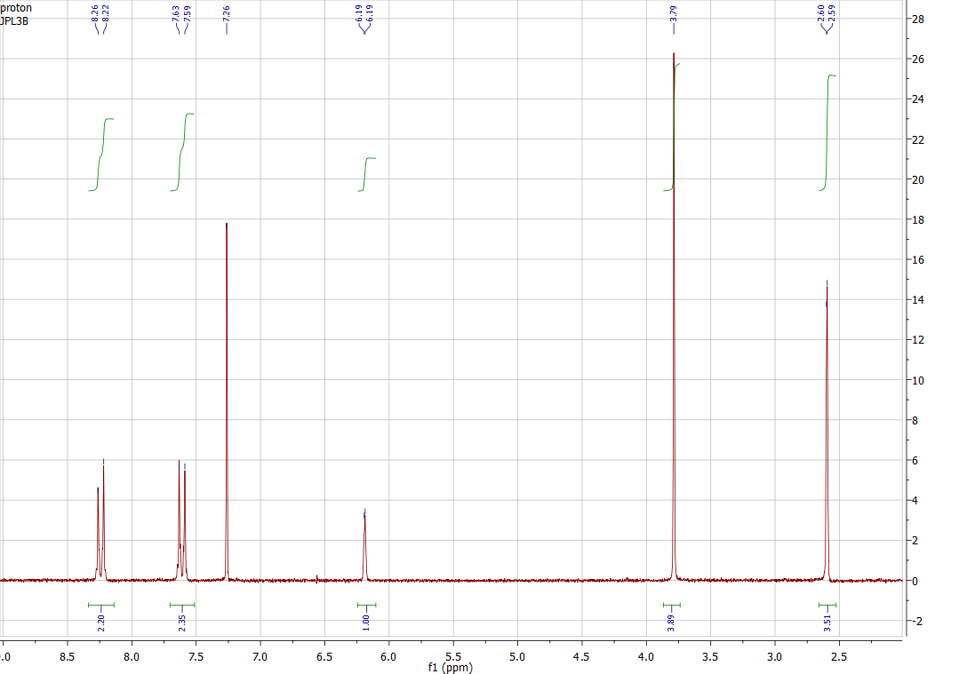

¹H NMR of 18b

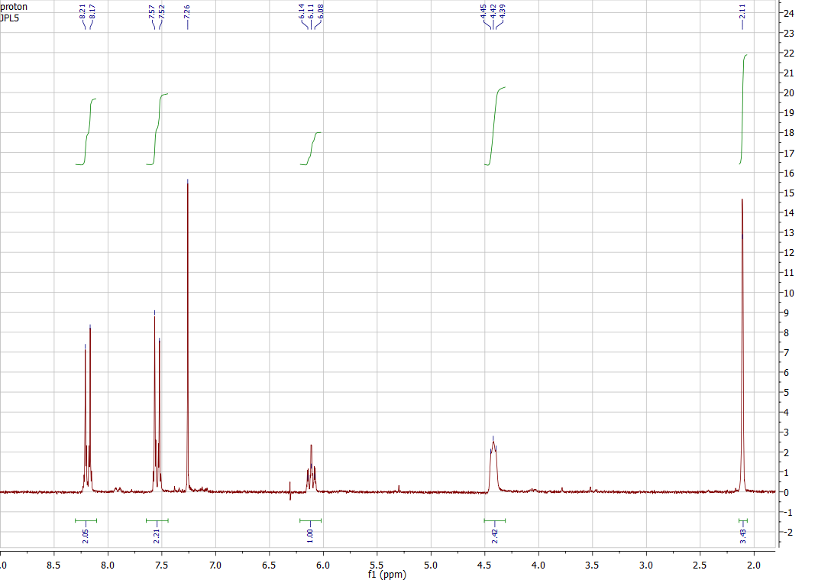

¹H NMR of 18

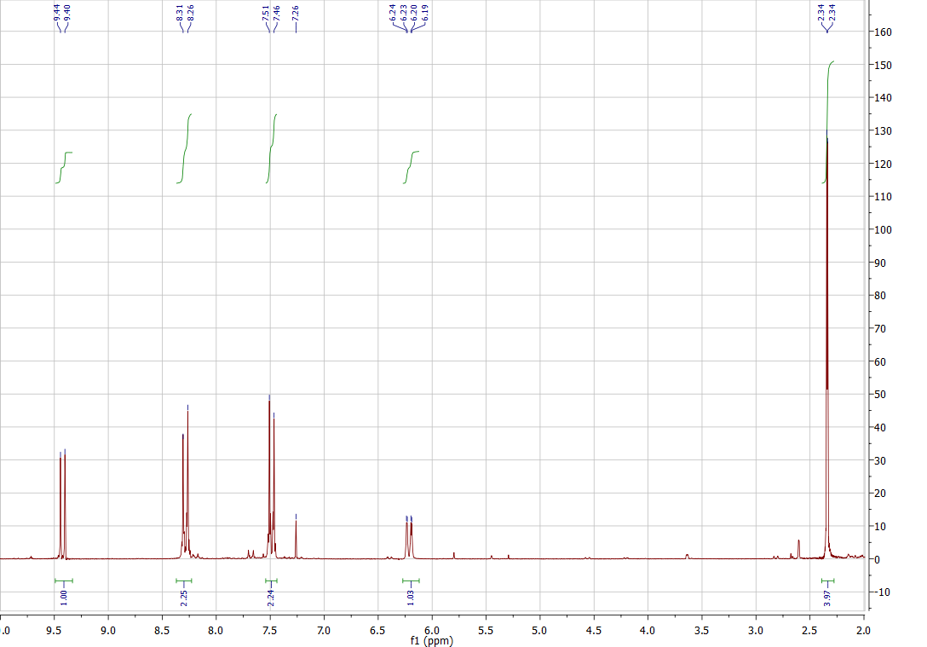

¹H NMR of 19a

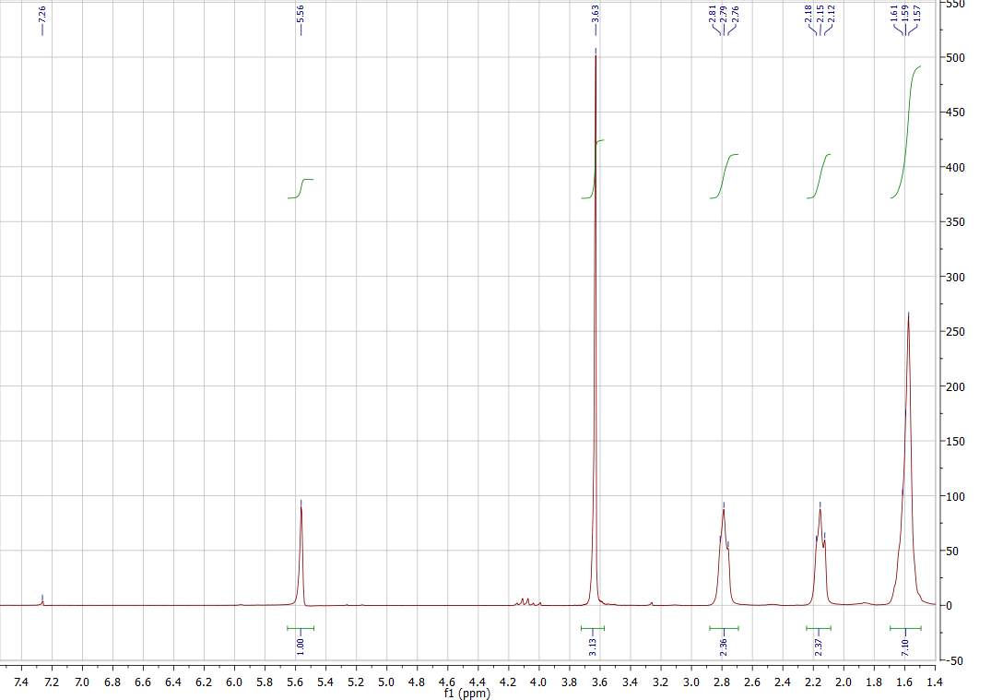

¹H NMR of 19b

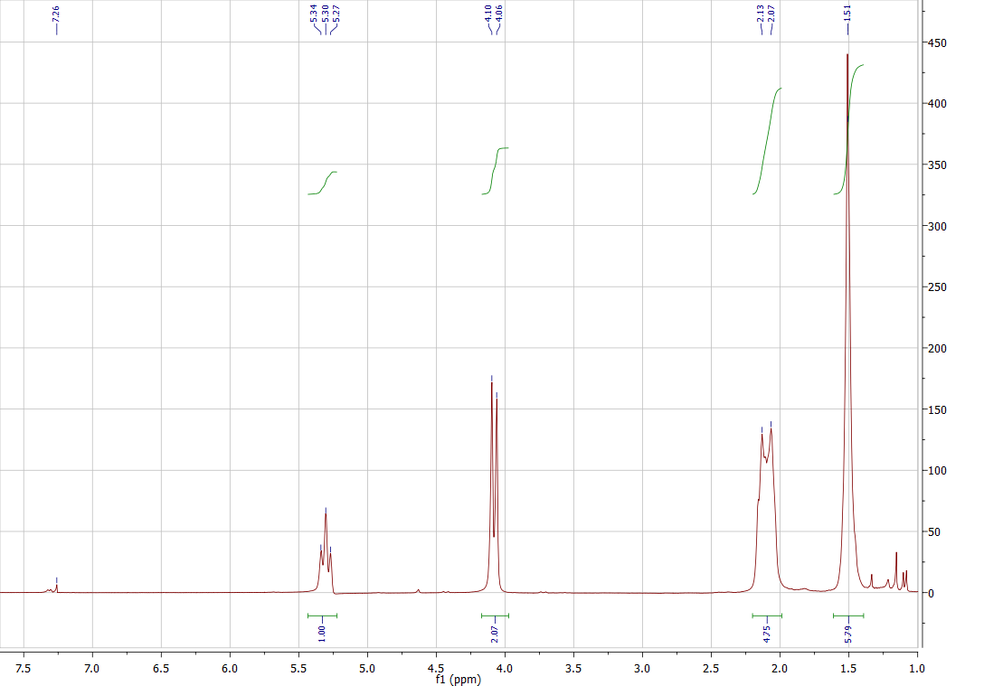

¹H NMR of 19

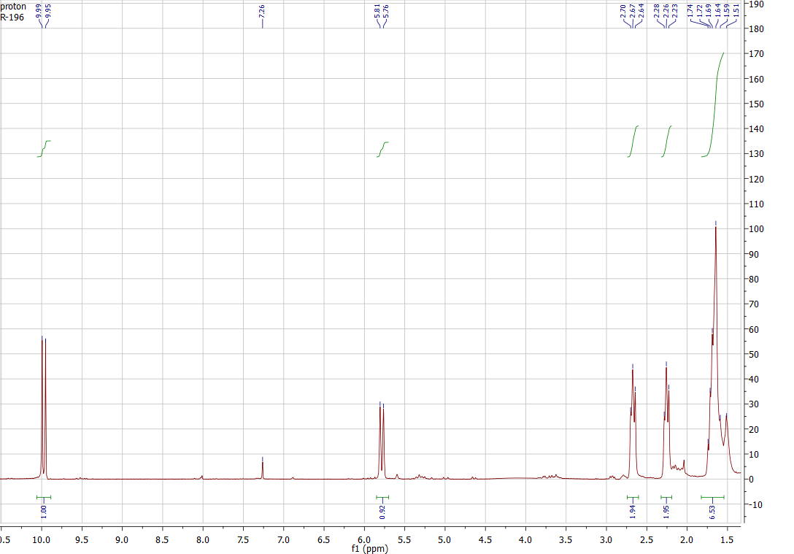

¹H NMR and ¹³C NMR of 20a

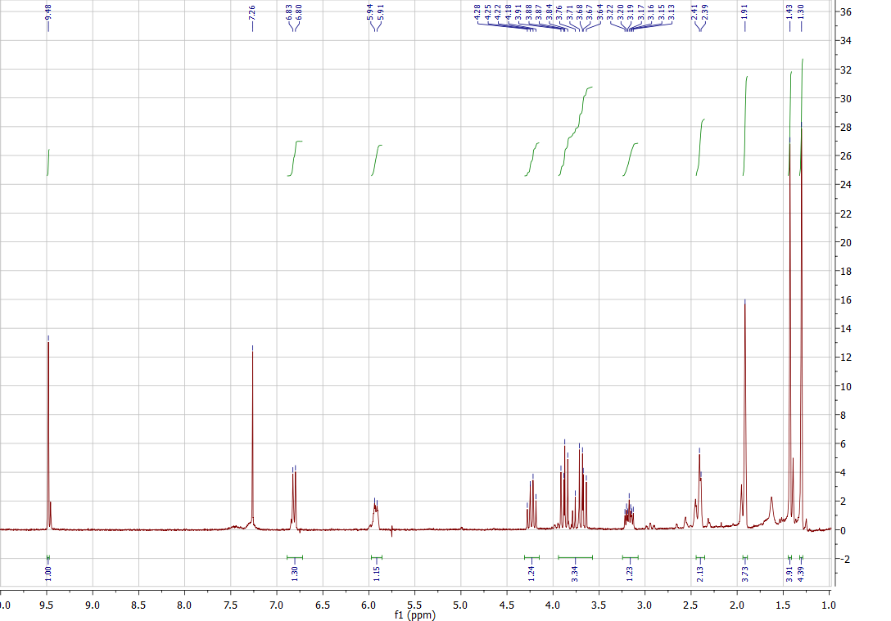

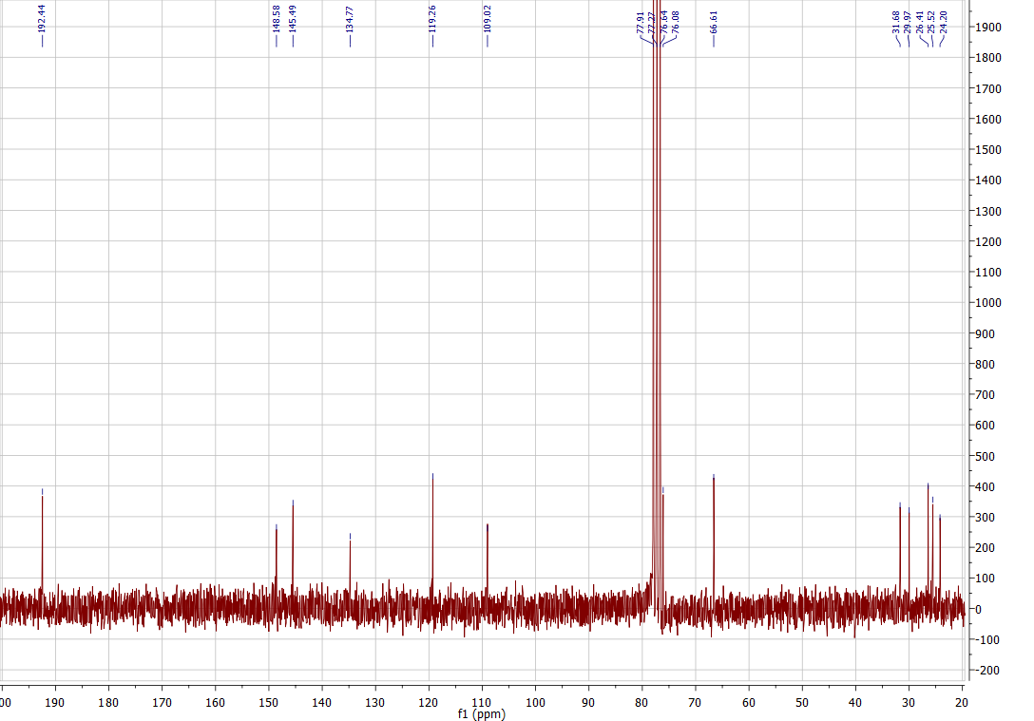

IR of 20a

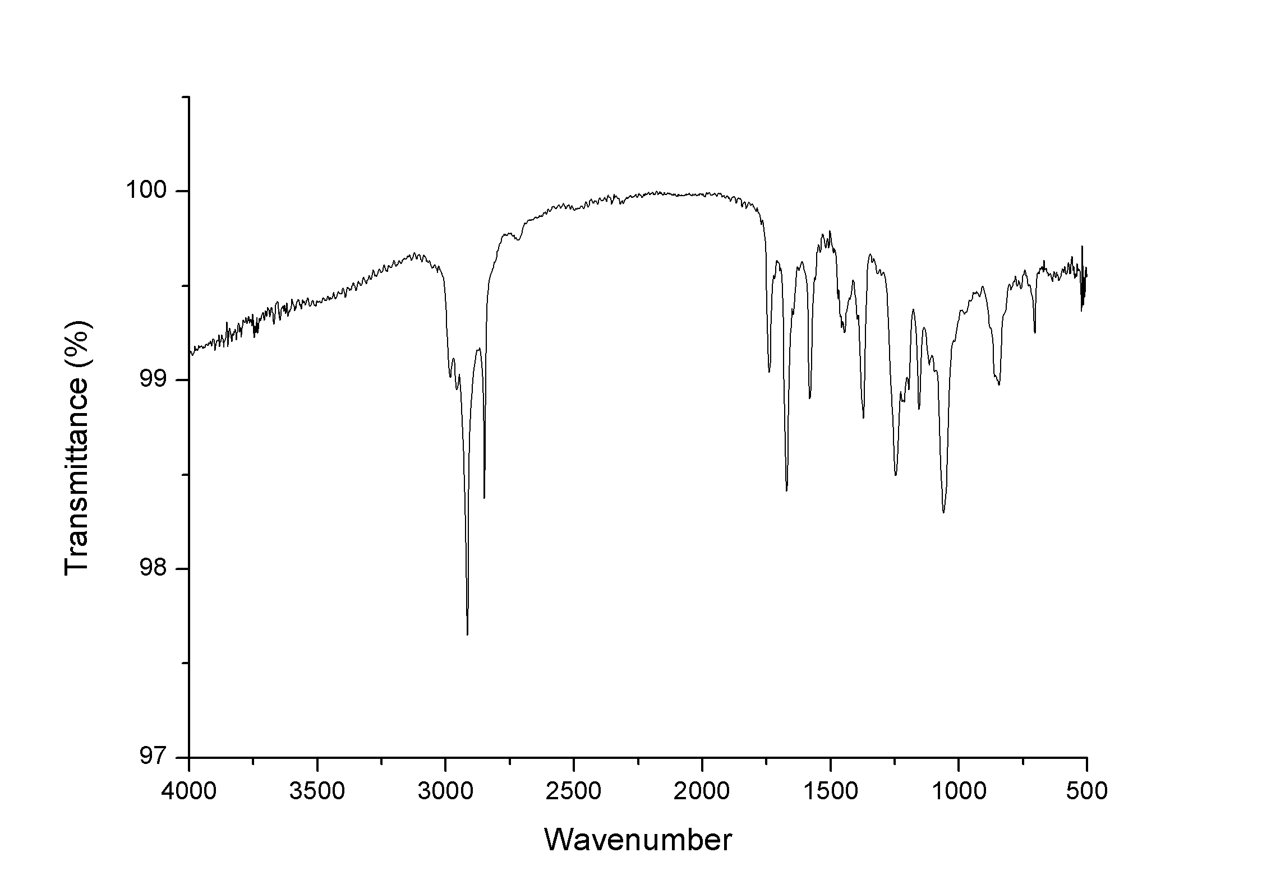

¹H NMR and ¹³C NMR of 20b

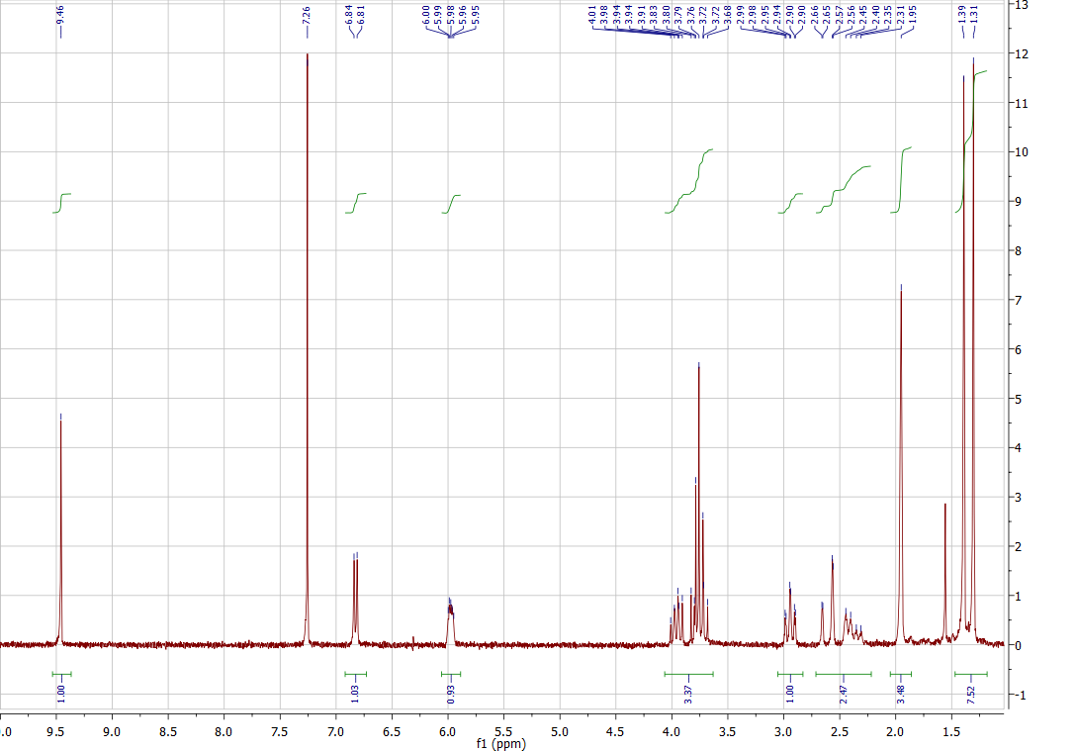

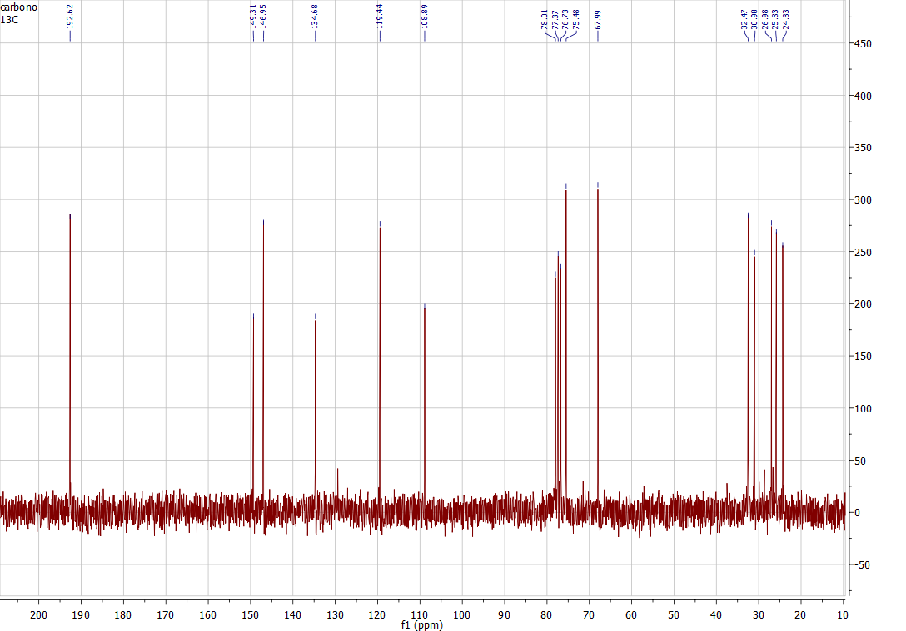

IR of 20b

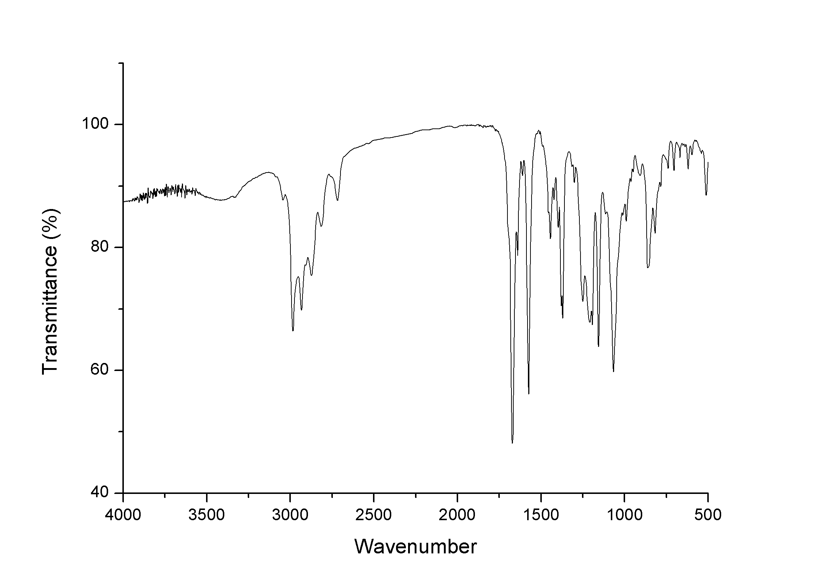

¹H NMR and ¹³C NMR of 21a

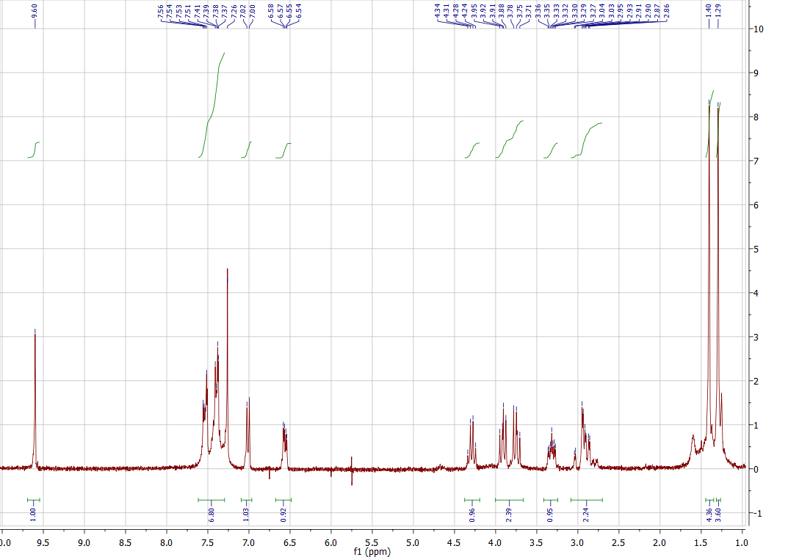

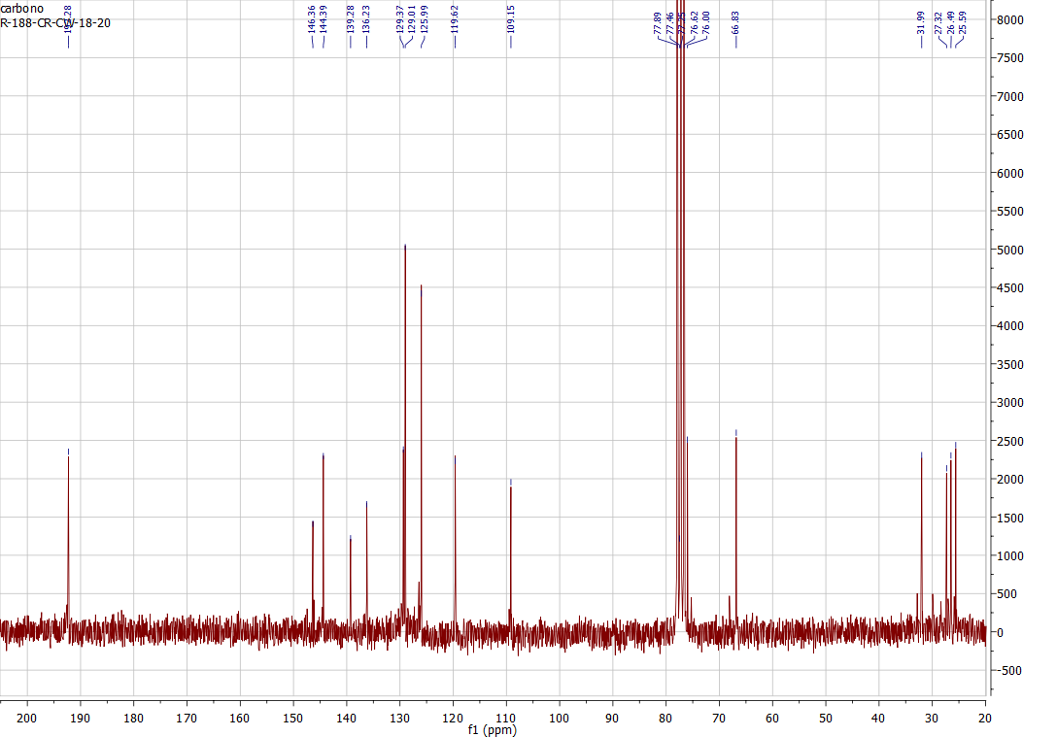

IR of 21a

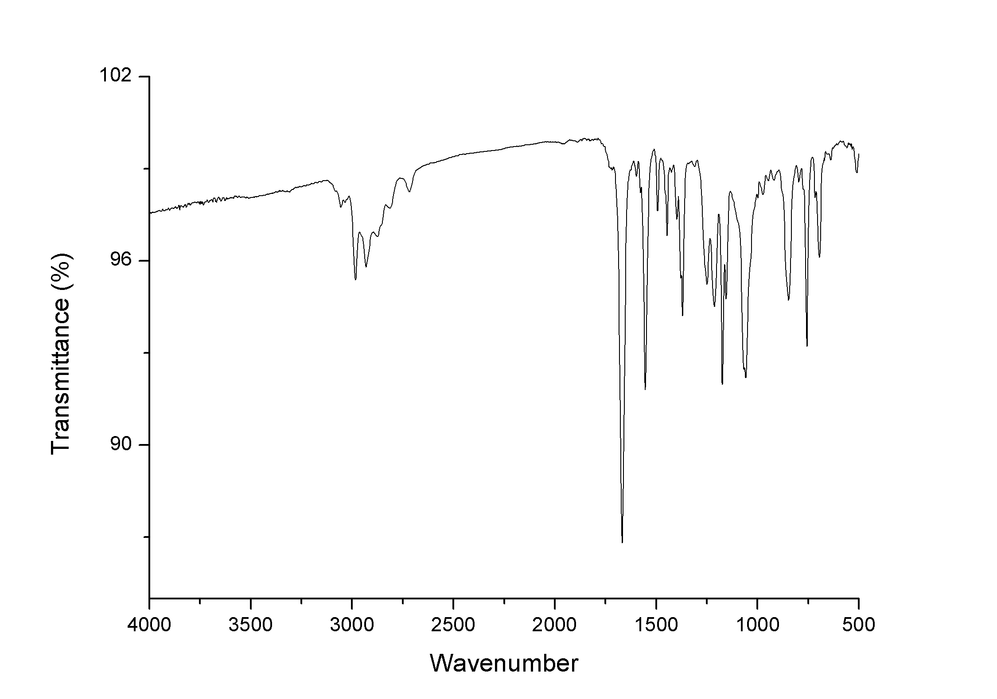

¹H NMR and ¹³C NMR of 21b

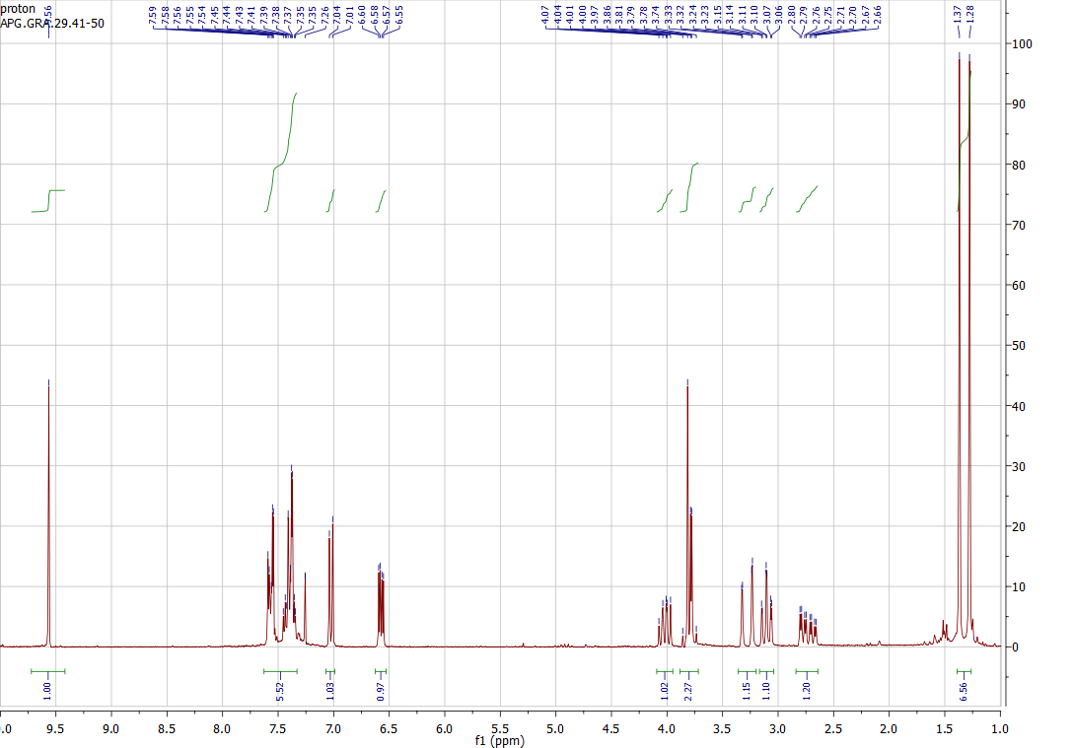

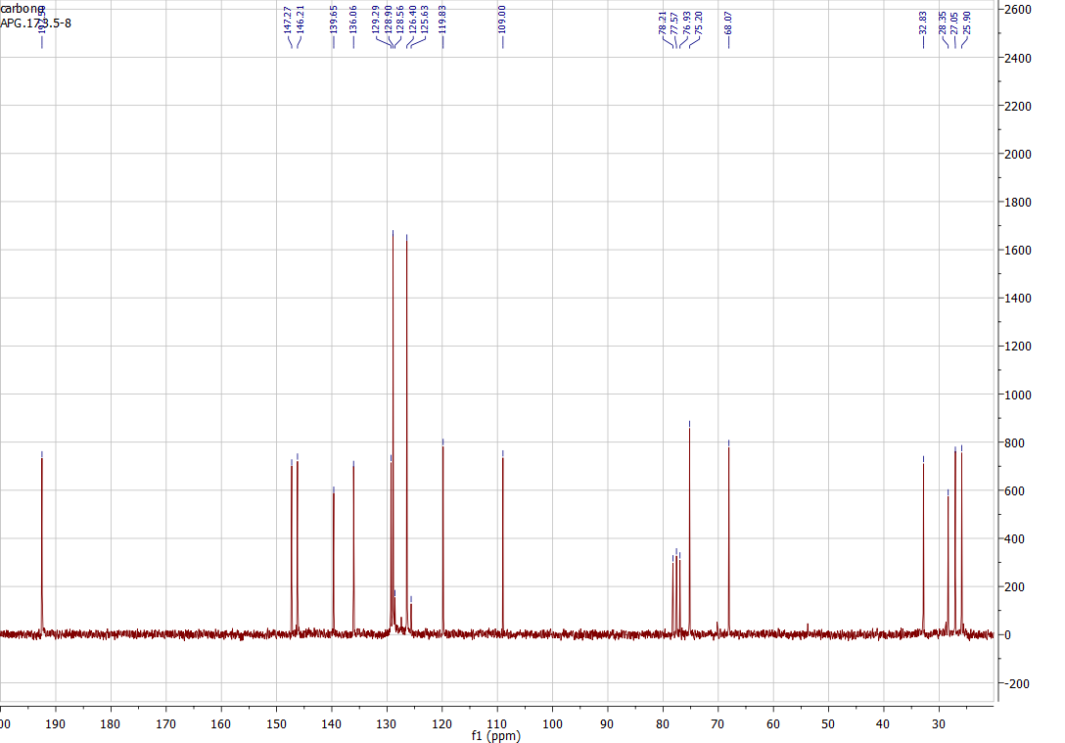

IR of 21b

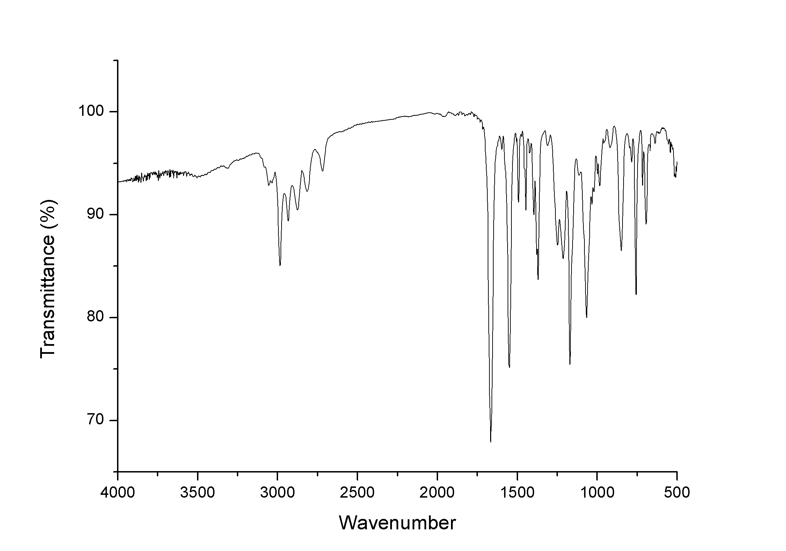

¹H NMR and ¹³C NMR of 22a

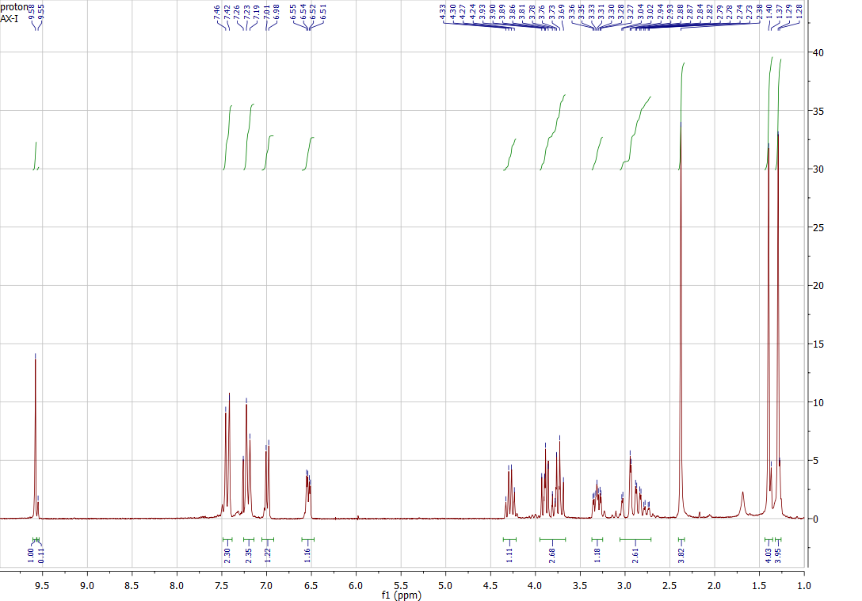

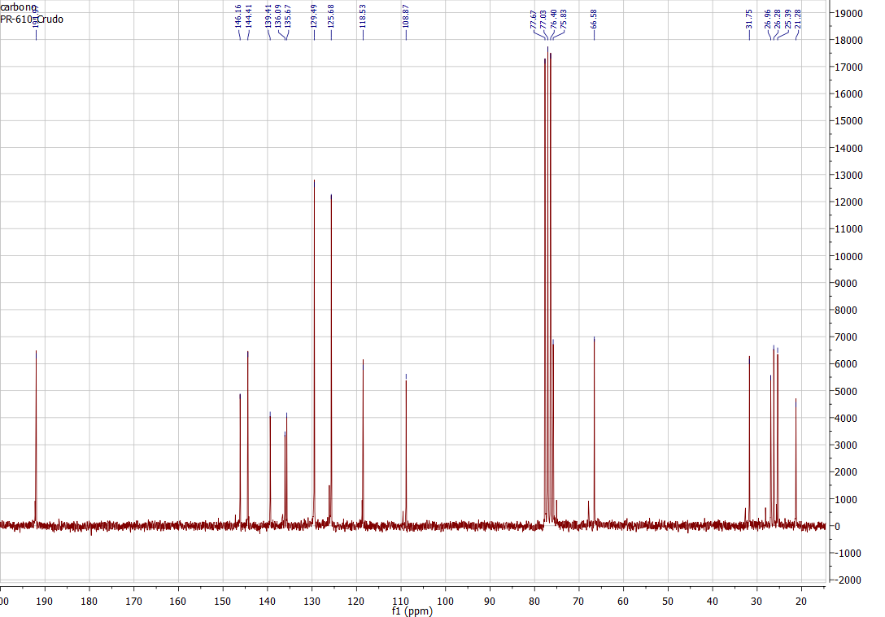

IR of 22a

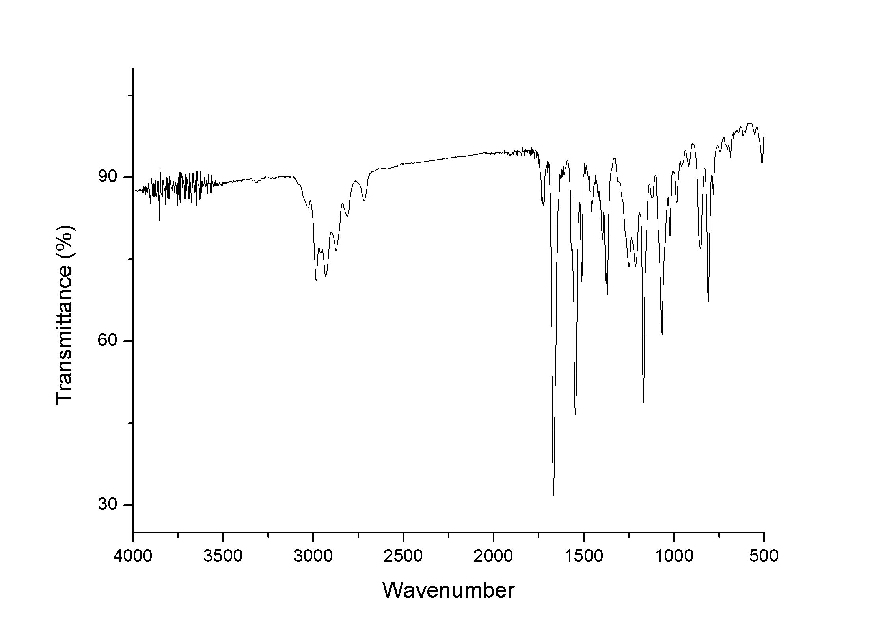

¹H NMR and ¹³C NMR of 22b

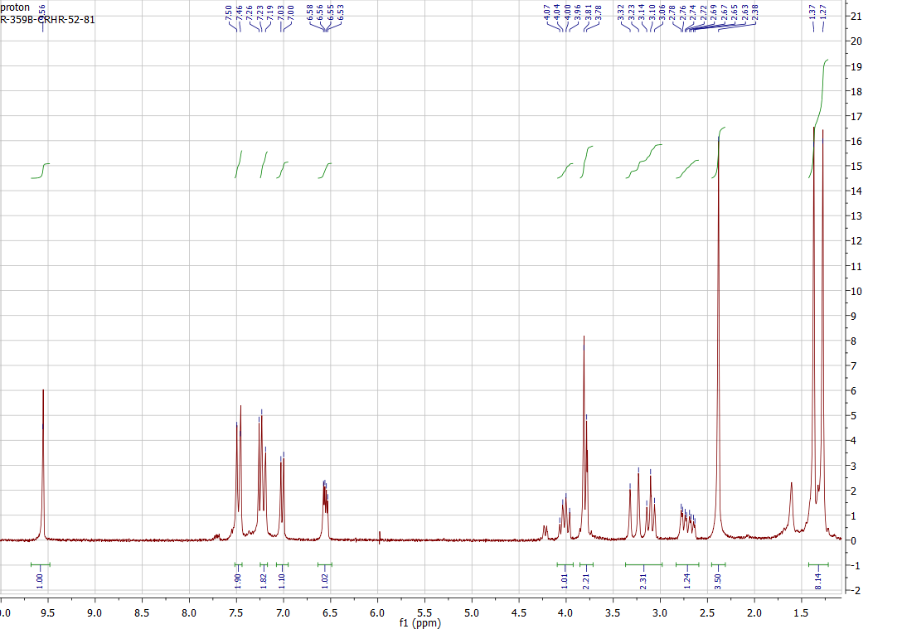

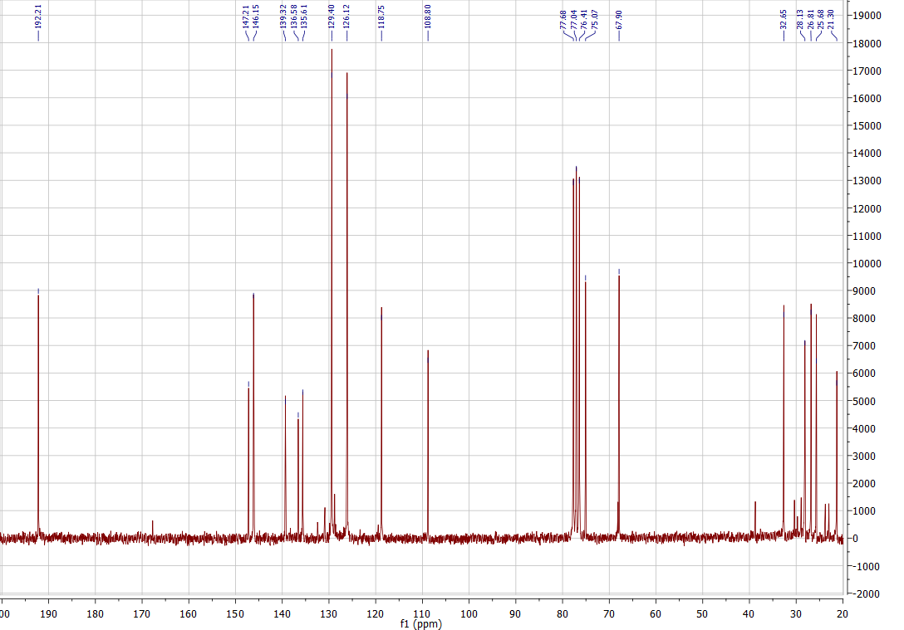

IR of 22b

¹H NMR and ¹³C NMR of 23a

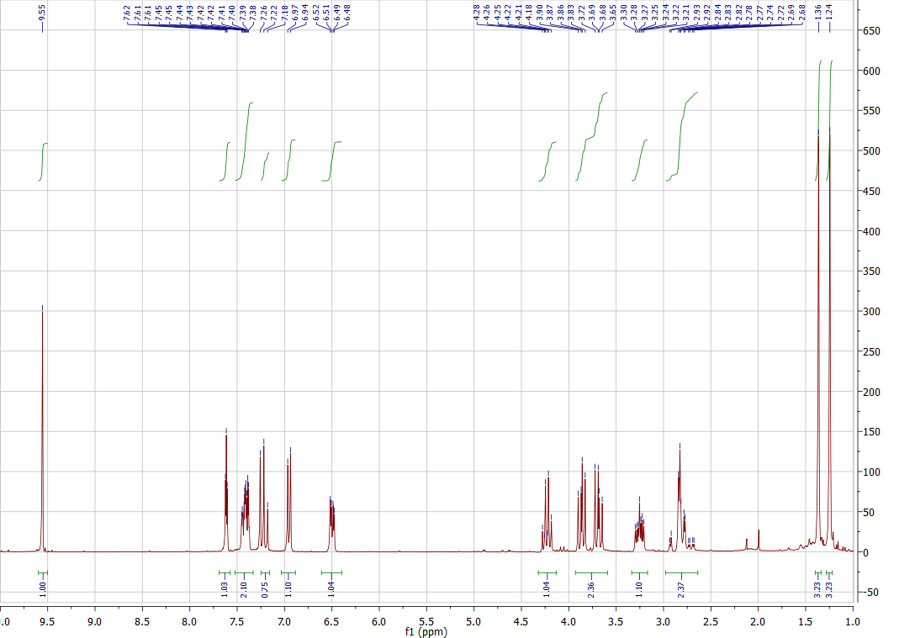

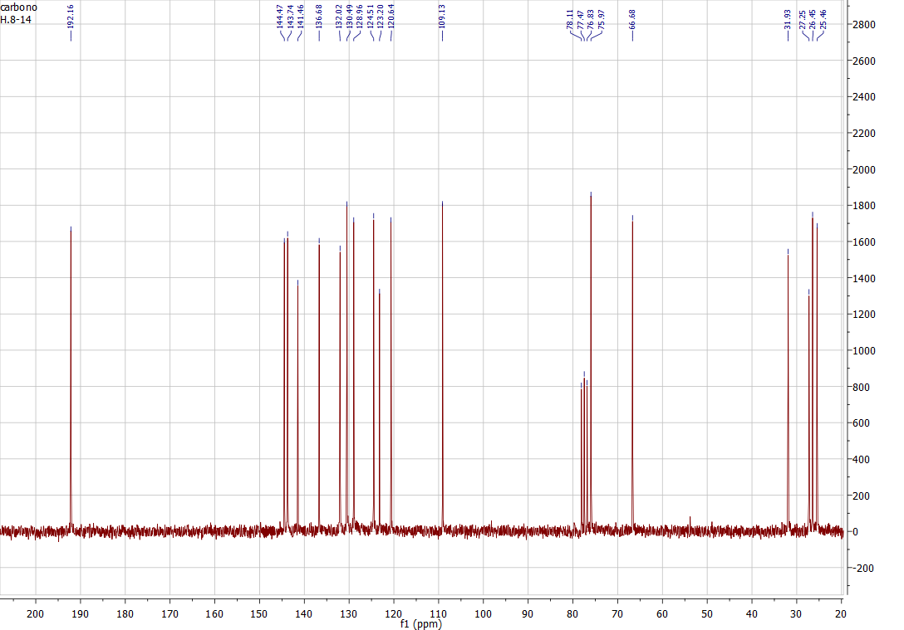

IR of 23a

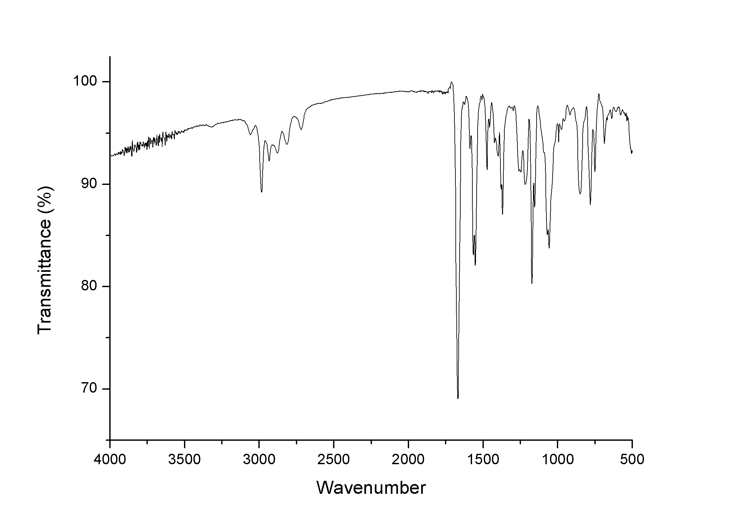

¹H NMR and ¹³C of NMR 23b

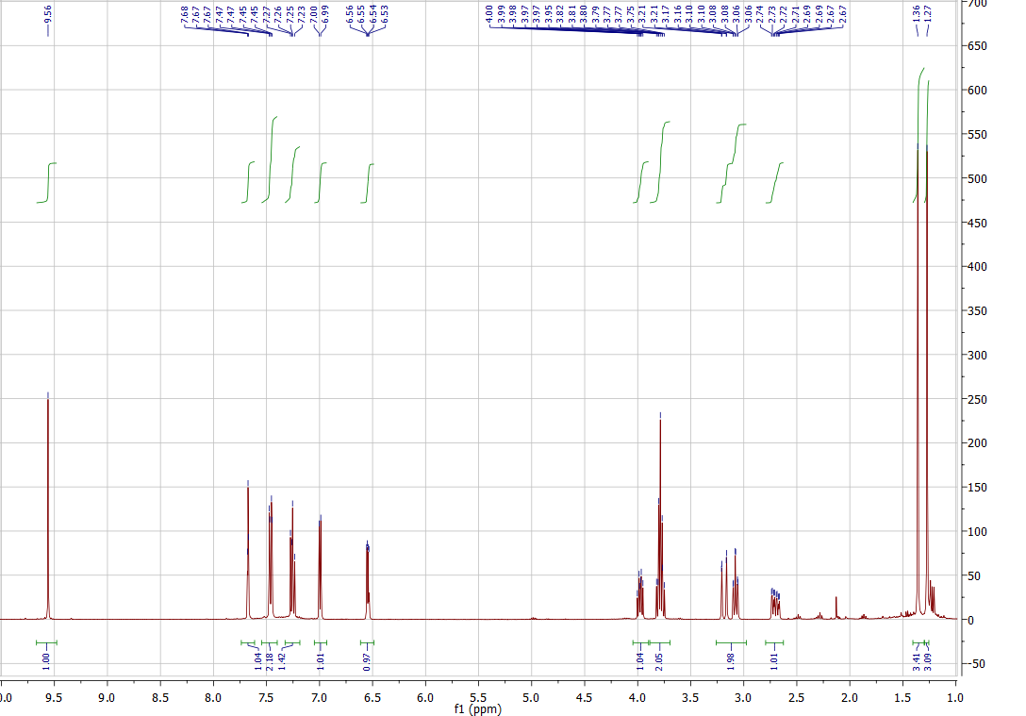

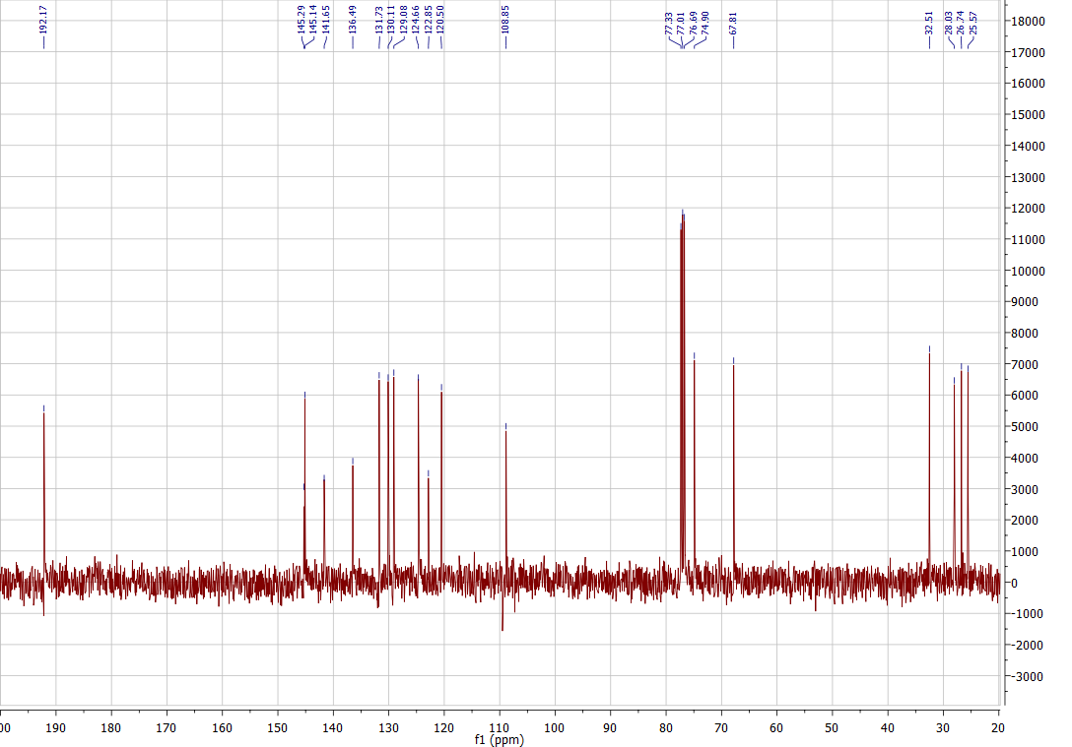

IR of 23b

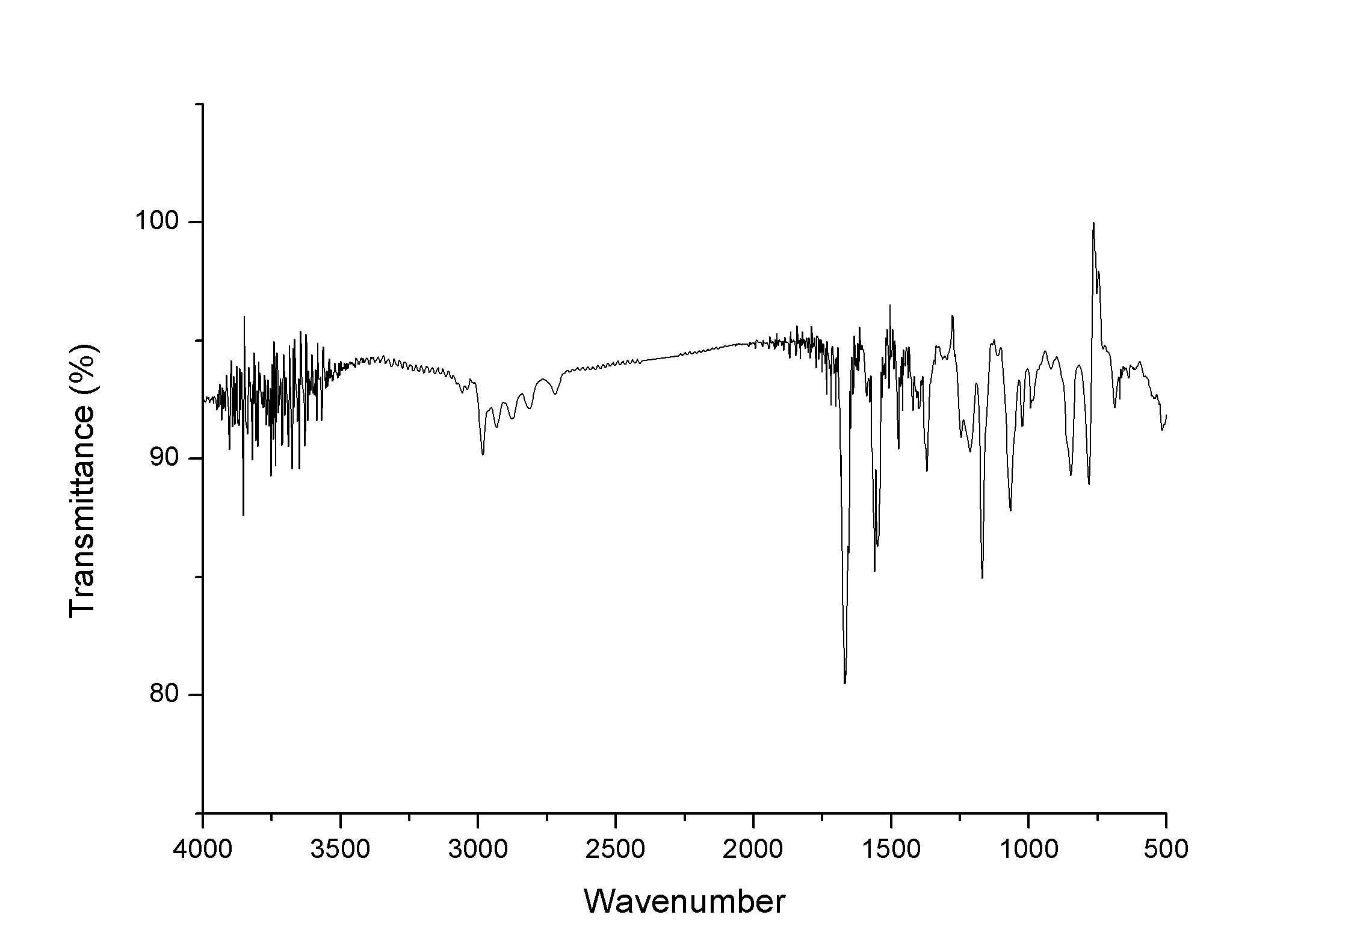

¹H NMR and ¹³C of NMR 24a

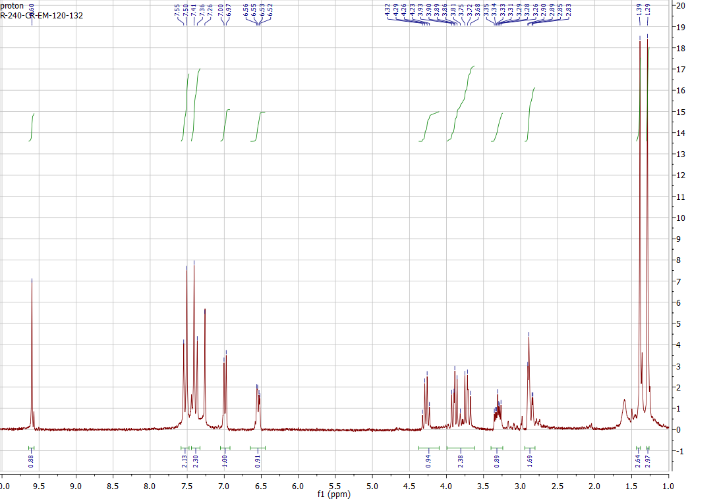

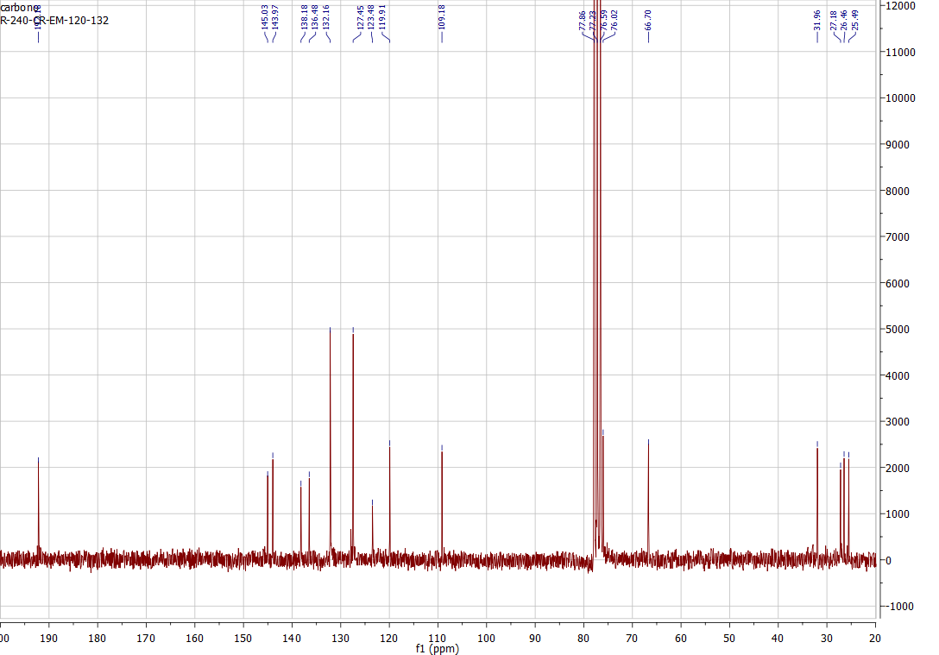

IR of 24a

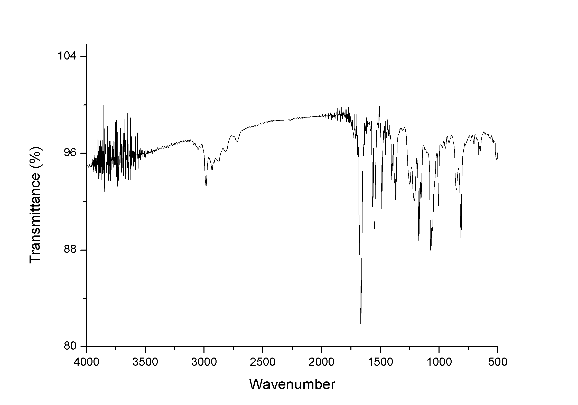

¹H NMR and ¹³C NMR of 24b

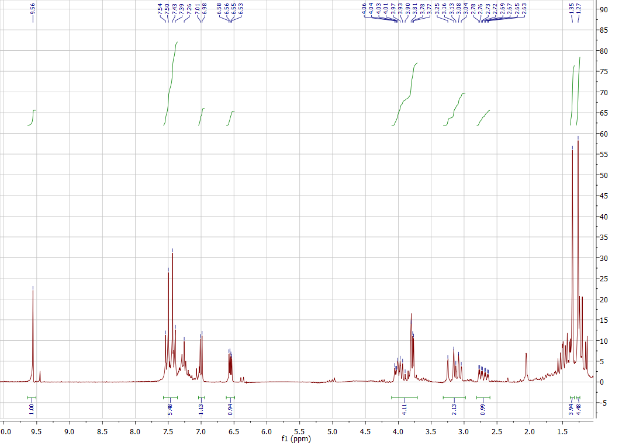

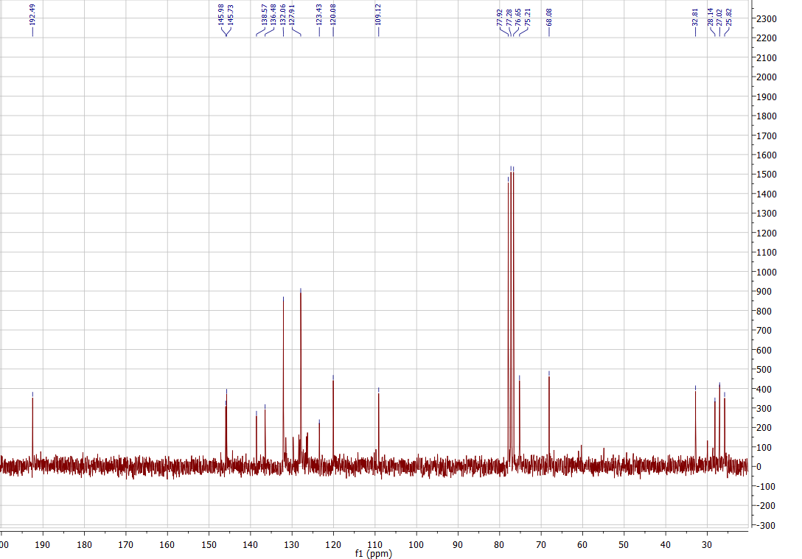

IR of 24b

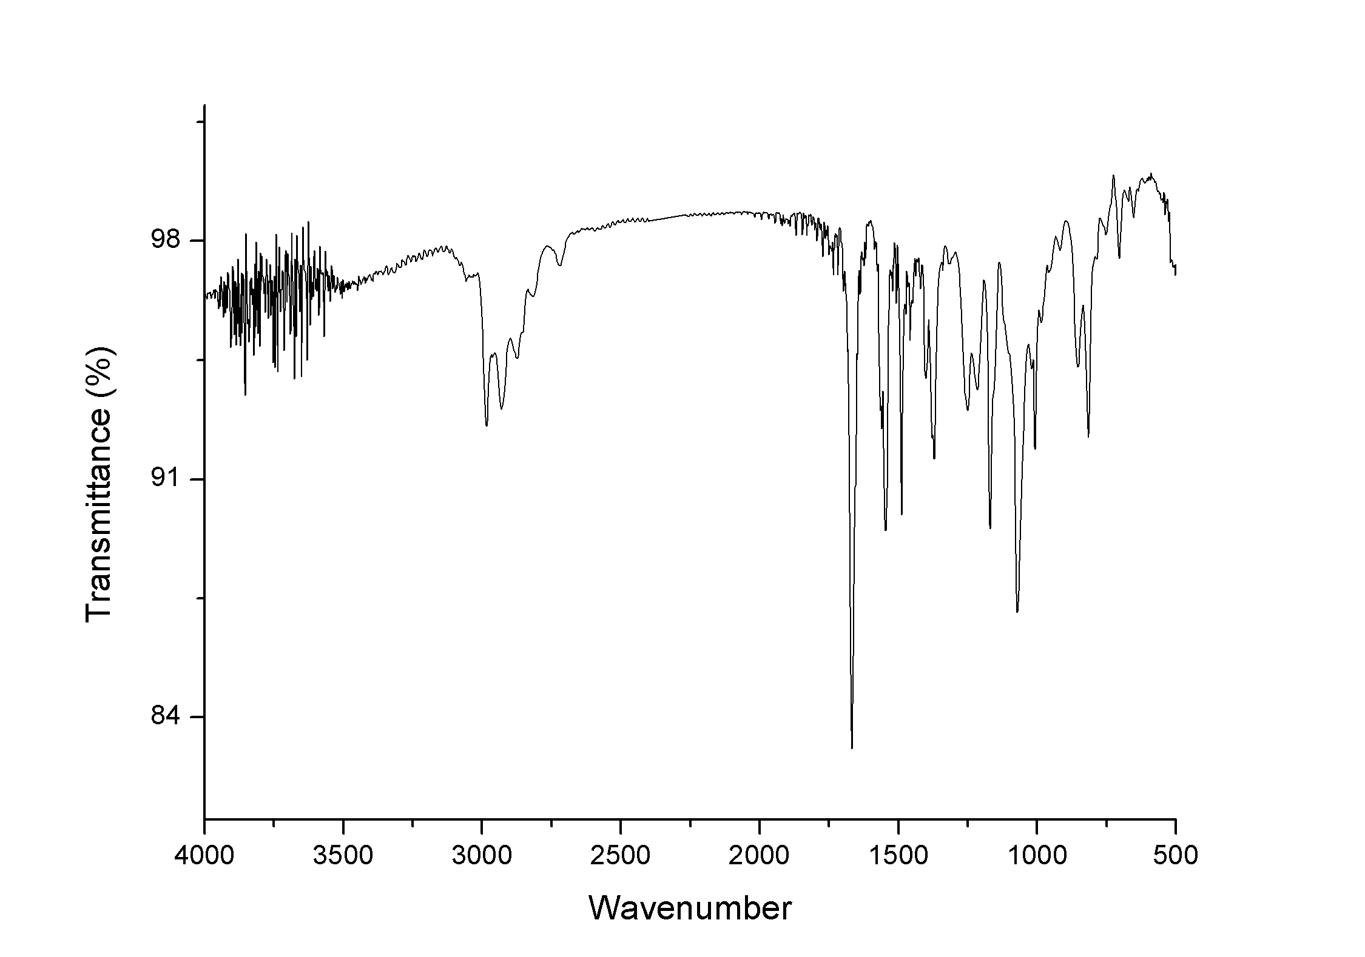

¹H NMR and ¹³C NMR of 25a

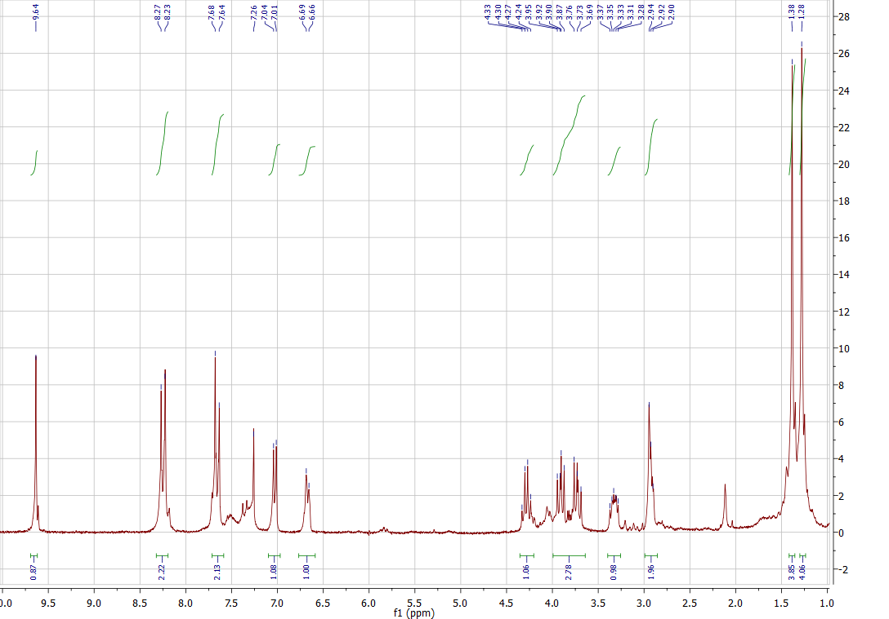

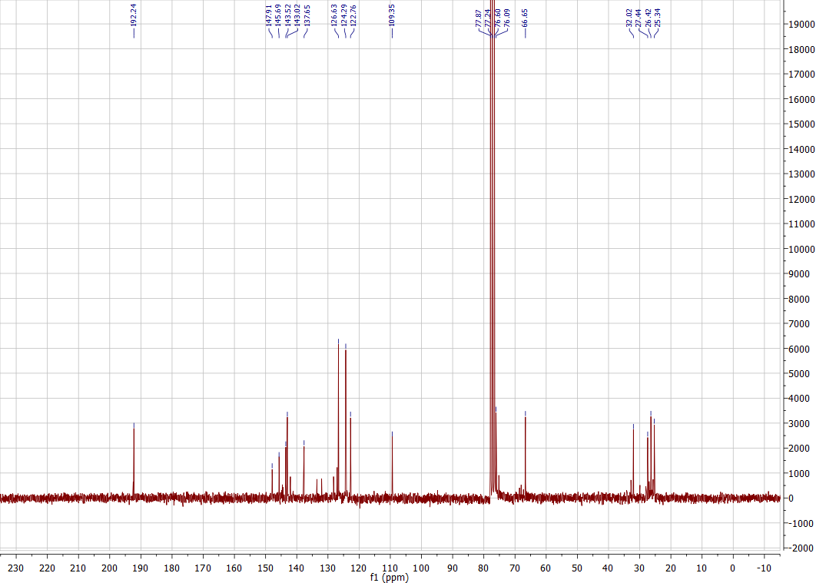

IR of 25a

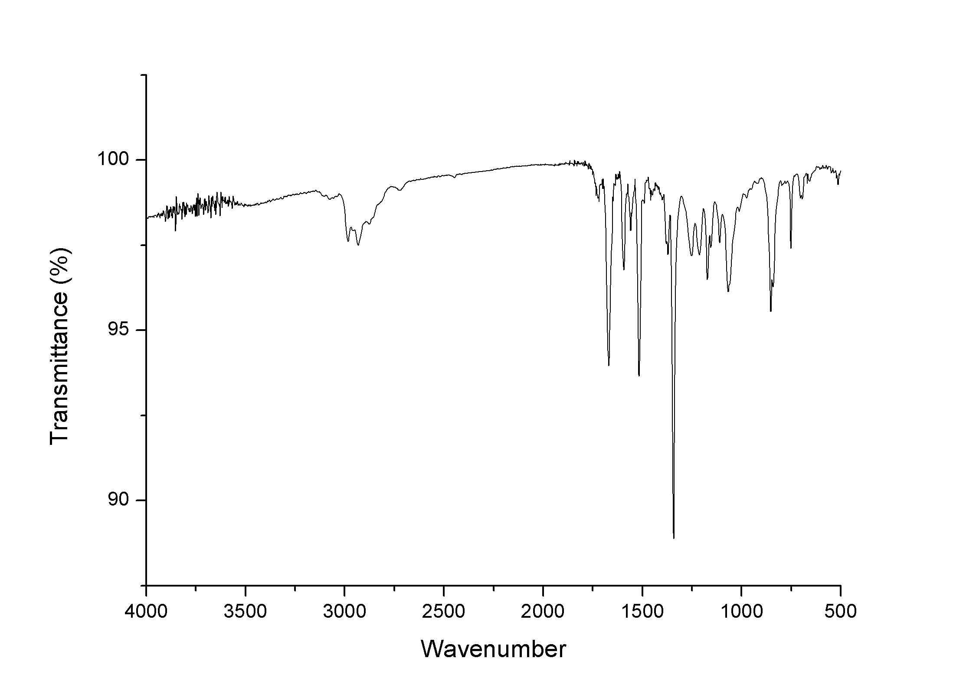

¹H NMR and ¹³C NMR of 25b

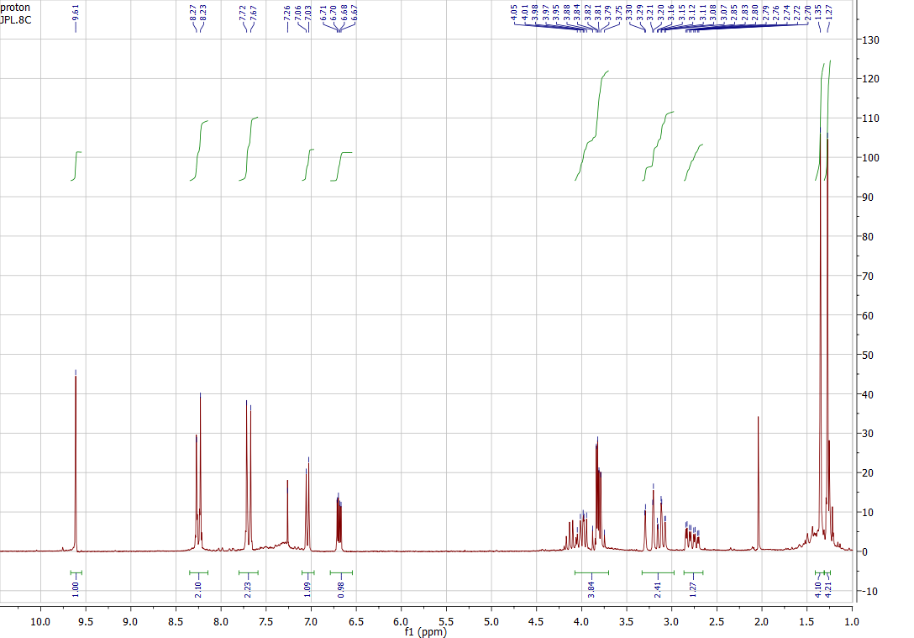

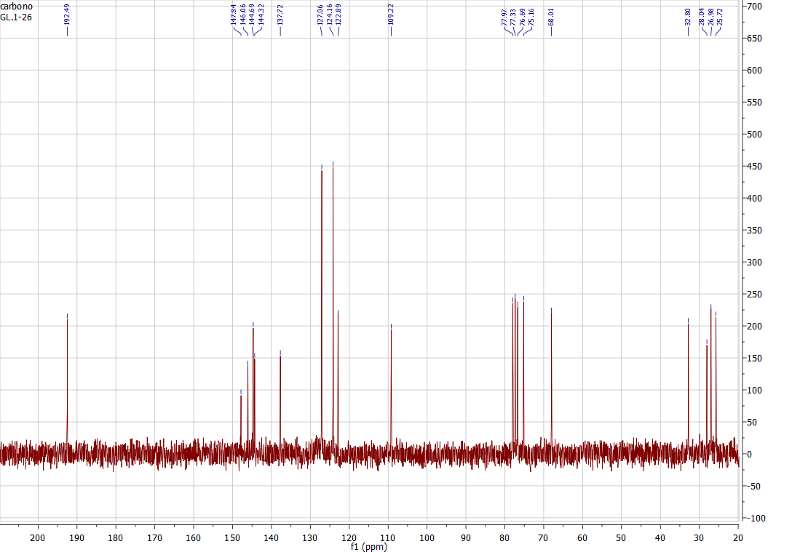

IR of 25b

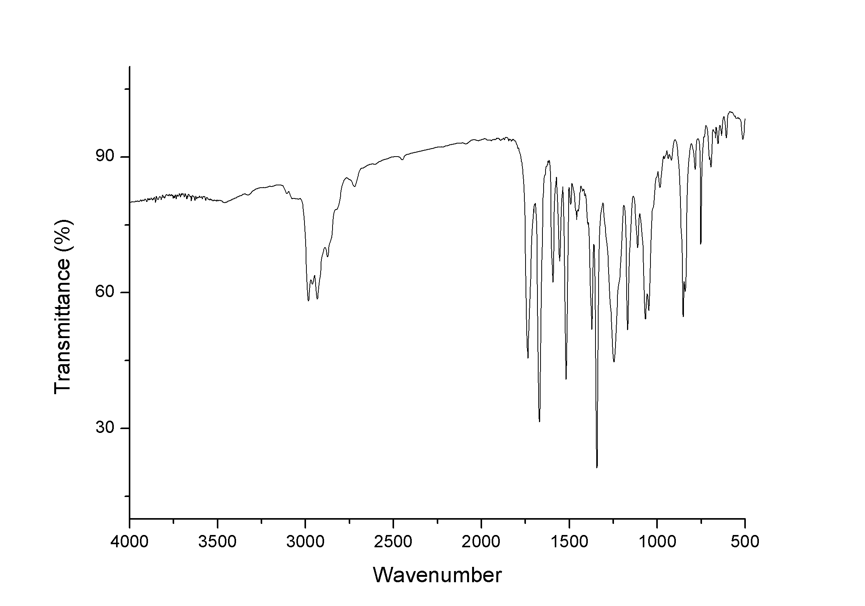

¹H NMR and ¹³C NMR of 26

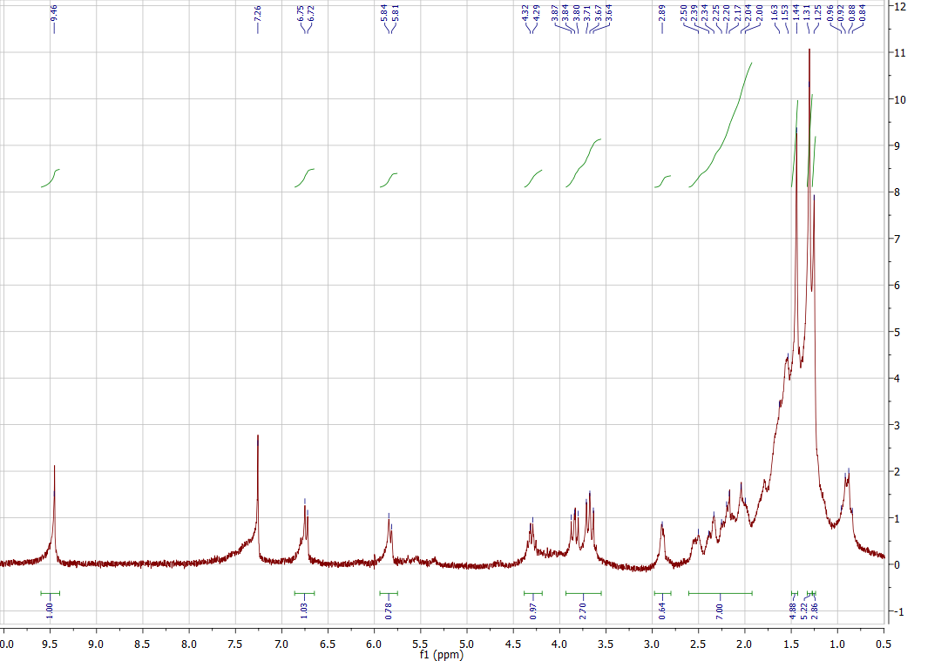

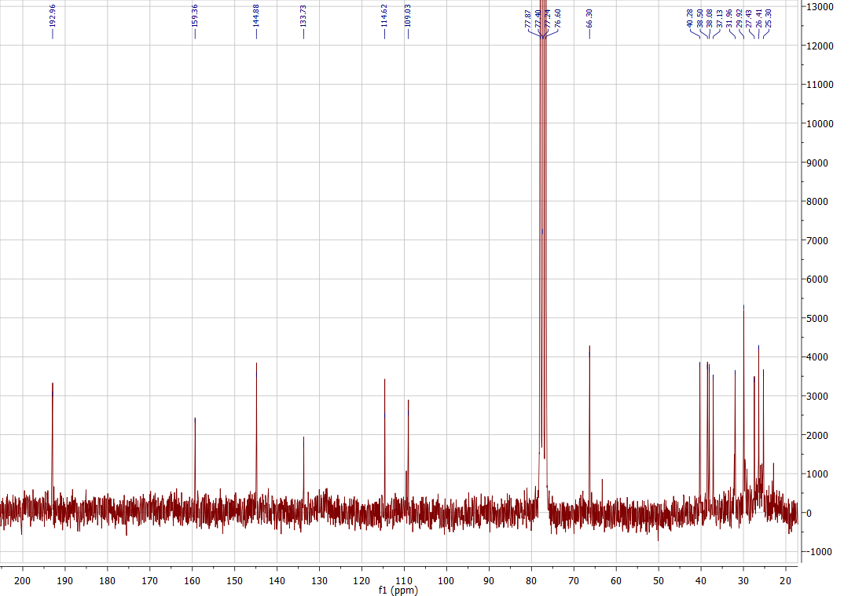

IR of 26

