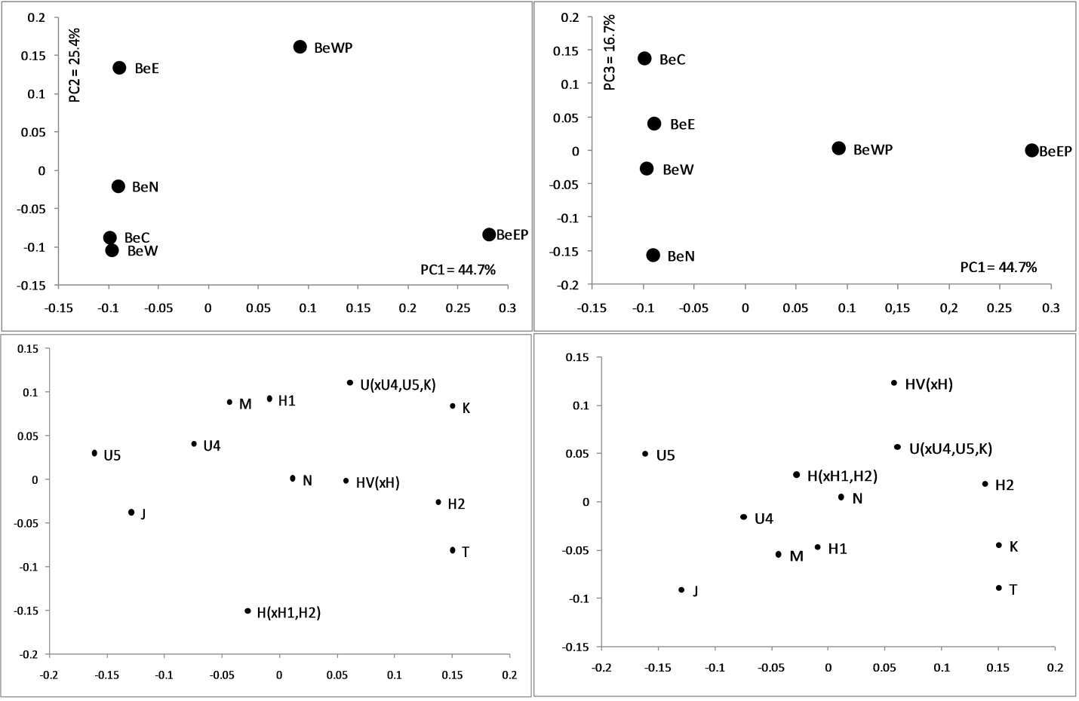

Figure S1. PC analysis based on mtDNA haplogroup frequencies in six Belarusian sub-populations. The distribution of the populations within 1-2 and 1-3 PCs is represented in the upper panels; the contribution of mtDNA haplogroups to each of the PCs is depicted in the lower panels. Sub-populations are designated as BeN – North, BeC – Centre, BeE – East, BeW – West, BeWP – West Polesie, BeEP – East Polesie.

