Supporting Information
Figure S1. Incidence rates (1/1000) as a function of follow-up time with 95% confidence intervals for a composite of all autoimmune diseases. Top: the whole study population; bottom, left: all patients with eating disorders; bottom, right: all control individuals.

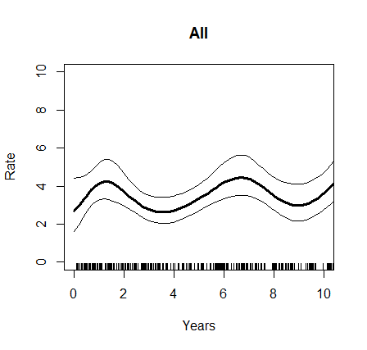
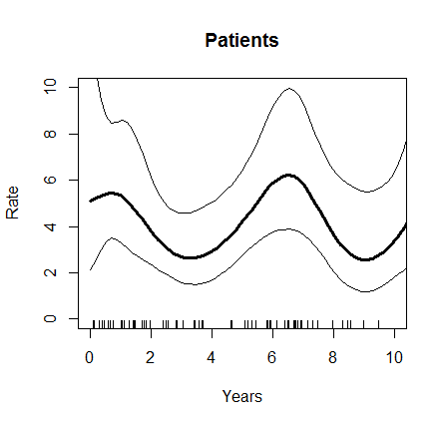 | 