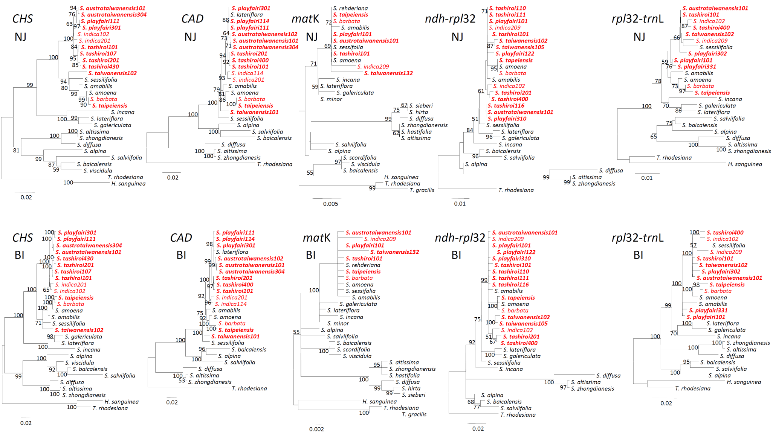
Figure S1 Neighbor-joining (NJ) and Bayesian inference (BI) trees of Scutellaria species reconstructed by each of five loci. Species marked in red and red bold are distributed in Taiwan and endemic to Taiwan, respectively. Values indicated in the nodes are the bootstrap values and posterior probabilities for supporting the grouping of lineages in NJ trees and BI trees, respectively.

