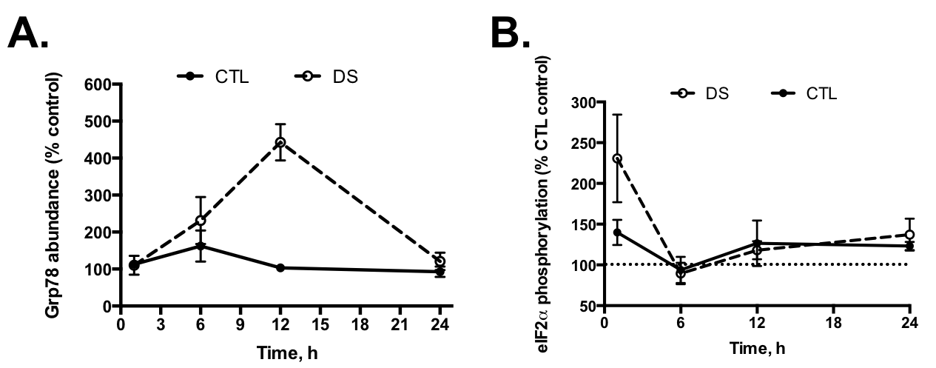

S1 Fig. Down syndrome cells are able to induce the ER stress response. DS and CTL LCLs were treated with MB (2.5uM) for 1-24h and Grp78 abundance (A) and eIF2α phosphorylation (B) were measured via Western blotting. These data show that ER stress signaling is not negatively impacted in DS cells.

