Supporting Information
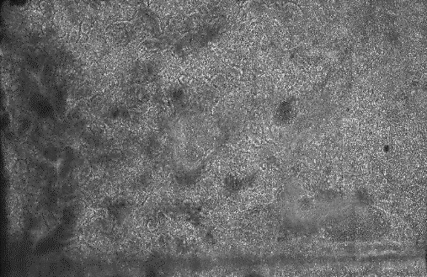
S8 Fig. Overview of the entire microchamber of Caco-2 cells at day 8 of in vitro cell culture. Caco-2 cells showed very observable dark patches at regions close to the inlet of the microchamber (indicated by red arrows). Caco-2 cells displayed villous-like structures. (scale bar = 50 µm)

