62-day target
31-day target
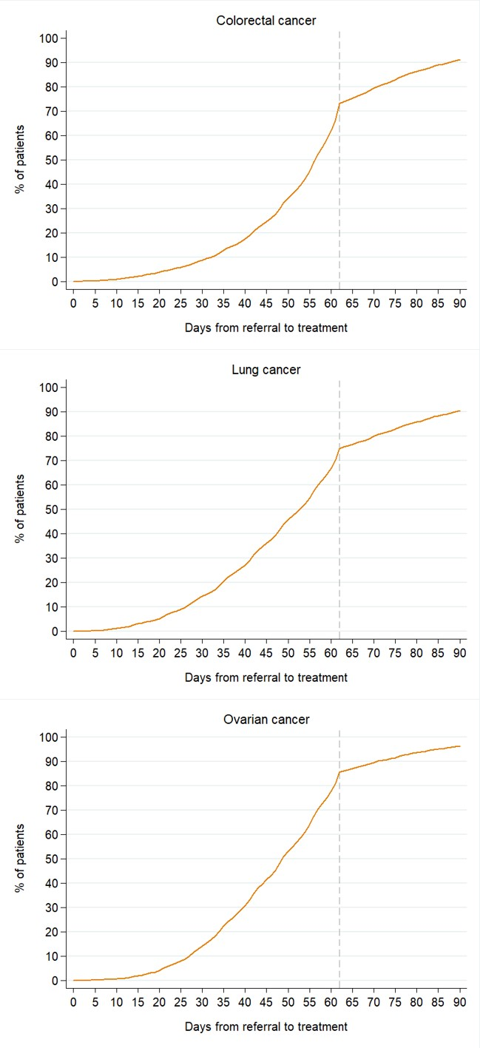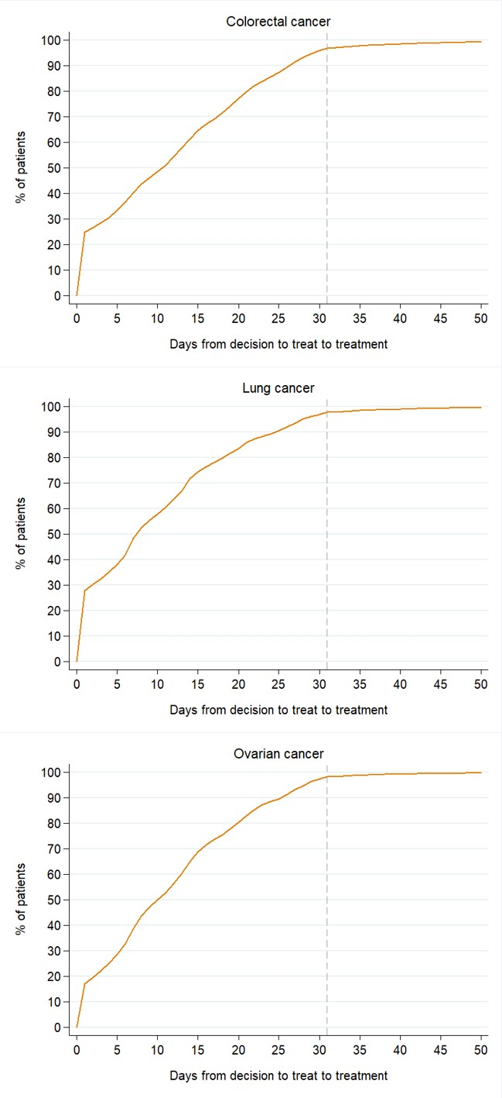
S2 Fig: Time to treatment (univariate analysis) for cancer patients who survived 90 days after diagnosis, England, 2009-13

