SUPPORTING FIGURE S1 for

Discerning the Subfribillar Structure of Mineralized Collagen Fibrils: a Model for the Ultrastructure of Bone

Yuping Li and Conrado Aparicio

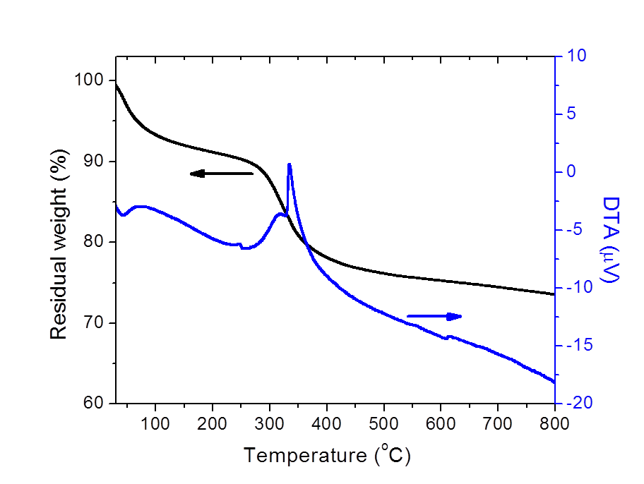

Figure S1. Thermogravimetric and differential thermal analysis (TG/DTA) of the crosslinked collagen matrix. Samples were mineralized via the PILP process for 14 days. Heating rate: 5 °C/min.

