S2 Appendix: Study 3 Post-experiment Survey

Interpersonal Attraction

How strongly do you agree or disagree with the following statements about your partner?

1. I like my partner
2. I would get along well with my partner.
3. I would enjoy a casual conversation with my partner.
4. My partner is the type of person I could become close friends with.
5. My partner is a good listener.
6. My partner is friendly.

Inclusion of the Other and the Self

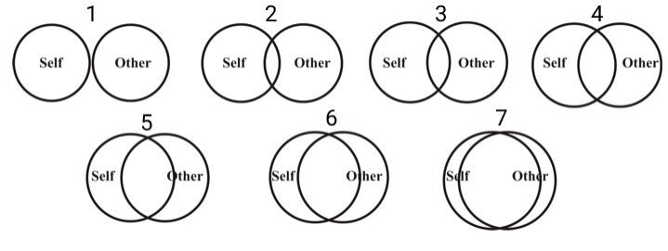
1. Please choose which of the figures above most accurately represents your relationship with your conversation partner.

Social Presence

1. When you think back on the task, to what extent did you have a sense that you were together with your partner in the same room?
2. I was often aware of my partner in the environment.
3. I sometimes pretended to pay attention to my partner.
4. My partner sometimes pretended to pay attention to me.
5. My partner paid close attention to me.
6. I paid close attention to my partner.
7. My partner tended to ignore me.
8. I tended to ignore my partner.
9. My partner understood what I meant.
10. I understood what my partner meant.

Open Ended Responses

1. Please describe in at least 5 sentences the conversation you had with your partner.
2. Please describe in at least 3 sentences your experience talking with your partner.
3. Please describe in 2-5 sentences the shirt/top that your partner was wearing.
4. What did you think the study was about?
5. Please describe any prior experiences in augmented/mixed reality.

