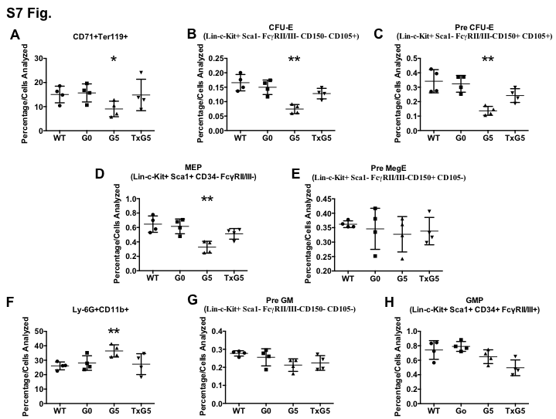

S7 Fig. Changes in Cell Populations as Defined By Mass Cytometry. Scatter plots showing percentages of (A) CD71+Ter119+ erythroblasts, (B) CFU-E, (C) Pre CFU-E, (D) MEP, (E) Pre MegE, (F) Myeloid, (G) Pre GM and (H) GMP populations in 11-14 months old WT Tert+/+ (n=4), G0 Tert+/- (n=4), G5 Tert-/- (n=4) and TxG5 Tert-/- (n=4) mice. Bars indicate standard deviation. p values are based on a 2-tailed t test. Statistically significant differences between WT and G5 Tert-/- mice are indicated by * (p value < 0.05) and ** (p value < 0.01). There were no significant differences between WT, G0 Tert+/- and TxG5 Tert-/- mice.

