2A_IWB8331
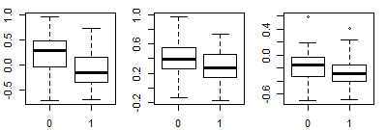
(a) (b) (c)
BLUP score

5A_IWB73709
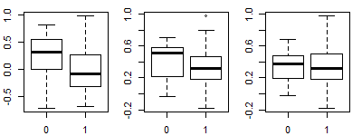
(a) (b) (c)
BLUP score

5B_IWB47298
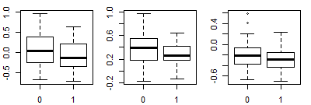
(a) (b) (c)
BLUP score

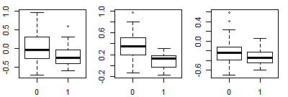
7A_IWB47160
(a) (b) (c)
BLUP score

7B_IWB45005
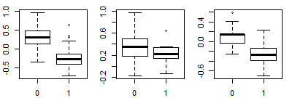
(a) (b) (c)
BLUP score

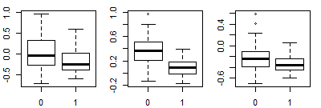
no map position_20731
(a) (b) (c)
BLUP score

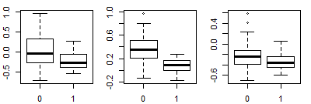
no map position_32948
(a) (b) (c)
BLUP score

S2 Fig. Boxplots of the seven most significant tagging markers effect on eyespot BLUP scores (a) in all lines; (b) lines without Pch1 resistance allele; and (c) all lines with the Pch1 resistance allele. 0= Panel A lines without resistance alleles; 1=Panel A lines with the resistance haplotype.

