SLOVENIA
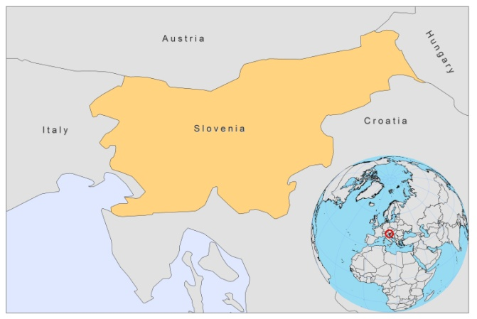

BASIC COUNTRY DATA
Total Population: 2,052,821
Population 0-14 years: 14%
Rural population: 52%
Population living under USD 1.25 a day: no data
Population living under the national poverty line: no data
Income status: High income economy
Ranking: Very high human development (ranking 21)
Per capita total expenditure on health at average exchange rate (US dollar): 2,175
Life expectancy at birth (years): 79
Healthy life expectancy at birth (years): 69
BACKGROUND INFORMATION
Leishmaniasis is rare in Slovenia. In 2010, a case of CL was documented in a 10-year-old boy and was probably imported [1]. In 2000, a case of CL was detected that was imported from Peru [2].

PARASITOLOGICAL INFORMATION
Leishmania  species | Clinical form | Vector species | Reservoirs
L. infantum | VL, CL | P. neglectus | Canis familiaris

MAPS & TREND
No information available.

CONTROL
The notification of leishmaniasis is not mandatory in the country and there is no national leishmaniasis control program. There is no leishmaniasis vector control program and no leishmaniasis reservoir control program.

DIAGNOSIS, TREATMENT, ACCESS TO CARE and ACCESS TO DRUGS

No information available.

SOURCES OF INFORMATION

1. Marovt M, Kokol R, Stanimirović A, Miljković J (2010). Cutaneous leishmaniasis: A case report. Acta Dermatovenerol Alp Panonica Adriat .19(2):41-3.

2. Brecelj M, Pikelj F, Gubensek F, Anderluh G (2000). Polymerase chain reaction as a diagnostic tool for detecting Leishmania. Infection 28(2):111-3.

