Supporting Information
Effect of sequence and stereochemistry reversal on p53 peptide mimicry
Alessio Atzori, Audrey E. Baker, Mark Chiu, Richard A. Bryce* and Pascal Bonnet*
School of Pharmacy and Pharmaceutical Sciences, University of Manchester, Oxford Road, Manchester, M13 9PT, UK
Biologics Research, Janssen Research and Development Inc., 145 King of Prussia Road, Radnor, PA, USA
Janssen Research & Development, a division of Janssen Pharmaceutica N.V., Turnhoutseweg 30, 2340 Beerse, Belgium

Figure S1. Replica exchange equilibration for the (initially) 270 K replica.
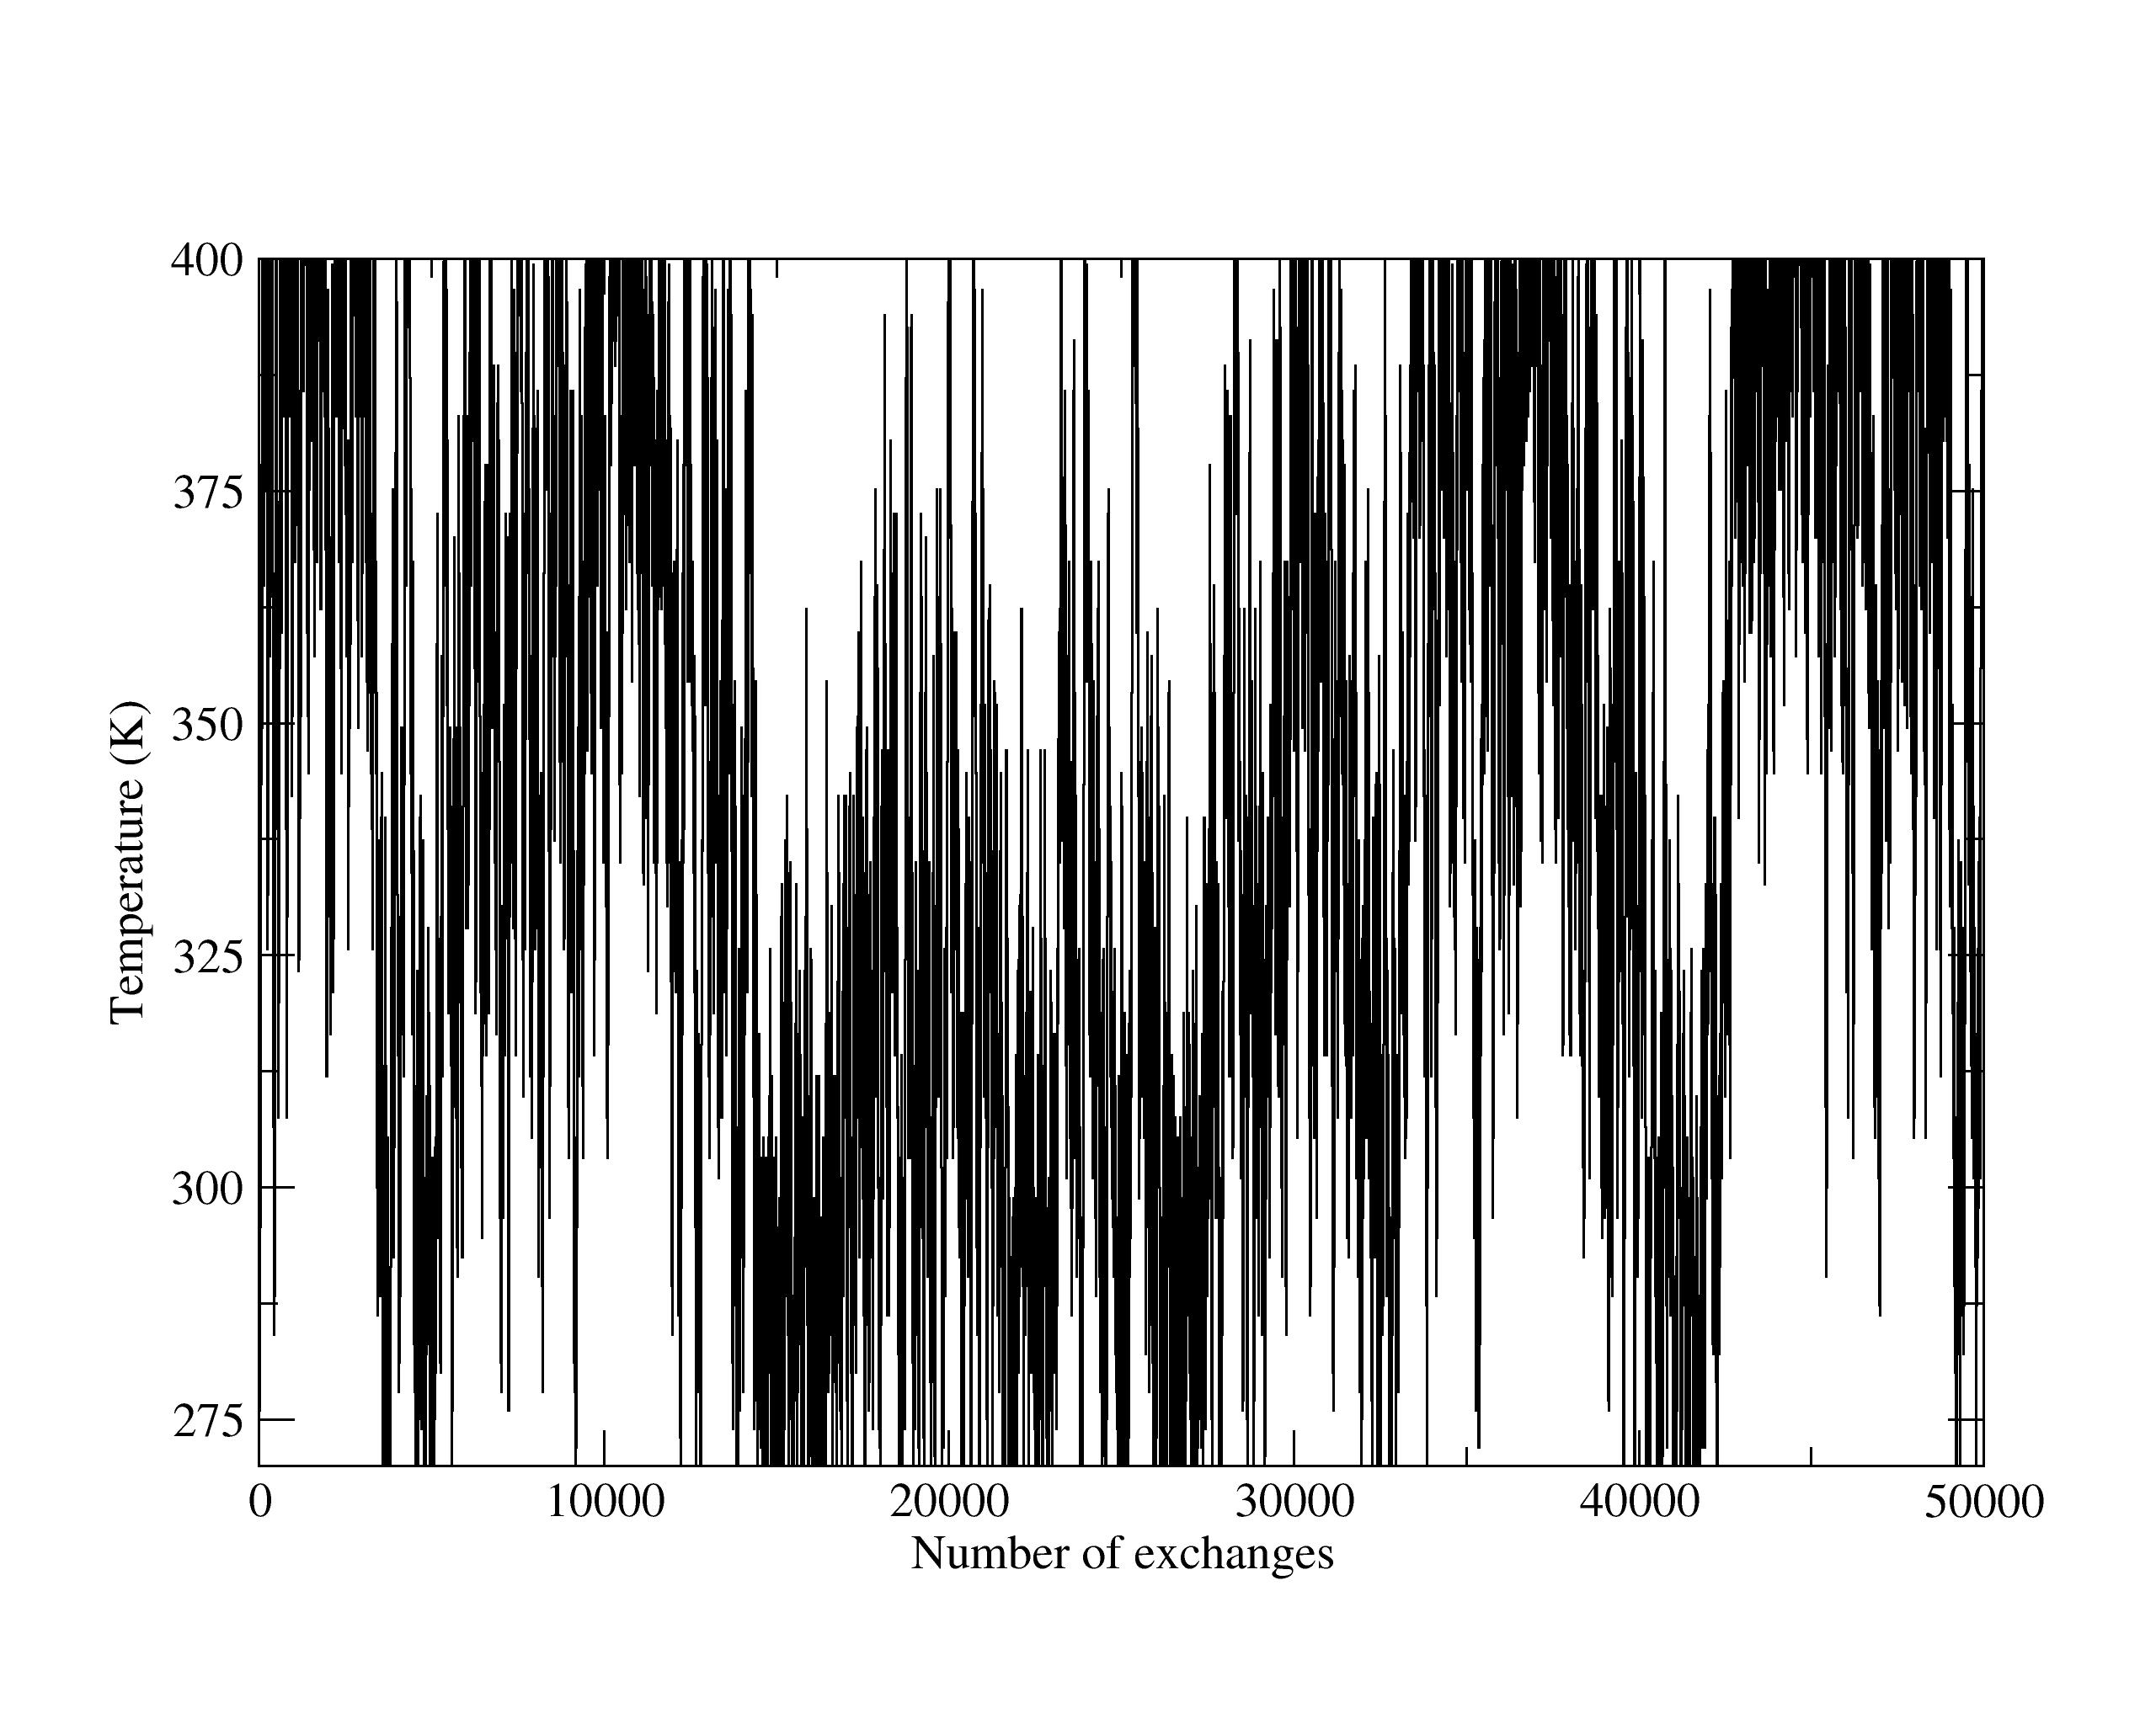

Figure S2. 3₁₀ helical content from REMD simulations of WT, I, R and RI.
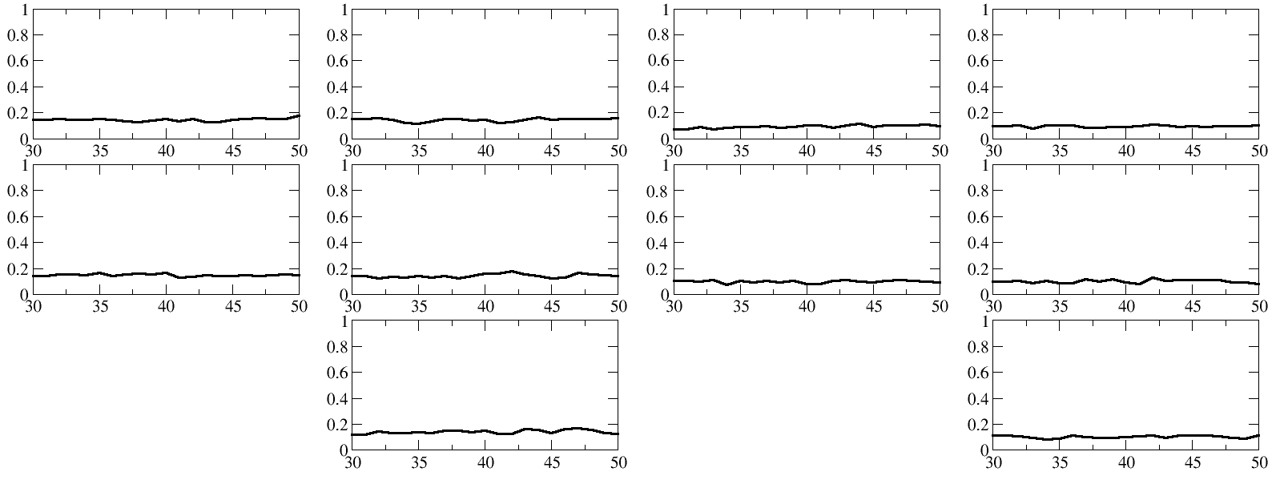

Table S1 Average number of hydrogen bonds between the backbone peptide C=O of residues i and the backbone peptide NH of the residues i + 4 and average total number of hydrogen bonds within sequence over final 20 ns of REMD for sequences WT, I, R and RI. Standard deviations in parentheses.

i → i+4 | i(WT/I) | i(R/RI) | WT | I | R | RI
0 – 4 | Ace | Ace | 0.04 (0.19) | 0.04 (0.19) | 0.00 (0.02) | 0.00 (0.03)
1 – 5 | Ser | Asn | 0.04 (0.21) | 0.04 (0.20) | 0.09 (0.28) | 0.05 (0.22)
2 – 6 | Gln | Glu | 0.11 (0.31) | 0.10 (0.30) | 0.31 (0.46) | 0.30 (0.46)
3 – 7 | Glu | Pro | 0.08 (0.26) | 0.07 (0.25) | 0.18 (0.39) | 0.17 (0.38)
4 – 8 | Thr | Leu | 0.14 (0.34) | 0.12 (0.33) | 0.26 (0.44) | 0.23 (0.42)
5 – 9 | Phe | Leu | 0.16 (0.37) | 0.18 (0.39) | 0.28 (0.45) | 0.28 (0.45)
6 – 10 | Ser | Lys | 0.05 (0.22) | 0.06 (0.23) | 0.12 (0.33) | 0.11 (0.32)
7 – 11 | Asp | Trp | 0.05 (0.21) | 0.04 (0.20) | 0.16 (0.37) | 0.14 (0.35)
8 – 12 | Leu | Leu | 0.25 (0.43) | 0.26 (0.44) | 0.15 (0.36) | 0.14 (0.35)
9 – 13 | Trp | Asp | - | - | 0.05 (0.22) | 0.06 (0.23)
10 – 14 | Lys | Ser | 0.00 (0.00) | 0.00 (0.01) | 0.09 (0.29) | 0.11 (0.31)
11 – 15 | Leu | Phe | 0.02 (0.15) | 0.01 (0.12) | 0.15 (0.36) | 0.14 (0.35)
total |  |  | 0.94 (0.92) | 0.93 (0.91) | 1.84 (1.48) | 1.74 (1.45)

