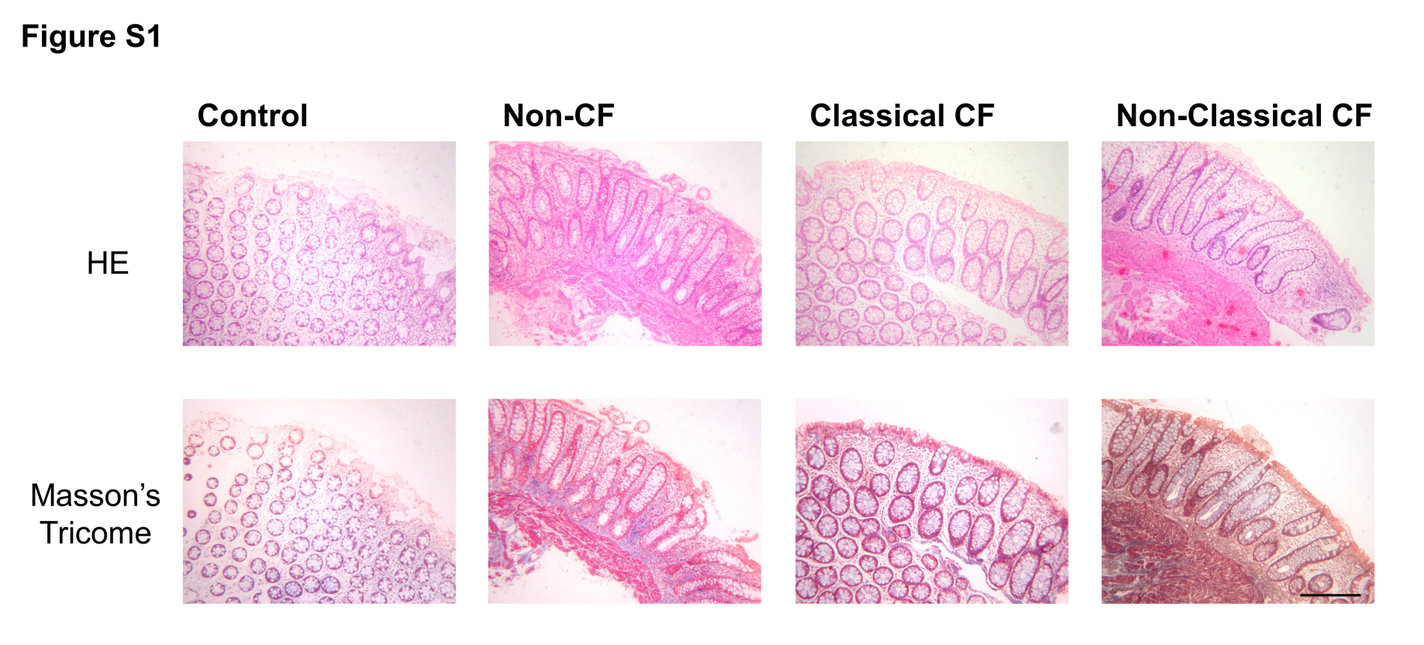
Figure S1 – Histological evaluation of rectal biopsies by Hematoxilin-Eosin (HE) and Masson’s Tricome stainings in control (transversal cut), Non-CF (longitudinal cut), Classical CF (transversal cut) and Non-Classical CF (longitudinal cut) showing a healthy epithelia, namely no fibrotic processes were observed and some biopsies presented inflammatory processes, independent of being CF or not. In HE stained sections we observe nuclei in blue and cytoplasm in pink to red. For Tricome’s Masson we observe collagen in blue, nuclei black, and muscle and cytoplasm in red. Black scale bar represents 250μM.

