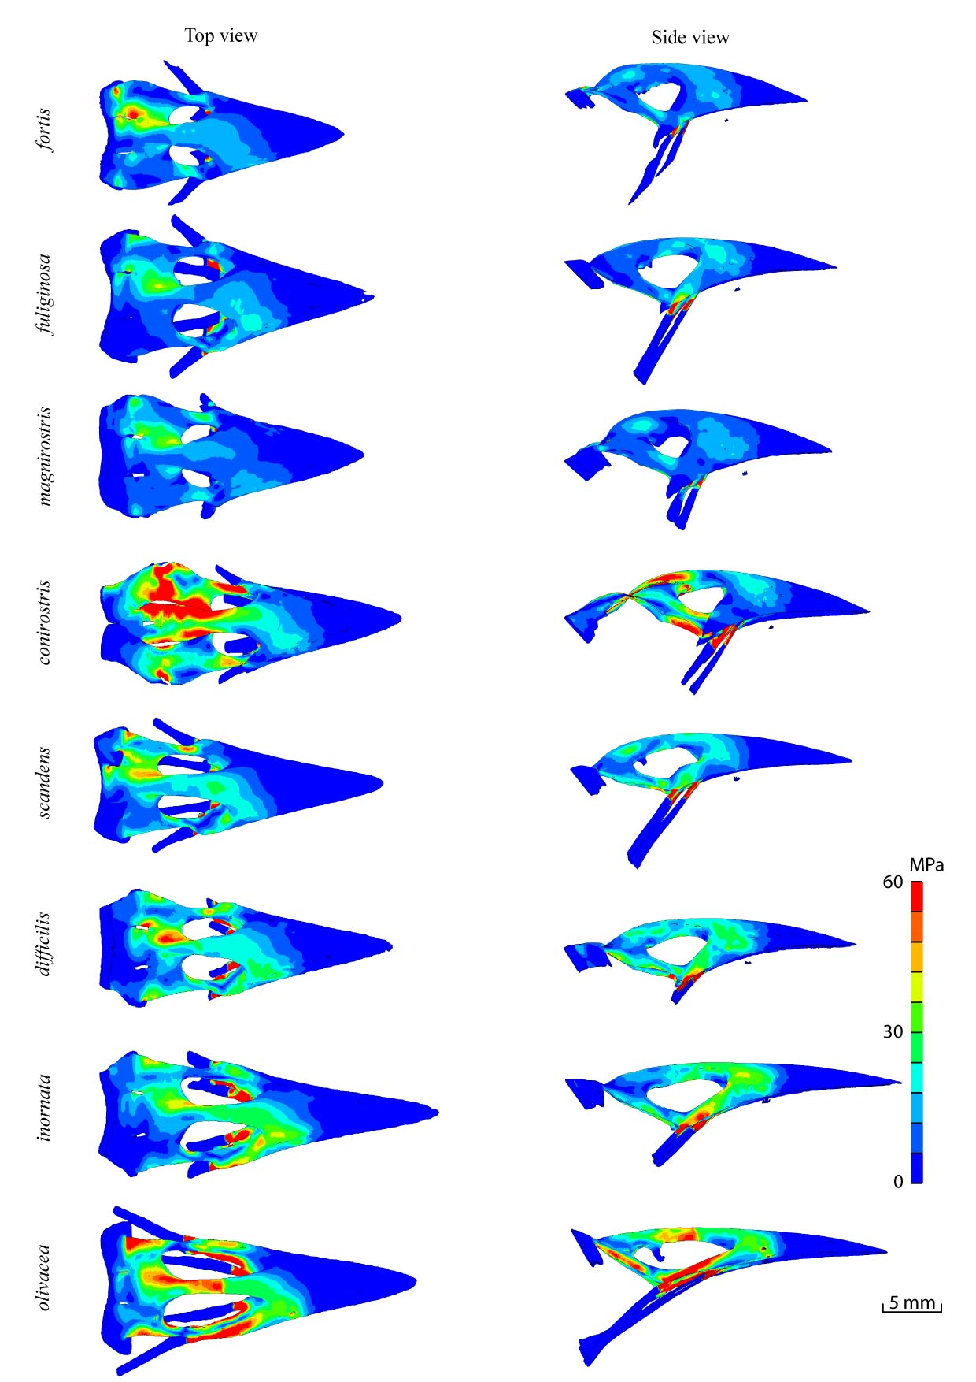
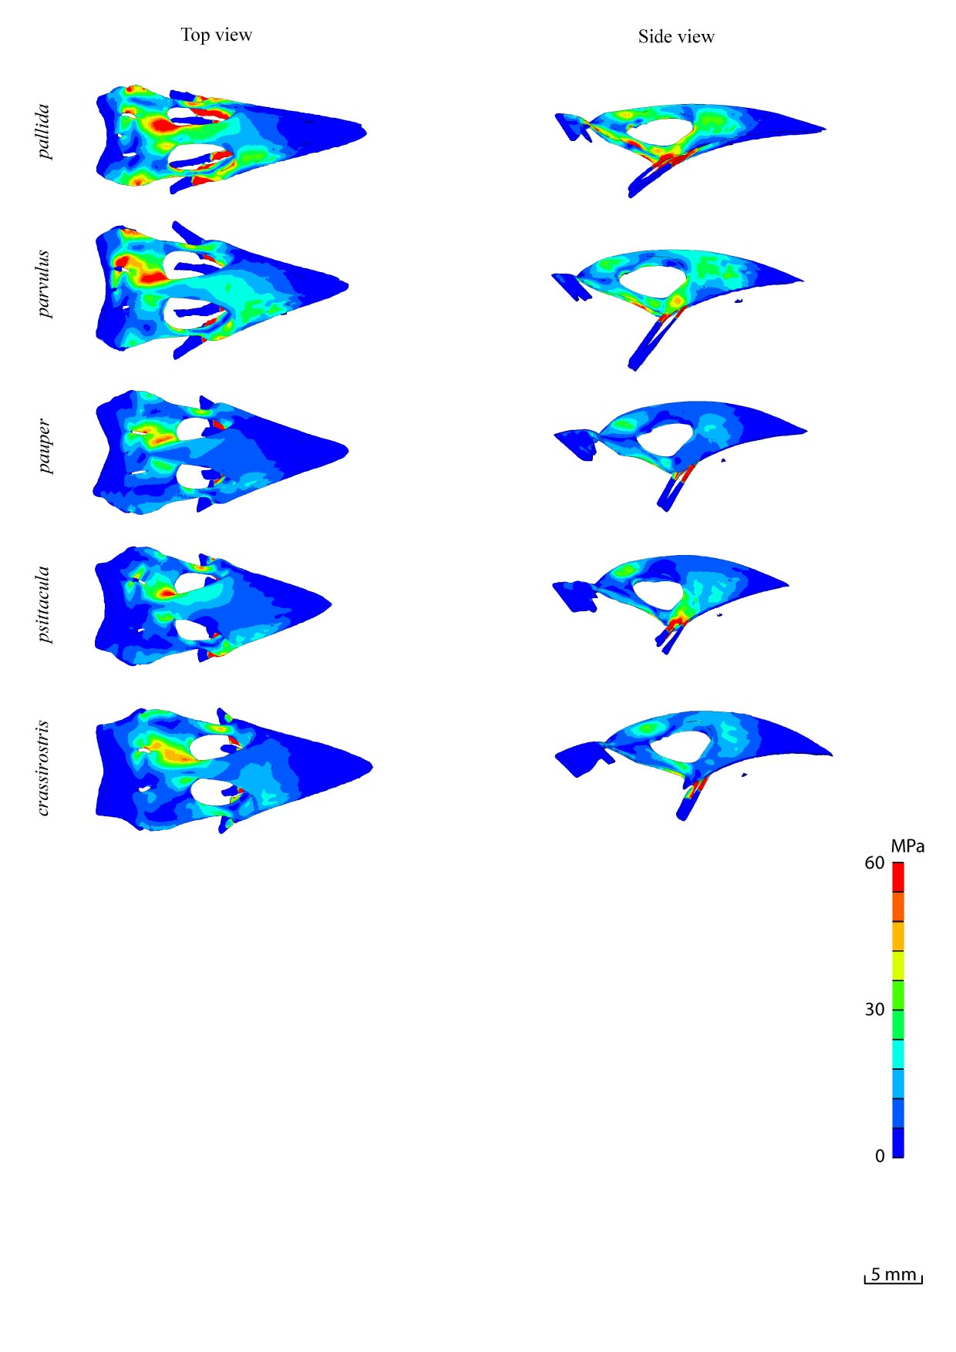
S4 Fig.: Top and side view for scaled FE models of upper beak during base biting for 13 Darwin finches.

