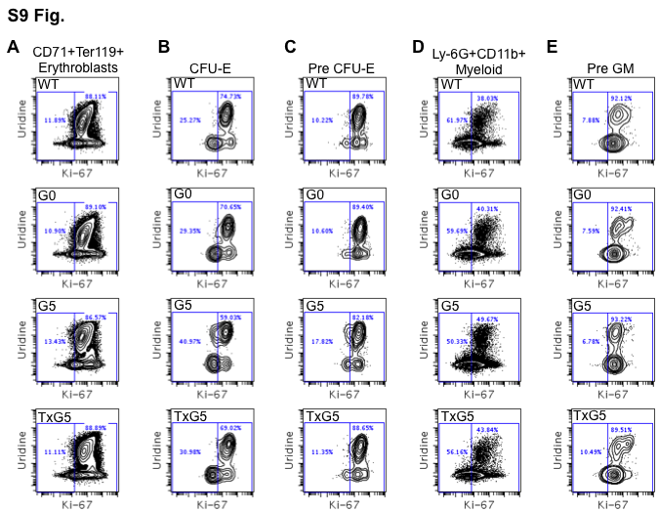

S9 Fig. Cell Cycle analysis as Determined by Mass Cytometry in Different Erythoid and Myeloid populations.
(A-E) Representative plots showing uridine incorporation and Ki-67 expression in (A) Erythroblasts (B) CFU-E, (C) Pre CFU-E, (D) mature myeloid cells and (E) pre GM populations in WT, G0 Tert+/-, G5 Tert-/- and TxG5 Tert-/- mice. Four mice of each genotype were studied.

