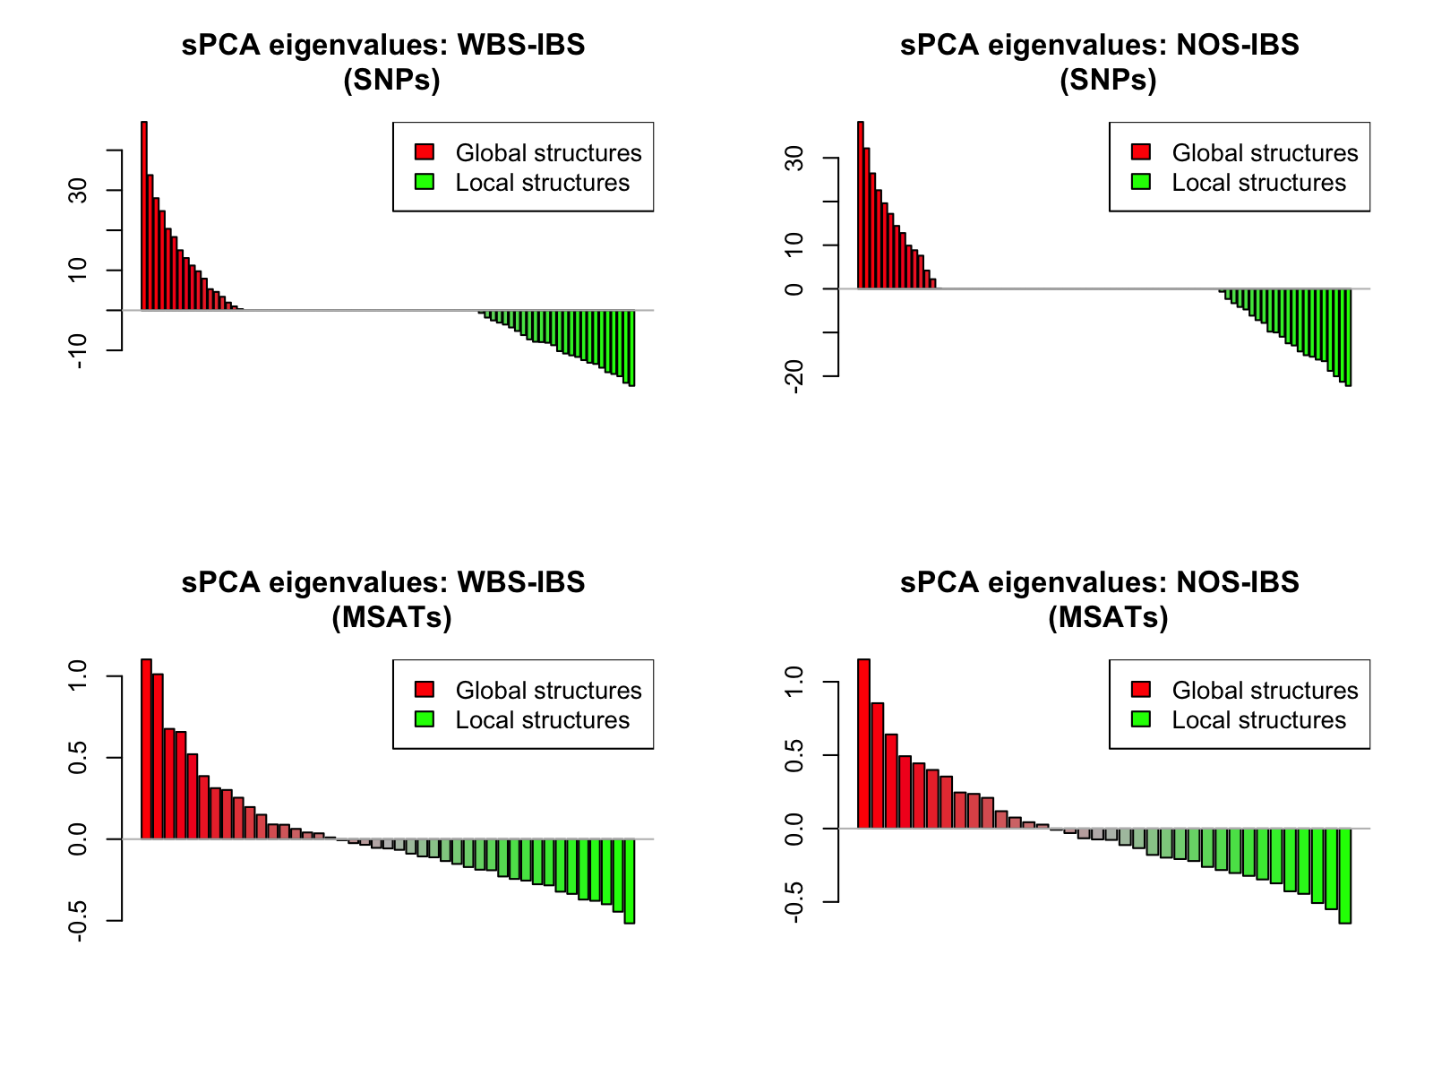
Figure S1. Eigenvalue plots of sPCA. Eigenvalue plots of sPCA based on the SNP (top panels) and the microsatellite (bottom panels) datasets for European Seas (WBS-IBS; left panels) and the North Sea to the Inner Baltic Sea sub-regions (NOS-IBS; right panels).

